ARPC looks forward to supporting our new responsible Minister, the Hon Stephen Jones MP, Assistant Treasurer and Minister for Financial Services. I also wish to thank insurers for their assistance and support during preparations for the Cyclone Reinsurance Pool (CRP).
We are set for a busy end to the financial year with preparation of our annual report and corporate plan, continuing work on the Terrorism Reinsurance Pool, and preparing for the operation of the CRP from 1 July 2022.
ARPC is finalising implementation arrangements for the CRP and has been consulting bilaterally with insurers on the premium formula design, the draft premium rates, and the reinsurance agreement. ARPC issued a draft of the reinsurance rates in May and is considering feedback before providing further information ahead of 1 July 2022.
ARPC has developed CRP premium rates by reviewing insurer exposure data, catastrophe modelling analysis, and consulting actuarial advice, with review by the Reviewing Actuary (the Australian Government Actuary). The reinsurance agreement has been developed using industry reinsurance practices updated to reflect the Terrorism and Cyclone Insurance Act 2003 and regulations.
Stay up to date on the CRP with our Special July Edition of Under the Cover, which will include more detail on premium rates and the reinsurance agreement.
In May, we held our annual Terrorism Risk Insurance Seminar at NSW Parliament House. I was delighted to chair the event in person and to engage with a live audience. I would like to extend my thanks to our expert speakers, Dr Kevin Foster, and Professor Paula Jarzabkowski. I encourage you to watch the recorded livestream and read the ARPC-funded research paper here.
Please contact us at enquiries@arpc.gov.au with any questions.

Sincerely,
Dr Christopher Wallace
Chief Executive Officer
ARPC’s new Minister
UQ research on terrorism and violent protests
ARPC’s Annual Terrorism Risk Insurance Seminar
IFTRIP ReCODE Conference
Standards Australia Risk Mitigation Handbook
Premium submissions due
Q&A

June 2022

Welcome to the Winter edition of our newsletter.

New Minister for ARPC
The Hon Stephen Jones MP, Assistant Treasurer and Minister for Financial Services, is the newly appointed responsible Minister for ARPC.
Stephen was first elected to the Federal Parliament in 2010 representing the Southern Illawarra seat of Throsby. He was re-elected in the 2013 election and elected to the re-named seat of Whitlam in the 2016 election.
Stephen holds a Bachelor of Arts degree from the University of Wollongong and a Bachelor of Laws degree from Macquarie University.
Prior to entering the Federal Parliament, he worked as a community worker for various front line disability services, youth, and health services and as a lawyer with the Australian Council of Trade Unions (ACTU) and as the Secretary of the Community and Public Sector Union (CPSU).
More information about Ministers in the Treasury portfolio, including media releases and transcripts, is available here

ARPC publishes UQ research on terrorism and violent protests
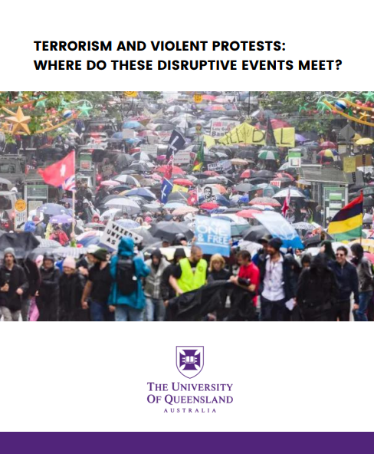
ARPC has published research by the University of Queensland exploring whether definitions of terrorism have shifted due to the social and economic disruption caused by the Covid-19 pandemic.
The research paper Terrorism and Violent Protests – where do these disruptive events meet? looks at the evolving nature of violent protests and other disruptive events.
The lead author of the research paper is Professor Paula Jarzabkowski, with Dr Corinne Unger and Dr Katie Meissner.
This research paper is the first in a series of ARPC-funded research papers on terrorism-related topics, to support a strategic priority to promote thought leadership.

Read the research paper here

ARPC’s 2022 Terrorism Risk Insurance Seminar
ARPC CEO Dr Christopher Wallace (pictured) chaired ARPC’s annual Terrorism Risk and Insurance Seminar at NSW Parliament.
The event was livestreamed with attendees taking part in-person and online. Dr Kevin J. Foster spoke on the features, benefits, and uses of Standards Australia’s Base Building Physical Security Handbook-Terrorism and extreme violence (HB-188), a project sponsored by ARPC.
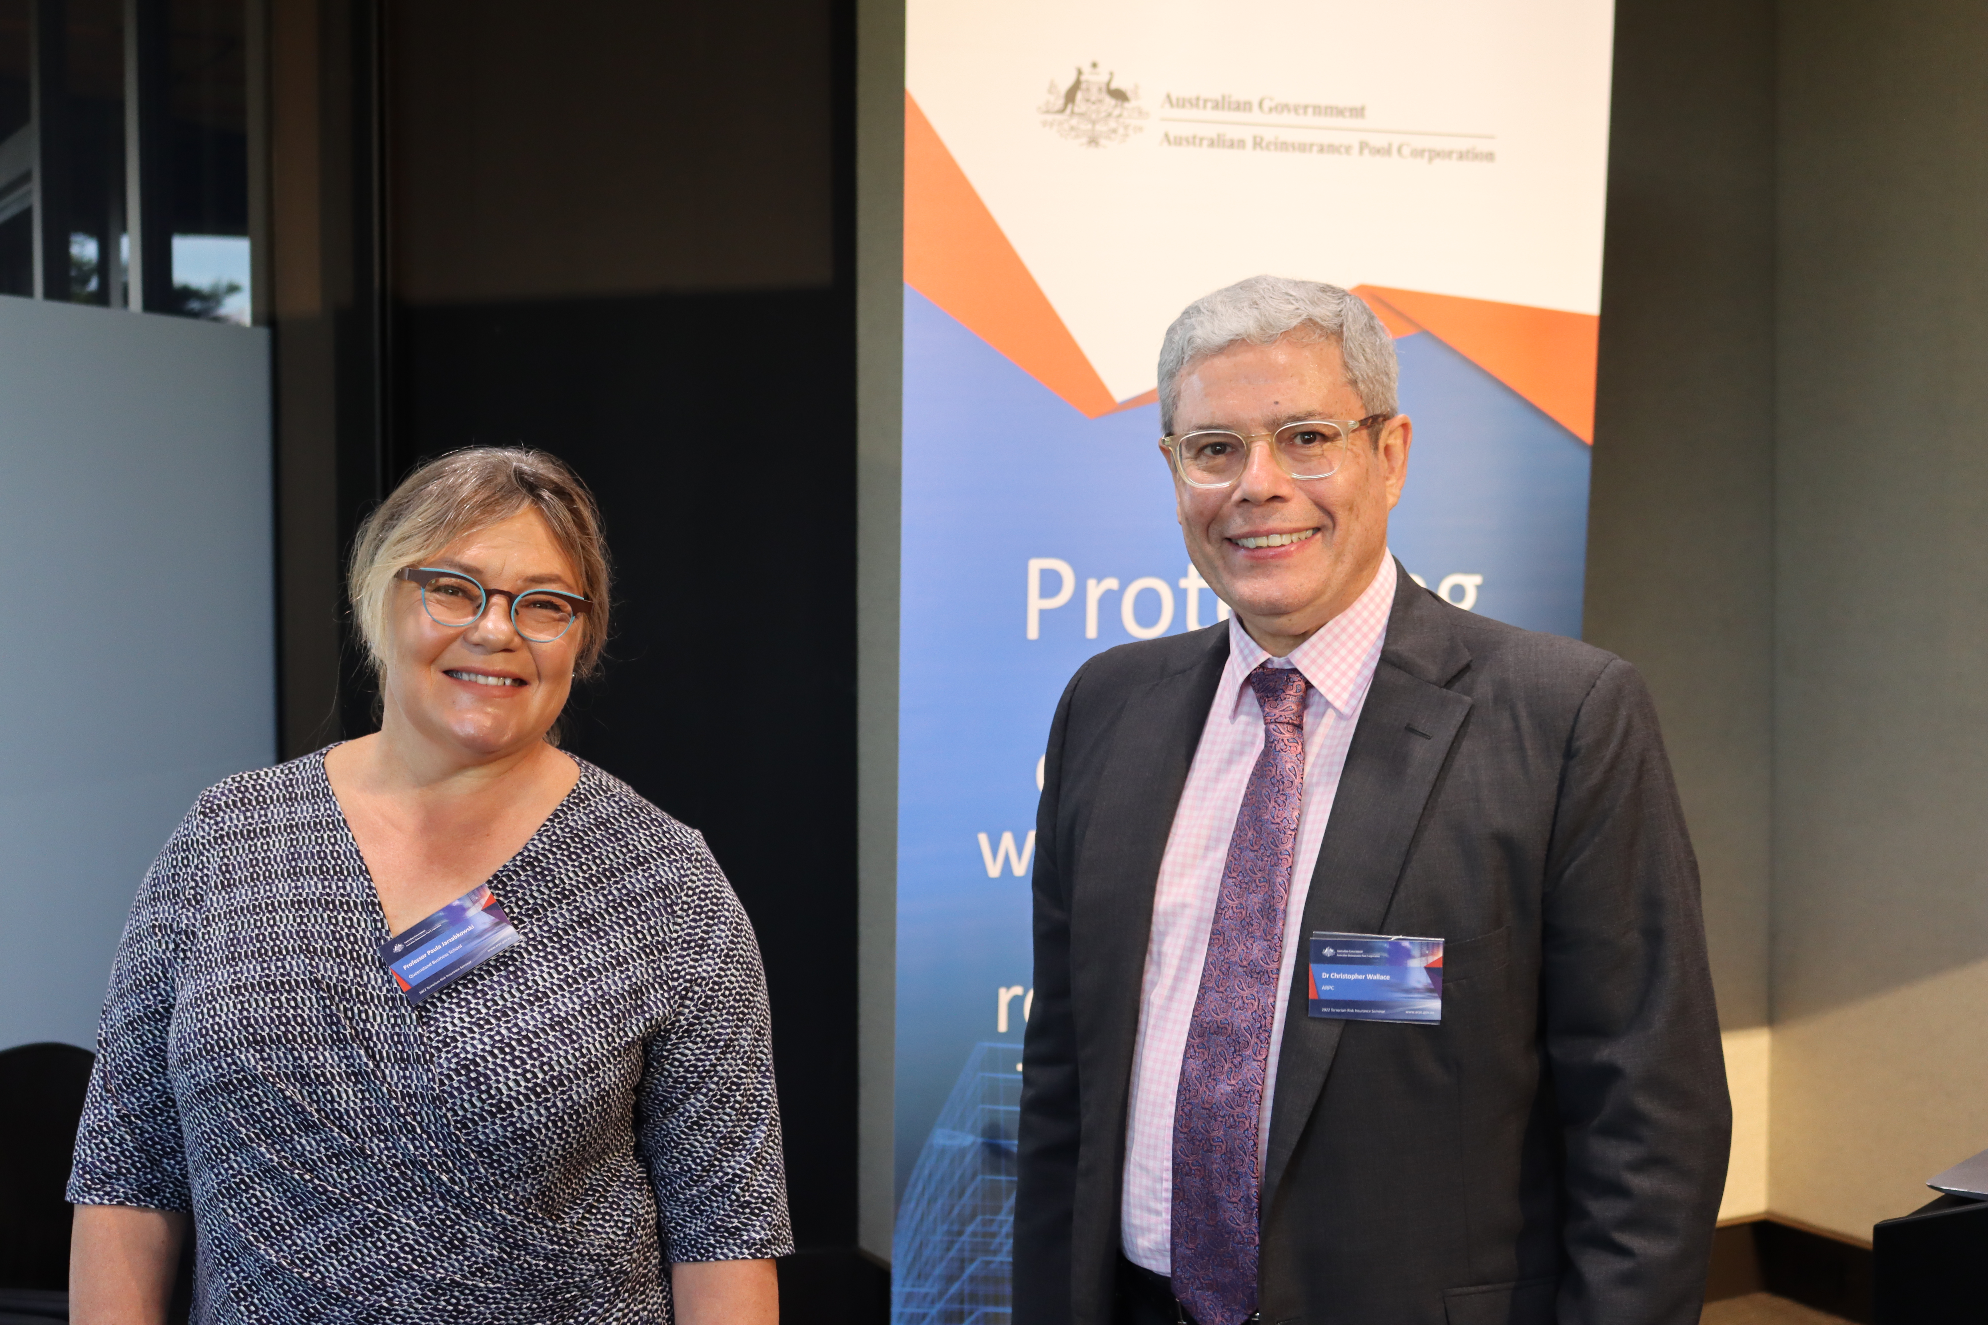
Dr Kevin Foster is electronics engineer with a MA degree in security risk analysis and a PhD in strategic project risk management. He is now an independent researcher with a focus on risk assessment methodologies for complex threat environments including potential risks from intelligent adaptive technologies.

Professor Paula Jarzabkowski, (pictured) Dr Katie Meissner & Dr Corinne Unger presented a thought leadership paper exploring the blurring boundaries between violent and disruptive protests and terrorist activities.
The paper is the first in a series ARPC has funded with The University of Queensland UQ Business School aimed at exploring the evolving experience and meaning of terrorism both in Australia and internationally.
Click here to watch the seminar in full.

IFTRIP ReCODE Conference 2022
The International Forum of Terrorism Risk Re/Insurance Pools (IFTRIP) conference was livestreamed on Tuesday, May 10, 2022.
IFTRIP is the world’s largest gathering of global terrorism reinsurance pools, (re)insurers, public agencies, academics, and risk/security professionals.
This year’s event was hosted by Nicolas Rasmussen, former Director of the U.S. National Counterterrorism Centre.
IFTRIP ReCODE featured 20+ international speakers, including exciting headline speakers Kennith Feinberg, former Special Master of the 9/11 Victim Compensation Fund, Ali Soufan Chairman & CEO, The Soufan Group and Former FBI Agent and Bronek Masojada, former CEO, Hiscox.
Four expert panels and live Q&A sessions discussed topics including ‘The pooling debate in the wake of covid’, ‘Climate change: fuelling terror and extremism’, ‘Where does the buck stop? Should insurers take more responsibility for risk mitigation?’ and ‘The Protection Gap’.
Stay up to date with IFTRIP’s exciting initiatives by subscribing here.

Standards Australia Risk Mitigation Handbook
In early 2018, ARPC submitted a proposal to peak standards development body, Standards Australia, for the development of a handbook to support proactive risk management of large-scale infrastructure from extreme acts of violence such as terrorism and civil commotion.
The Handbook was published on 17th December 2021 and an overview was presented to stakeholders at ARPC’s 2022 Terrorism Risk Insurance Seminar on Thursday 26th May. The Standards Australia project manager from Standards Australia, Emily Dawson, and the co-drafting leader Dr Kevin Foster spoke about the Handbook and its benefits for property owners, risk managers and security managers.
ARPC will engage with stakeholders this year as part of a targeted program to promote the use of the Handbook by major property owners and managers.
Purchase the handbook via the links below.

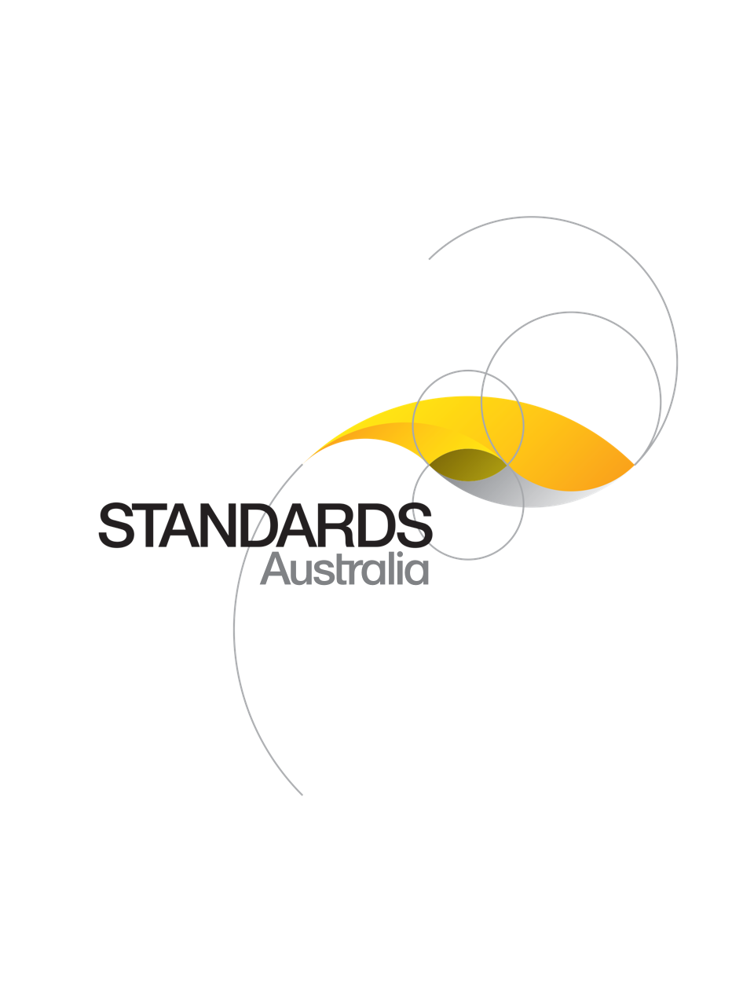
The 85-page Handbook is now on sale at Standards Australia. Hard copy and soft copy options are available for purchase via the& SAI Global Standards – SAI Global.

Premium submissions due
Terrorism reinsurance pool premium submissions and payments for the fourth quarter (1 April – 30 June) of the 2021-22 Financial Year are due on 30 July 2022.
All terrorism reinsurance pool premium submissions, including nil submissions, must be lodged by that date.
To submit a TRP premium please log into http://rise.arpc.gov.au and select ‘download templates’.
For further instructions, please refer to page 27 of the RISe Cedant User Manual here.
If you have any questions, please contact enquiries@arpc.gov.au or call +61 2 8223 677

Q. Can insurer customers submit quarterly premiums separately/in different installments (that is, for accounts handled by different branches within the customer’s organisation)?
A. No. Quarterly premiums need to be consolidated and reported as one submission which includes all eligible insurance contracts processed by the customer during the quarter

