I firstly want to acknowledge the tragic events in Ukraine and the flooding disaster here in Australia. My thoughts are with all the people and communities impacted in these tragic disasters.

Since our last update, ARPC has finalised its retrocession reinsurance program for 2022. The $3.475 billion retrocession program was renewed with a $225 million excess, for the same price as 2021, which is an impressive result.

The Treasury Laws Amendment (Cyclone and Flood Damage Reinsurance Pool) Bill 2022 has passed the House of Representatives and is under review by a Senate committee. This is the Bill that will legislate the proposed Cyclone Reinsurance Pool (CRP) announced by the Australian Government in May 2021.

Jason Flanagan has been appointed ARPC Chief Claims and Customer Officer. His role will include ARPC’s Terrorism Reinsurance Pool and the proposed CRP covering cyclones and related flood damage. The CRP is intended to commence from 1 July 2022 and would be administered by ARPC.

- Cyclone bill passes Lower House
- 2022 retrocession program finalised
- Appointment of Chief Claims and Customer Officer
- Register for 2022 IFTRIP Livestream
- Premium submissions due
- Q&A

March 2022

Welcome to the Autumn edition of our newsletter.

Cyclone Pool bill passes Lower House
The Treasury Laws Amendment (Cyclone and Flood Damage Reinsurance Pool) Bill 2022 has passed the House of Representatives.
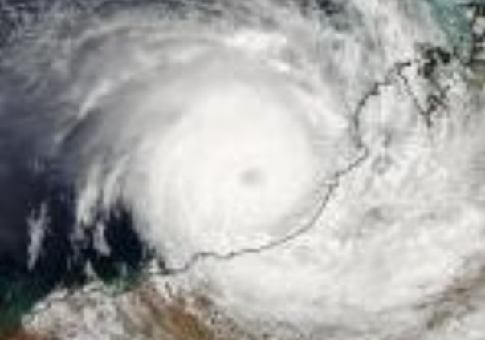
Between now and late March, the Senate Economics Legislation Committee will review the Bill.
On 4 May 2021, the Government announced its intention to establish a reinsurance pool for cyclones and related flood damage, to commence from 1 July 2022.
The reinsurance pool will be backed by a $10 billion annually reinstated Commonwealth guarantee and be administered by ARPC from 1 July 2022.

2022 retrocession program finalised
ARPC has renewed its terrorism retrocession program for the 2022 calendar year.
The $3.475 billion retrocession program, plus ARPC’s net assets and the $10 billion Commonwealth guarantee, provides scheme capacity in the event of a declared terrorism incident against commercial and eligible property assets, of approximately $14 billion.
“This year, ARPC worked with our reinsurance advisor AON to simplify the program by converting it to a full multi-year arrangement and renewing at expiring terms,” said Dr Chris Wallace, ARPC CEO.
“ARPC renewed its $3.475 billion retrocession with a $225 million excess, for the same price as 2021, which is an impressive result,” he said.
The $3.475 billion retrocession program and ARPC’s net assets are the first layers of funding for claims in the event of a terrorism incident.
Dr Wallace and Chief Underwriting Officer, Michael Pennell PSM, met with over 50 reinsurers online in key global markets to negotiate the 2022 program.
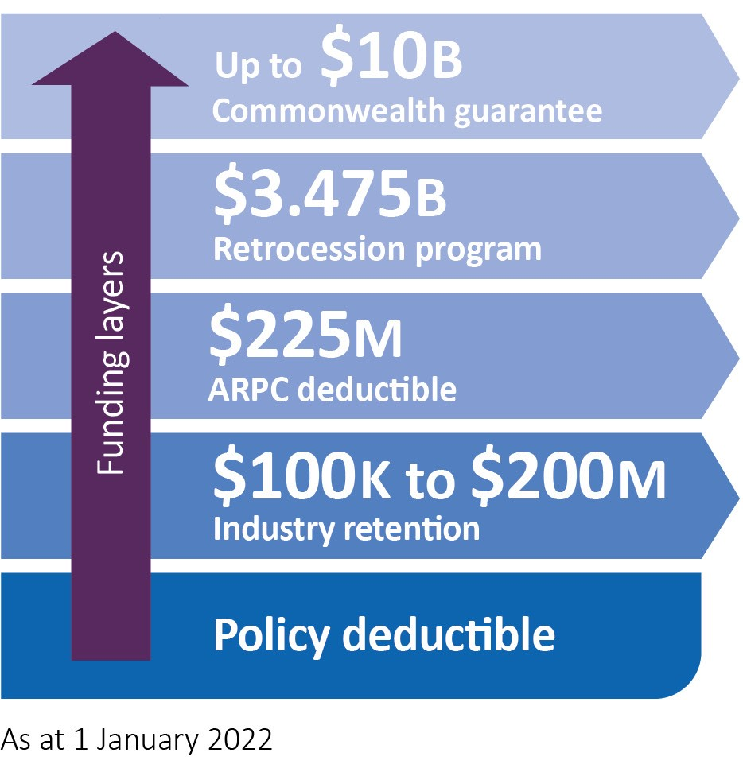

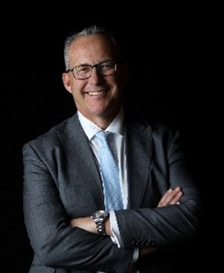
ARPC appoints Chief Claims and Customer Officer

ARPC has announced the appointment of Jason Flanagan (pictured) as Chief Claims and Customer Officer.

His role includes ARPC’s Terrorism Reinsurance Pool as well as the proposed Cyclone Reinsurance Pool, covering cyclones and related flood damage, which is intended to commence from 1 July 2022.

Jason is also leading ARPC’s project for scheme implementation of the proposed Cyclone Reinsurance Pool.

He commenced in the CCCO role with ARPC on 7 February 2022.

Jason has substantial experience across both Claims and Customer functional areas within the insurance industry. His previous roles include Head of General Insurance Claims and Head of Customer Care and Regulatory Change at Westpac and an earlier stint with BT Financial Group as Head of Contact Centres and Head of Customer Relations.

“Jason has direct experience with natural disaster insurance claims management in Northern Australia, gained through his role as Head of General Insurance Claims with Westpac,” said Dr Christopher Wallace, ARPC CEO.

“Jason was on the ground during the Townsville floods in 2019, where he gained firsthand experience about how such events impact local communities and the important role that general insurance plays in the community,” Dr Wallace said.

Jason also has external and internal auditing experience within financial services having worked as an auditor with KPMG and in internal audit roles with Bankers Trust early in his career.

In November last year, Jason commenced working with ARPC as Chief of Scheme Implementation for the Cyclone Reinsurance Pool.

Register now for 2022 IFTRIP Livestream

Registration is now open for 2022 IFTRIP LIVESTREAM. The International Forum of Terrorism Risk Re/Insurance Pools (IFTRIP) will host its 2022 conference online on Tuesday, May 10, 2022.
IFTRIP is the world’s largest gathering of global terrorism reinsurance pools, (re)insurers, public agencies, academics, and risk/security professionals.

2022 IFTRIP ReCODE focuses on Challenges and Opportunities for the (re)insurance industry, and the Data and Expertise required to strengthen global financial stability

ARPC is a founding IFTRIP member and strongly encourages Australian insurers/reinsurers and other stakeholders to attend.

For more information and to register, click here: https://iftrip.org/iftrip-conference-2022/.

IFTRIP Livestream 2022 recordings will be available for registered delegates unable to attend live sessions due to the timezone difference.

Premium submissions due
Premium submissions and payments for the third quarter (1 January – 31 March) of the 2020-21 Financial Year are due on 29 April 2022. All premium submissions, including nil submissions, must be lodged.
To submit a premium please log into http://rise.arpc.gov.au and select ‘download templates. For further instructions, please refer to page 27 of the RISe Cedant User Manual. here.
If you have any questions, please contact enquiries@arpc.gov.au, or call +61 2 8223 6777.
Q. Is a contract of reinsurance covered by the Terrorism Insurance Act 2003?
A. No, as per section 7 of the Act, a contract of reinsurance (facultative or treaty) is not an eligible insurance contract even if it provides cover for eligible insurance property.

