OCTOBER 2021

ARPC publishes 2021-25 Corporate Plan

ARPC awarded Gold for 2019-20 Annual Report

ARPC and ReachOut New Board appointment
Welcome Alexander Drake, Head of Public Affairs

Retention information due Premium submissions due Q&A

Welcome to the Spring edition of our newsletter.

Our deepest condolences go to those affected by the terrorist attack in Auckland, New Zealand, on Friday 3 September. Terrorism is a scourge on communities everywhere.

September marked the 20th anniversary of the devastating 9/11 terrorist attacks in USA, which claimed approximately 3,000 lives and injured thousands more. At this time of remembrance, we pause and reflect on those lost and impacted by these tragic events. Since then, there have been many changes to the terrorism threat landscape and to mitigation and recovery measures.

Turning to ARPC, I am pleased to announce ARPC has won Gold in the Australasian Reporting Awards for its 2019-20 Annual Report. This is a fantastic achievement, reflecting both the quality of reporting and effort by our team across the organisation.
ARPC published its 2021-25 Corporate Plan in August which outlines key activities, performance measures and assessment criteria that will drive the delivery of our strategic priorities in the next four years. The plan also details a new Wellbeing value for ARPC and with it, our sponsorship of mental health youth support charity, ReachOut Australia.
Insurer customers will also find retention information and premiums due to ARPC. Please contact us at enquiries@arpc.gov.au with any questions regarding submissions to the RISe platform.

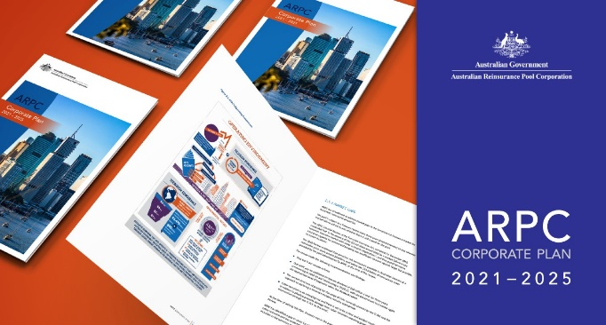
ARPC publishes 2021-25 Corporate Plan
Australian Reinsurance Pool Corporation (ARPC) has published its 2021-25 Corporate Plan, which outlines how it intends to administer the terrorism insurance pool over the next four years, including key activities, performance measures and assessment criteria.

The 2021-25 Corporate Plan sets out ARPC’s five performance areas to measure the delivery of its strategic priorities: provide reinsurance for eligible terrorism losses; encourage private sector participation through the retrocession program; compensate the government; maintain financial sustainability and organisational resilience; and engage understand and collaborate with stakeholders.

Over the period, ARPC will undertake the following key activities to support its functions:

- continue the retrocession program
- enhance catastrophe modelling capabilities
- develop thought leadership by engaging and working with academics both locally and internationally and continue strong engagement with other global terrorism pools through the International Forum of Terrorism Risk Insurance Pools (IFTRIP) and
- improve ARPC’s capability to respond to a terrorism catastrophe by improving systems and processes, through regular testing and continuous improvement.

ARPC Awarded GOLD for 2019-20 Annual Report
ARPC is pleased to have won the coveted GOLD Award in the Australasian Reporting Awards.

Gold Award-winners demonstrate excellence in annual reporting, high quality coverage of the ARA’s demanding criteria, and full disclosure of key aspects of the organisation’s core business.

ARPC is proud to have achieved this milestone after winning Silver (2018-19) and Bronze (2017- 18) for previous annual reports.

You can ARPC’s Gold award winning 2019-20 Annual Report here.

ARPC supports ReachOut Australia

ARPC’s 2021-25 Corporate Plan outlines key strategic projects which include a social engagement project with ReachOut, a mental health service provider for youth. The aim is to reduce the risk of young people engaging in anti- social behaviours that could result in violent extremism.
ReachOut is currently developing its next evolution of mental health services to help young people at risk. This sponsorship will see ARPC assist ReachOut with undertaking research into identifying at-risk youth and developing programs and services to connect disengaged youth to the wider community.
Visit the ReachOut website here.

Appointment of new Board member
Australian Reinsurance Pool Corporation (ARPC) has welcomed the Australian Government’s appointment of Julie- Anne Schafer to the ARPC Board as a part- time Member for a three-year term commencing 14

Julie-Anne Schafer
September 2021.

Julie-Anne is a Brisbane-based director and qualified lawyer with experience across the insurance, superannuation, energy, water, transport and health sectors. She is currently a Non-Executive Director at Queensland Urban Utilities, C S Energy, and Av Super. She is also President of the National Competition Council, a Treasury portfolio agency.

Her career also includes retail consumer insurance

Welcome Alexander Drake, Head of Public Affairs
ARPC is pleased to welcome the appointment of Alexander Drake as Head of Public Affairs. This newly created role will help ARPC maintain effective stakeholder relationships across the

Alexander Drake
industry and community.
Alexander joins ARPC from Genworth where he was responsible for leading the government relations programs, fostering relationships with government, researching and planning for policy- making trends, and supporting strategic global business needs. In 2019, Alexander was appointed by the Assistant Treasurer, The Hon. Michael Sukkar MP, to sit on his advisory panel to design the First Home Loan Deposit Scheme, as proposed by the Prime Minister.

and cyclone risk experience through her past roles as President of RACQ and Chair of RACQ

Insurance, and as a Non-Executive Director for the Territory Insurance Office.

Julie-Anne holds a Bachelor of Laws with Honours (LL.B. Hons) from the University of Queensland and is a Fellow of the Australian Institute of Company Directors. She is also a member of the Australian and New Zealand Institute of Insurance and Finance (ANZIIF).

Ian Carson AM, ARPC Chair, said: “I warmly welcome Julie-Anne Schafer to the ARPC Board. Her deep insurance and public sector experience, coupled with her legal background, will be an asset to the ARPC Board at a time of dynamic
Register now

ARPC Terrorism & Insurance Webinar, Wednesday, 10 November 2021 (3pm-5pm)

Systemic risks of terrorism and biosecurity will be explored in ARPC’s annual Webinar. The Webinar will be chaired by Professor Paula Jarzabkowski, Professor in Strategy, School of Business, at the University of Queensland and an expert in insurance

change for the organisation.”

The full Government media release on the appointment can be viewed here.
Paula Jarzabkowski

terrorism.
protection gaps across multiple perils including

Webinar topics include:

  - Protection Gap Entities: What are they and why they are essential to terrorism insurance
  - The Australian terrorism threat landscape

- The global terrorism threat landscape
- The bioterrorism threat
Register for the Webinar here.

Retention Information is Due
ARPC would like to remind insurer customers that they are required to submit Gross Written Premium (GWP) information for the 2021-22 Financial Year. The GWP submission was due on 31 August 2021 for non-APRA registered insurers and will be due on 30 September 2021 for APRA- registered insurers. This submission will set each insurer’s retention for the current retention period (which aligns with the Australian financial year).

Failure to meet these deadlines means the default retention of $12.5 million will apply. The Fire and Industrial Special Risks (ISR) GWP reporting applies to all eligible and ineligible Fire and ISR policies, not just those already reported through quarterly premium returns. For APRA-registered insurers, this figure will be the same as that reported to APRA (GRF 310.1), which is also due on 30 September each year. If you are experiencing difficulties using ARPC’s RISe system, please consult the manual on our website here or contact ARPC at enquiries@arpc.gov.au or phone
+61 2 8223 6777.

Premium Submissions Due
Premium submissions are due by 30 October for the first quarter (1 July – 30 September) of the 2021-22 Financial Year. All premium submissions, including nil submissions, must be lodged. The premium return template is available in RISe and must be used to submit all premium returns. If you have any questions, please contact enquiries@arpc.gov.au or phone +61 2 8223
6777.

RISe login here.
Q: What is the difference between Premium Returns, Aggregate Returns and the GWP declarations?
A: The aggregate return is due once a year, by 31 August, and is a snapshot
of your risk exposure by postcode and state as at 30 June of that year. Premium Returns are due quarterly and are used to calculate how much premium is payable to the ARPC by business class, tier and state. The gross written premium declaration is due once a year, by 30 September and is the sum of your annual gross written premium for the fire/ISR Class of business (less any Fire Service Levy) and is used to calculate your annual retention figure for the current financial year.

