JULY 2021

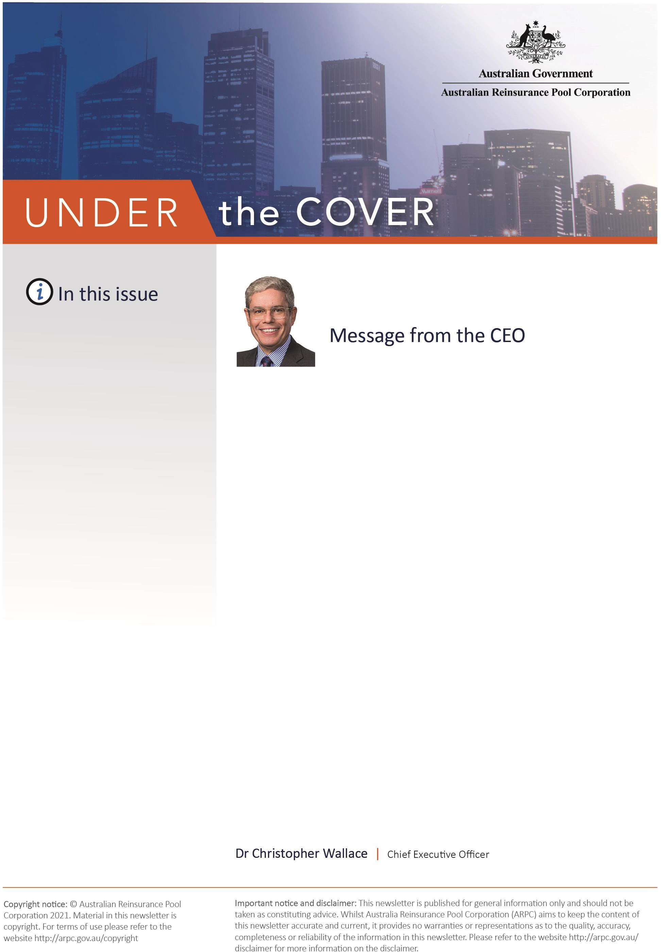
ARPC’s customer survey results

ARPC welcomes 2021 Triennial Review

Board update

ARPC supports Treasury’s Cyclone Reinsurance Pool Taskforce

Risk mitigation handbook update

INSIGHTS: The economic impact of exclusion zones

Reports due

Annual aggregate exposure reports

Q&A

Welcome to the Winter edition of our newsletter.

I am pleased to present ARPC’s Winter newsletter for 2021. I hope you are keeping safe and well in these uncertain times.
ARPC has received positive feedback from respondents to our first insurer customer survey, conducted by ORIMA Research in November and December 2020. I would like to thank all of you who completed the survey. ARPC is looking forward to using this and future survey feedback to enhance our customer and stakeholder experiences.
I am pleased to welcome the Government’s reappointment of Elaine Collins as a Member for a further three-year term, and the new appointment of Jan van der Schalk as a Member. Jan brings deep experience in reinsurance and investment management and we look forward to working with him and continuing to work with Elaine Collins. We extend our thanks and appreciation to Members Janet Torney and John Peberdy whose terms expired on 30 June 2021, we will miss their leadership and support to the organisation.

ARPC has responded to the Government’s 4 May announcement on a cyclone reinsurance pool for cyclones and related flood damage. Two ARPC employees have been seconded to Treasury’s Cyclone Reinsurance Pool Taskforce which will finalise pool design after consulting with industry and community representatives and other stakeholders.
In the final pages of this newsletter, you will find all information regarding reports and submissions due for financial year end.

Please do not hesitate to contact ARPC at enquiries@arpc.gov.au should you have any queries regarding due dates or submissions. Our Insurance Audit team are happy to assist you.

ARPC’s customer survey results
ARPC has released the results of our first survey of insurer customers, conducted by ORIMA Research.
Overall, the survey results indicated that ARPC is largely delivering on its vision, is a valuable and important partner, a trusted expert and is communicating and engaging well.

In ARPC’s 2020-24 Corporate Plan, ARPC said it would develop and launch a stakeholder engagement survey to set a baseline for measuring effectiveness while using the results to improve stakeholder outcomes.
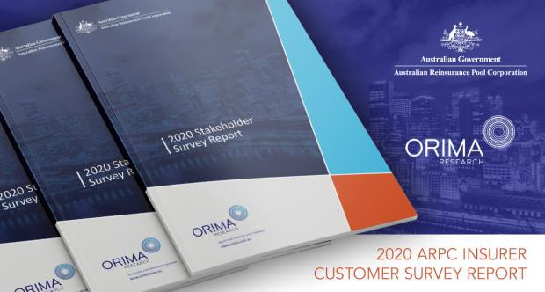

Conducted by ORIMA in November and December
2020, the short online survey was sent to ARPC’s 225 insurer customers, 36 of which are in Australia and 189 based overseas.
The survey design was guided by a senior executive
workshop which identified several ‘Big questions’: Are we delivering on our vision? What do our customers think of us? Does ARPC represent value for money?
Does ARPC engage effectively with stakeholders? Key survey findings included that:
- 97 per cent respondents overall (Australia and
overseas) agree ARPC is an effective provider of terrorism risk insurance
- 98 per cent agree ARPC is a trusted expert on terrorism reinsurance
- 96 per cent agree ARPC is easy to deal with and 89 per cent said ARPC is transparent
- Respondents strongly rated ARPC’s publications and digital business to business communications, particularly Australian respondents
- 80 per cent found the ARPC insurer customer review process very or somewhat useful
Despite the strong overall results, the survey revealed Australian respondents (who account for 90 per cent of ARPC’s premium income) are more engaged with ARPC than overseas respondents.

Some Australian respondents said they would welcome more discussion and contact outside of insurer customer reviews (audits).

ARPC CEO Dr Christopher Wallace said: “ARPC has committed to this annual survey of our insurer customers so we can gauge feedback and make improvements that benefit customers.

“ARPC would like to thank ARPC insurer customers for their strong overall support of ARPC and looks forward to making continuous improvements in their interests.”

The survey report, including ARPC’s actions in response to the report are published on the ARPC website here.

ARPC welcomes 2021 Triennial Review
Australian Reinsurance Pool Corporation (ARPC) has welcomed the terms of reference for the 2021 Triennial Review of the Terrorism Insurance Act 2003 (TI Act), which will be conducted by The Treasury.

The TI Act requires that a review be conducted at least once every three years to test whether market failure for terrorism insurance exists and therefore whether the Act should continue. Previous reviews have also been used as an opportunity to improve the scheme.

“I am pleased to welcome the terms of reference for the 2021 Triennial Review of the scheme and look forward to supporting The Treasury during the Review,” said Dr Christopher Wallace, ARPC CEO.

“The Triennial Review is an important process for making sure ARPC remains fit for purpose, so I strongly encourage ARPC stakeholders to make submissions
through The Treasury process.”

The terms of reference for the 2021 Triennial Review comprise:

- whether there continues to be market failure in
the private sector supply of terrorism insurance

and consequently whether there is a need for the Act to continue
- whether the governance, administration and resourcing of the scheme remain appropriate, including interactions between the Cyclone Reinsurance Pool and the Terrorism Reinsurance Pool, and
- whether the risk of cyber terrorism causing physical property damage should be included in the scheme
ARPC will support the review including connecting stakeholders to The Treasury if they wish to provide

Board update

ARPC has welcomed the Government’s reappointment of Elaine Collins and the new appointment of Jan van der Schalk as Members, both for a three-year term from 1 July 2021.

Jan van der Schalk

We would like to thank Janet Torney and John Peberdy for their service to

input into the Review.

Previous reviews completed in 2006, 2009, 2012, 2015 and 2018 each found there was insufficient terrorism insurance available commercially on reasonable terms, and concluded that the Act should continue in operation, subject to further review, in no more than three years.

As in previous years, The Treasury is responsible for undertaking the 2021 review and preparing a report for ARPC’s Minister, The Hon. Michael Sukkar MP, Assistant Treasurer, Minister for Housing and Minster for Homelessness, Social and Community Housing.

To view the full 2021 Triennial Review terms of reference and process for making submissions, click here. Submissions closed on 30 July 2021.

To view the media release issued by the Hon. Michael Sukkar MP, Assistant Treasurer, Minister for Housing and Minister for Homelessness, Social and Community Housing, click here.

ARPC. Their terms as Members expired on 30 June
2021.

Ian Carson AM, ARPC Chair, said: “The ARPC Board is pleased that the Government has reappointed Elaine Collins as a Member of ARPC. Her skills as an actuary are highly valued by the ARPC in administering the Terrorism Insurance Scheme.”

“Jan van der Schalk’s appointment will benefit ARPC
as he has deep reinsurance and investment
experience and I look forward to working with him.”

Earlier in his career, Jan was part of a team which founded and built property catastrophe specialist, ACE Tempest Reinsurance where he was Chief Underwriting Officer (International).

He also served as CEO of Asset Management and Reinsurance at Insurance Australia Group (IAG) for seven years.

Dr Christopher Wallace, ARPC CEO, also thanked Janet Torney and John Peberdy for their service to ARPC, following the expiry of their terms.

“Janet Torney has skilfully chaired ARPC’s Audit & Compliance Committee, contributed investment and governance expertise and more recently guided the organisation’s risk management oversight,” Dr Wallace said.

“John Peberdy made a significant contribution to ARPC during his term, assisting with the annual reinsurance program placement and as a reinsurance and insurance expert,” he said.

ARPC supports Treasury’s cyclone pool taskforce
ARPC’s Chief Underwriting Officer, Michael Pennell PSM and Insurance Audit & Claims Advisor, Jessie Khan, have joined Treasury’s newly created Cyclone Reinsurance Pool Taskforce which will advise the Government on an optimal design for the new cyclone reinsurance pool.
The Australian Prudential Regulation Authority (APRA) and the Australian Government Actuary have also joined the Taskforce.

In May, Treasury released a detailed consultation paper which asked stakeholders for comments and feedback by 18 June.
Visit the Taskforce website for more information here.

Risk mitigation handbook approaches publication date
ARPC’s risk mitigation handbook, produced in collaboration with peak standards development body, Standards Australia, is in its final stages of development, and is anticipated to be published in coming months.

ARPC has worked closely with Standards Australia to develop a handbook to support proactive risk management of large-scale infrastructure (commercial buildings).

The handbook will provide guidance to owners and operators of commercial buildings on identifying and assessing relevant sources of building risk associated with terrorism and other deliberate acts of extreme violence (such as civil commotion). It will also contain guidance on controls to mitigate such risks.
ARPC looks forward to hosting a series of market presentations and seminars to promote industry integration of the recommendations contained within the handbook.
Read more about the Handbook on ARPC’s website here.

The economic impact of exclusion zones

Extracted from a June 2021 article by ARPC Chief Underwriting Officer, Michael Pennell PSM (pictured), published in Asia Insurance Review
A new research paper, ‘Exclusion Zones and ARPC’s
Interaction with First Responders’, authored by Australian Reinsurance Pool
Corporation (ARPC) with Finity Consulting and FPL Advisory, estimates damage areas for different sized bomb blasts and/or biological/chemical attacks and the financial consequences of exclusion zones.
An exclusion zone is an area that people are not allowed to enter.
However, this paper does not make recommendations on the appropriate size of exclusion zones.

In summary

- Exclusion zones are a necessary tool which should be used to reduce the risk to the public, stabilize property and assist the post-event investigation process.
- Business interruption or prevention of access losses from the application of widespread exclusion zones can result in up to 10 times the insured loss expected from within the physical damage footprint.
- Analysis of large and moderately sized cities shows that business interruption losses are extremely sensitive to the size of the exclusion zone set by the emergency responders.
- ARPC, in conjunction with other government agencies and departments, has developed terrorism blast and plume catastrophe models to estimate losses from damage to buildings and exclusion zones.
- Exclusion zones that encompass (or are set amidst) a high density of businesses will result in increased business interruption losses.

- Most SME businesses are uninsured for business interruption suffered due to prevention of access.
- Standoff guidance tables vary greatly highlighting the uncertainty of such events.
- Biochemical attacks tend to result in high business interruption losses, with longer-term impacts, due to the ability of these materials to spread far beyond the immediate danger zone.
To access a full copy of the research, including case studies, complete a digital request form on our website here.

Reports due
Please see below a breakdown of the reports due to be submitted to ARPC over the coming months.

Report | Due date
Premium reports and payments for the period ending 30 June | 30 July 2021
Annual aggregate reports as at 30 June | 30 August 2021
Annual gross written premium declarations | 30 September 2021

Annual aggregate exposure reports
The annual aggregate reports are a snapshot at 30 June and are due by 30 August each year. When compiling these reports, please note:

- For ‘all risks ex construction works’, we require clients to split sums insured between the building contents and contents components. Clients should not be entering amounts in the combined building and contents column amounts without contacting ARPC.
- Policies without a building risk (i.e. contents and/or business interruption only policies) should not be included in the ‘all risks ex construction
works’ worksheet but should be included in the ‘Street Address’ worksheet. Street address data is required for the following major postcodes within tier A locations:
2000 in Sydney
3000 in Melbourne
4000 in Brisbane
5000 in Adelaide
6000 in Perth
Business interruption and contents risks (even if not linked to a building) are to be included in the ‘Street Address’ worksheet.
When submitting your annual aggregate return, RISe
will compare this year’s submission with the previous year. If there is a variance greater than 10 per cent, you will be asked to review your submission or explain the reason for the change in exposure.
To submit your annual aggregate exposure report, please log into http://rise.arpc.gov.au and select
‘download templates’. For further instructions, please
refer to page 27 of the RISe Cedant User Manual here.
If you have any questions, please contact enquiries@arpc.gov.au, or call +61 2 8223 6777.

Q. Can insurer customers submit quarterly premiums separately/in different installments (that is, for accounts handled by different branches
within the customer’s
organisation)?

A. No. Quarterly premiums need to be consolidated and reported as one submission which includes all eligible insurance contracts processed by the customer during the quarter.

