I would first like to extend my condolences to all those impacted by the floods which devastated parts of eastern Australia this week. This past year has certainly posed many challenges and I sincerely wish a swift recovery for all those affected.
ARPC has renewed its retrocession reinsurance program from 1 January 2021. ARPC purchased $3.475 billion in retrocession capacity, including a new layer of $25m which reduced ARPC’s deductible from $250m to $225m.
I am pleased to welcome the appointment of Samantha Lawrence as General Manager, Governance and Compliance. Samantha brings deep experience in Board Secretary roles, including Government Boards, and will be a valuable addition to our team.
ARPC is pleased to have published the first in a series of thought leadership papers on terrorism in partnership with The University of Queensland. Titled: ‘Analysis of identified gaps in Australia’s terrorism insurance environment’, the paper concluded that some losses from terrorism are not covered by existing arrangements or are not covered fully or consistently.
In February, I was honoured to attend the CareerTrackers Gala Awards, a virtual event which celebrated the achievement of Indigenous university students gaining meaningful work experience. ARPC supports one intern through the CareerTrackers program.
Finally, I would like to thank our insurer customers for contributing to ARPC’s first customer feedback survey. The results will be made available on the ARPC website soon.
As always, please do not hesitate to contact ARPC for any enquiries on insurance premium submissions or due dates.

Sincerely,

March 2021
New executive appointment
New ARPC reinsurance broker
GAPS paper published
Retrocession renewal 2021
Exclusion zones and impacts
COVID-19 and systemic risk
Career Trackers Awards
Premium submissions
Q & A

Welcome to the Autumn edition of our newsletter.

Welcome Samantha Lawrence
ARPC welcomes the appointment of Samantha Lawrence as General Manager, Governance and Compliance.
Samantha has over 15 years’ experience in Board Secretary roles, including Government Boards and solid experience in the insurance industry.
She will lead ARPC’s Governance and Compliance function and secretariat support to the ARPC Board and Audit and Compliance Committee.
Samantha commenced with ARPC on 1 March.

Aon Reinsurance Australia Limited appointed as ARPC reinsurance broker
ARPC conducted a scheduled tender for the provision of reinsurance broking services.
As a result of that process, Aon has been appointed and will commence from 1 April.
Mike Pennell PSM, ARPC’s Chief Underwriting Officer, will oversee the transition-in and commencement of broking services to ARPC by Aon.
GAPS paper published
In December 2020, ARPC published a new research report in partnership with The University of Queensland Business School, ‘Analysis of identified gaps in Australia’s insurance environment’.
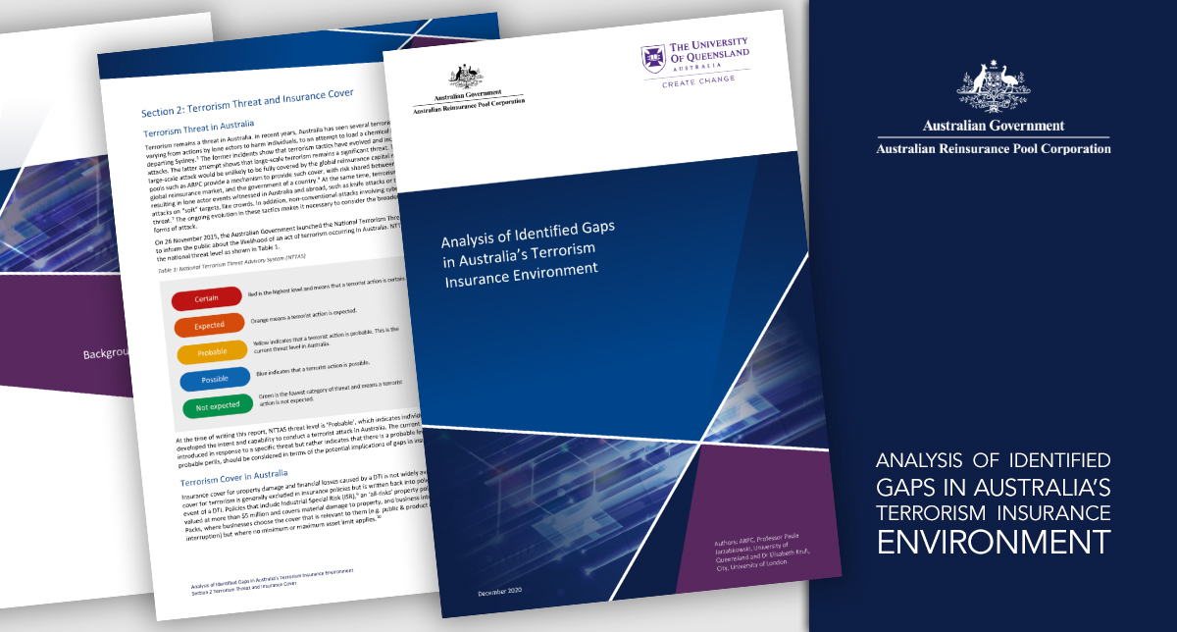
The report found some losses from terrorism are not covered by existing arrangements or are not covered fully or consistently. The gaps include:
- Physical property damage caused by cyber terrorism
- Low business interruption uptake by SMEs
- Compulsory Third Party (CTP) motor insurance schemes
- Inconsistencies in Workers’ Compensation schemes
- Inconsistencies in Victims of Crime schemes and coverage of State and Commonwealth assets.
The purpose of the report is to identify gaps and inform future discussions on insurance coverage, such as what risks should be covered, and by whom within the commercial or public sector.
This is the first in a series of research papers on terrorism and re/insurance to be produced by ARPC in partnership with UOQ.
The research report is available on our website here.

Retrocession renewal: ARPC helping cover the economy against terrorist attacks
ARPC renewed its retrocession reinsurance program for the 2021 calendar year. The $3.475 billion retrocession reinsurance program, plus ARPC’s net assets and the $10 billion Commonwealth guarantee, provides scheme capacity in the event of a declared terrorism incident, against commercial and eligible property assets of just under $14 billion.
ARPC’s retrocession program encourages a mix of global and Australian reinsurers to provide terrorism cover for Australian-based property assets, which transfers the risk and protects the Australian Commonwealth Guarantee and Australian taxpayers.
The $3.475 billion retrocession program and ARPC net assets are the first layers of funding for claims in the event of a terrorism incident.
Dr Christopher Wallace, ARPC CEO and Michael Pennell Chief Underwriting Officer, met online with almost 70 reinsurers in key global markets to negotiate the 2021 program.
For the 2021 program, ARPC purchased an additional $25 million layer of reinsurance at the bottom of the program. This reduced ARPC’s deductible from $250 million to $225 million and improved ARPC’s capital strength.
“ARPC remains well positioned to be an effective provider of terrorism risk insurance that facilitates market participation, supports national resilience and reduces potential losses arising from terrorism catastrophe.” – Dr Christopher Wallace, ARPC CEO

ARPC’s retrocession program in detail
Retrocession refers to when a reinsurer purchases insurance. The retrocession program renews on 1 January, each year. The 2021 placement of $3.475 billion of retrocession capacity includes approximately $3 billion of capacity written on a multi-year agreement, to reduce pricing volatility for ARPC and its retrocessionaires.
The multi-year agreement allows adjustment if ARPC’s portfolio changes by more than 10 per cent year-on-year, or if ARPC’s audited forecast premium income reduces by 10 per cent or more.
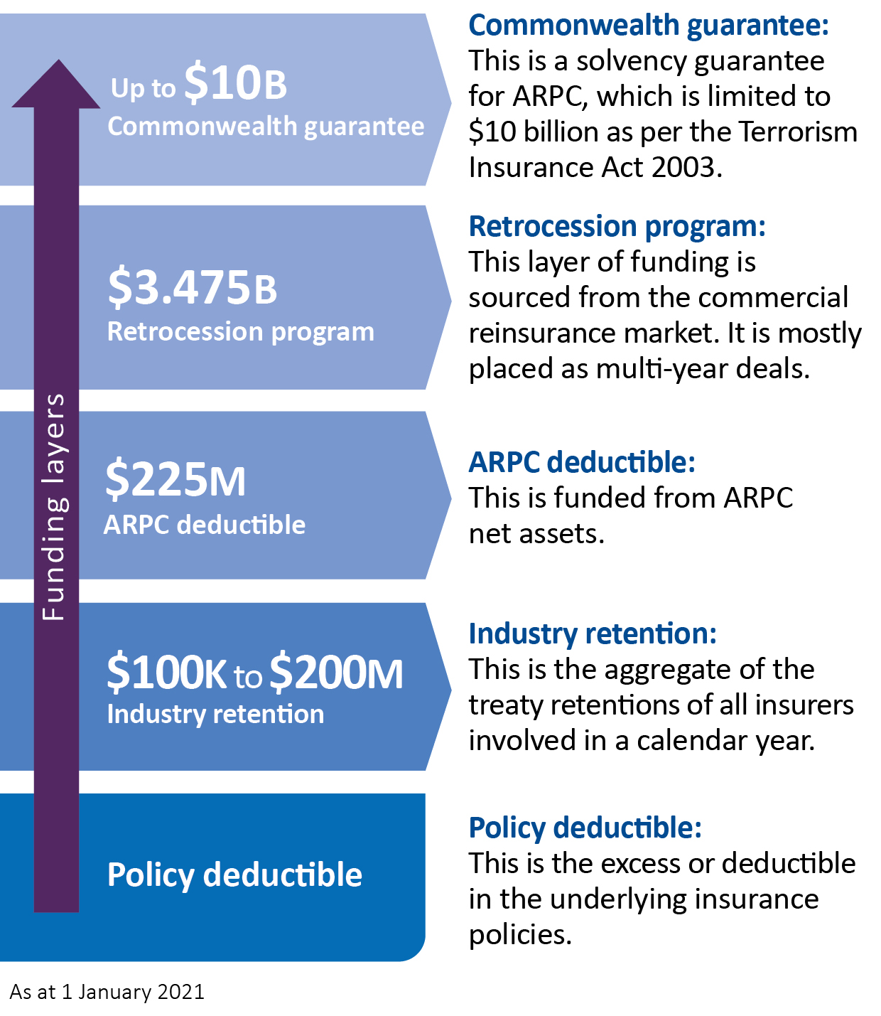
Below is a simple diagram of the 2021 ARPC scheme showing the different layers.

The economic impact of exclusion zones
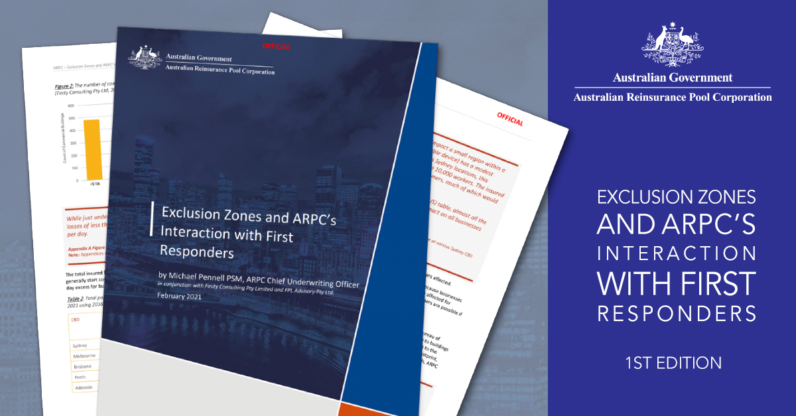

ARPC, in association with Finity Consulting and FPL Advisory, has produced a paper on the economic impact of exclusion zones established during terrorism incidents, or large-scale civil commotions.
The paper was inspired by ARPC presentations to Australian state and federal police forces on exclusion zones during 2019 and 2020. The paper covers ARPC’s modelling capabilities as well as scenarios developed for ARPC employees during regular Declared Terrorism Incident (DTI) exercises.
The paper will be made available by request on the ARPC website this week.

COVID-19 brings greater awareness of systemic risks*

*Extracted from an article by Dr Christopher Wallace published in Asia Insurance Review (December 2020)

One positive outcome of the COVID-19 pandemic is a greater recognition of systemic risks which should prompt closer collaboration between the public and private sector.

In 2020, the COVID-19 pandemic prompted massive, disruptive changes in society, including how we work, socialise, travel and in our use of technology. These changes in society will continue well into 2021 and beyond.

2021 will be the year where large-scale systemic risks become better understood by organisations and society. 2021 and beyond will see greater awareness of pandemic, cyber, terrorism and natural disasters as systemic risks, which all impact on the role of insurance in protecting society and the protection gaps in cover.

Pandemics were often listed on organisations’ risk registers, but many had reduced the risk rating of it occurring and pandemic plans may not have been kept up to date.

While cyber risk has seen the most attention presently with a pandemic-related spike in hostile cyber threats, all these systemic risks are real and present major threats to organisations and to society.

These systemic threats have similarities in their societal impacts. When large-scale systemic risk events occur, they often cause suffering or death and subsequently cause significant changes in the global society.

Cyber – clear and present risk

Cyber threats are the new frontier of technology risk, and risks have further increased with many more people relying entirely on technology for their social and work connections. However, the pandemic has also seen an acceleration in improvements in technology security and organisations are more aware than ever of the threats.

Lockdowns and social restrictions, while aiding physical health outcomes in the pandemic, have accelerated online connections. Unfortunately, this has also increased the risk of exposure to extremist online material which can radicalise individuals and inspire hostile acts. Some of these online spaces have created extremely toxic peer environments which encourage hate or violence. The problem could worsen due to the social isolation, economic dislocation and mental health issues born of successive waves of COVID-19.

However, we are seeing technology increasingly being used to identify and remove or mitigate this content.

Meanwhile, an acceleration of the remote working revolution necessitated by COVID-19 restrictions will continue for those fortunate enough to be able to perform their roles from home. This will give employees more control over their lives as they transition to a hybrid office-remote routine. It will also bring its own set of challenges, including management of workplace culture where employees are no longer as often physically present, as well as new cyber risks.

Public-private collaboration needed

Climate risk, seen through extreme weather events, will continue to occur, sparking insurance availability and affordability concerns and causing reputational risks to the insurance industry.

Catastrophic terrorist attacks around the world, over time have had a profound effect on the insurance and reinsurance industry globally, but one of the more enduring changes was the establishment of various government sponsored public private partnerships for risk sharing through terrorism insurance pools. There were also major advances in security and safety in workplaces and to transport, which have had an enduring positive effect on society.

Government sponsored pools or public-private partnerships that currently cover systemic risks such as terrorism could be developed by some countries as possible solutions to pandemic risk. Systemic risks such as terrorism and pandemic suit public-private risk sharing mechanisms. Both can be declared. Both have aspects of social disruption and risk mitigation through government.

CareerTrackers Awards 2021
ARPC CEO, Christopher Wallace attended the annual CareerTrackers Gala Awards in February. This year’s virtual event celebrated Aboriginal and Torres Strait Islander excellence in the internship program. It also premiered the short film, In Their Tracks.
CareerTrackers is a national non-profit organisation supporting Indigenous university students gain valuable, industry experience through meaningful internships.

ARPC is a proud member of the CareerTrackers network, frequently hosting Indigenous interns and offering them a supportive environment to gain valuable professional experience.

Premium Submissions due
Premium submissions and payments for the third quarter (1 January – 31 March) of the 2020-21 Financial Year are due on 30 April 2021. All premium submissions, including nil submissions, must be lodged.
To submit a premium please log into http://rise.arpc.gov.au and select ‘download templates’. For further instructions, please refer to page 27 of the RISe Cedant User Manual here.
If you have any questions, please contact enquiries@arpc.gov.au, or call +61 2 8223 6777.
Q. Is a contract of reinsurance covered by the Terrorism Insurance Act 2003?
A. No, as per section 7 of the Act, a contract of reinsurance (facultative or treaty) is not an eligible insurance contract even if it provides cover for eligible insurance property.

