2020 Terrorism Risk and Insurance Webinar
ORIMA Survey
RISC Reimagined 2020
2019-2020 Annual Report
ARPC Farewells Karen Payne
Insights – 2020 IFTRIP LIVESTREAM
Premium Submissions Due
Q&A

It’s a pleasure to present our final Under the Cover for 2020. This has been an unprecedented year which has brought many challenges and changes. Among the takeaways from this year is that as communities, our collective strength allows us to evolve and adapt, even during uncertain times. At ARPC, we have sought to adapt in ways that serve you, our insurer customers.
ARPC successfully hosted its 2020 Terrorism Risk and Insurance Webinar on Thursday 12 November. This event attracted over 200 delegate registrations and showcased the high-level thinking of leading industry experts, Risk Frontiers and CHC Global.
October saw us launch the inaugural ARPC Insurer Customer Survey. This is ARPC’s first survey of its insurer customers and will assist us with assessing how we are performing and whether there are any areas in which we can improve our service.
As 2020 IFTRIP (International Forum of Terrorism Risk (Re) Insurance Pools) President, it was great to participate in this year’s virtual IFTRIP LIVESTREAM conference. The speaker line-up was very impressive, with much discussion of systemic risk coverage in the context of 2020.
ARPC’s 2019-2020 Annual Report was tabled in Parliament in October and can be viewed here. The report showcases strong operational and financial performance during the financial year.
Wishing you a safe, healthy and happy holiday season.

DECEMBER 2020

Welcome to the Summer edition of our newsletter.

2020 Terrorism Risk and Insurance Webinar

ORIMA Survey
Many thanks to insurer customers who participated in ARPC’s inaugural customer survey, conducted by independent research agency, ORIMA. The survey closed on 9 December.
The purpose of the survey was to seek your feedback on our performance, including what you think ARPC is doing well and if there are any areas in which you think we could improve our service to you.
Results from this survey will be shared in our 2020-21 annual report. The survey will be repeated in the coming years using the 2020 survey as a baseline.

More than 200 delegates registered to attend ARPC’s 2020 Terrorism Risk and Insurance Webinar on Thursday, 12 November.
ARPC CEO, Dr Christopher Wallace and Chief Underwriting Officer, Michael Pennell PSM, delivered an overview of the terrorism landscape, including the threat posed by the extreme right wing (XRW). XRW groups constitute 40 per cent of counterterrorism caseloads nationally, up from 10-15 per cent of cases before 2016.
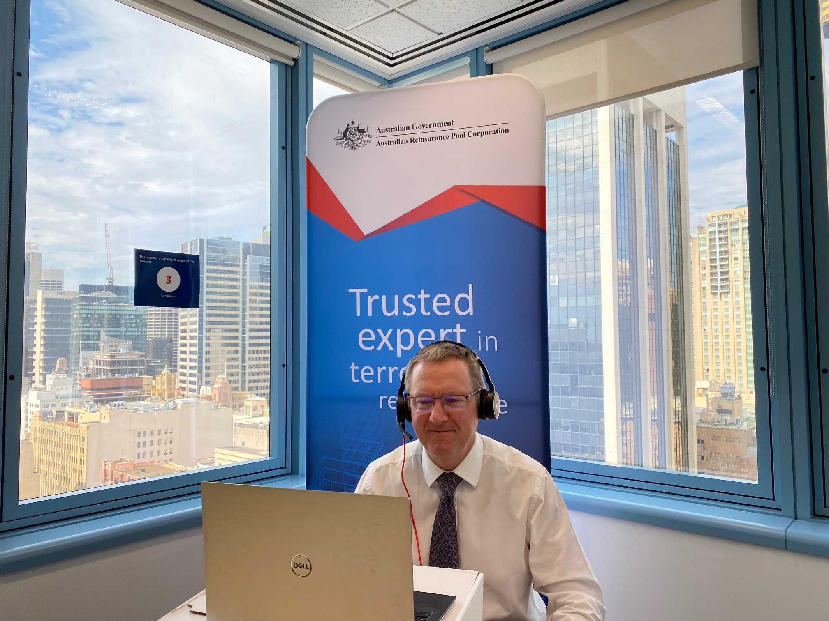

ANZIIF Reinsurance International Study Course (RISC) Reimagined 2020
Normally a 4-day live event, this year’s Reinsurance International Study Course (RISC) took place over 4 weeks and involved groups of syndicates from Australia, New Zealand, Asia and Europe learning a range of reinsurance topics.
As a syndicate leader and course presenter, ARPC Chief Underwriting Officer, Michael Pennell PSM, was impressed by the teamwork and learning capability displayed by syndicates.
“It was inspiring to see our learning group persist with their online training, starting from a basic understanding of reinsurance to achieving a level where they produced one of the best board submissions for RISC I have seen in almost 20 years.”
RISC covered topics such as risk appetite, property reinsurance, casualty reinsurance, catastrophe reinsurance and actuaries in reinsurance. Michael Pennell said he viewed his mentorship and online presentations for RISC as an opportunity to continue his own lifelong learning journey. This included the skills needed to navigate a world of webinars and online meetings.
ARPC was a proud portfolio sponsor of the event.

ARPC Chief Underwriting Officer, Michael Pennell PSM
Chris Holt MBE and Jerry Smith OBE from CHC Global in the United Kingdom, delivered an insightful presentation on chemical, biological and radiological (CBR) threats using the 2018 Salisbury novichok poisonings as a case study. This was followed by Dr Ryan Crompton, Managing Director of Risk Frontiers, who presented a response to the Federal Government’s 2020 Cyber Security Strategy.
Over 210 industry professionals registered for ARPC’s live event, and a further 262 requested a recording.
More than 80 per cent of attendees rated the overall presentation skills of the speakers as Excellent, with many commenting on their expertise and ability to relate issues back to the wider insurance space.

ARPC’s Annual Report 2019-2020 Published
ARPC’s 2019-2020 Annual Report was tabled in Parliament in October. The report showcases strong operational and financial performance in the financial year.
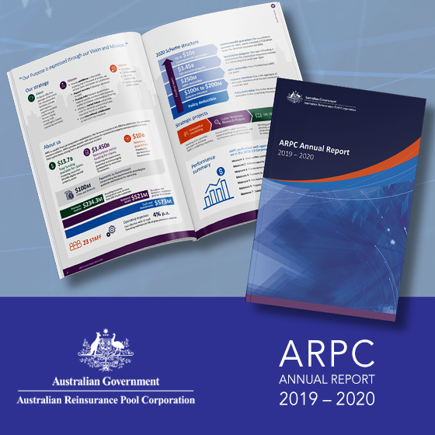
There were 227 insurer customers covered by ARPC for terrorism risk for commercial property and business interruption policies.

The ARPC Scheme had funding capacity for claims of $13.7 billion, and this capacity was provided through a combination of $521 million ARPC net assets, $3.45 billion retrocession reinsurance cover purchased from 71 global reinsurers and the $10 billion Commonwealth guarantee. Read the 2019-2020 Annual Report here.

ARPC Farewells Karen Payne

ARPC has recognised Member Karen Payne for her service to the Board, following completion of her term on 4 October 2020. Karen was very interested in, and supported, the performance and operations of ARPC.
We thank Karen for her service and deep engagement with ARPC.

IFTRIP LIVESTREAM 2020
ARPC CEO and acting 2020 IFTRIP President, Dr Christopher Wallace, presented to over 800 delegates at IFTRIP LIVESTREAM in October.
This event is the largest gathering of international terrorism reinsurance pools, insurers, reinsurers, security specialists, academics and thought leaders in the industry.
In Panel 6, ‘Beyond Terrorism: How do we reinforce the Re?’, Dr Wallace presented on the similarities between terrorism and pandemics. Both can be declared, and both have aspects of societal disruption and risk mitigation through government. Like terrorism, pandemics would benefit from a public/private pool to help lift the reputation of insurance by helping it to remain relevant to our society.
This presentation echoed an article later published by ANZIIF. You can read the article here.

Premium Submissions due
Premium submissions are due by 30 January 2021 for the second quarter (1 October – 31 December) of the 2020-21 Financial Year. All premium submissions, including nil submissions, must be lodged.
The premium return template is available in RISe and must be used to submit all premium returns. If you have any questions, please contact enquiries@arpc.gov.au or phone +61 2 8223 6777.

Q: As an insurer customer (cedant) how can I update my client profile details?
A: Insurer customers can manage their profile and notify changes to ARPC in the “Manage Profile” section of RISe.

