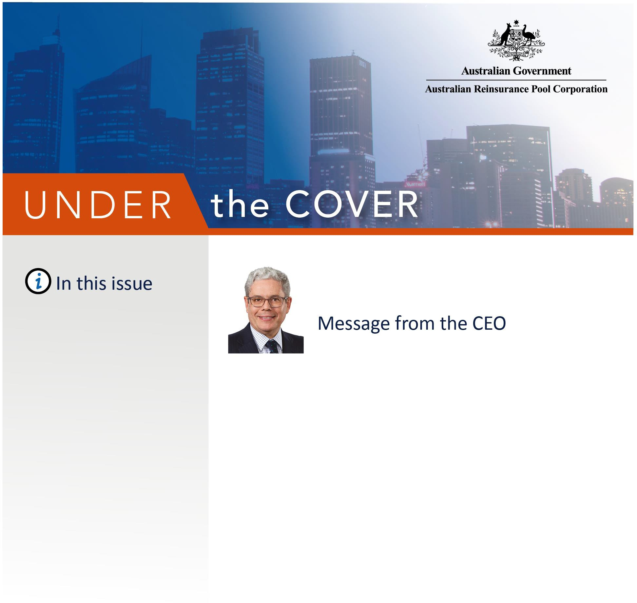
MARCH 2020

Desktop Cedant Reviews

Cyber Terrorism Research Project

Cyber Terrorism Research and Insurance Seminar Rescheduled

Risk Mitigation Handbook IFTRIP 2020
‘Eligible Insurance’ Amendment

ARPC Welcomes Newly Appointed Staff

Q&A

Welcome to the Autumn edition of our newsletter.

It’s been an awful start to 2020.

Our international and local insurer customers (cedants) will be deeply affected by the Coronavirus (COVID-19) crisis in a variety of ways. ARPC is continuing our high standard of service to insurer customers while remaining consistent with Australian Government and Health Department advice. Please do not hesitate to contact ARPC if you have any questions or concerns during this difficult time.

I would also like to extend my sympathies to Australians affected by the devastating bushfires earlier this year.

In January, ARPC renewed its retrocession reinsurance program for 2020. The $3.45 billion
retrocession reinsurance program, plus ARPC’s net assets and the $10 billion Commonwealth guarantee, provides scheme capacity in the event of a declared terrorism incident, against commercial and eligible property assets, of just under $14 billion.

I am pleased to announce that ARPC’s cyber research study titled ‘Insurance risk assessment of cyber terrorism in Australia’, is complete and accessible via a digital request form on ARPC’s website at arpc.gov.au. ARPC commissioned Cambridge Centre for Risk Studies at the University of Cambridge, (Cambridge) and the Organisation for Economic Co-operation and Development (OECD) to identify and explore current and prospective threats, plausible scenarios and the practicalities of extending insurance coverage to include cyber terrorism in Australia.

Due to travel uncertainties for our international speakers connected to the COVID-19 situation, we rescheduled our Cyber Terrorism Research and Insurance Seminar to 12 November 2020. We look forward to sharing deeper insights from the OECD/Cambridge research with you then.

Stay safe and look after each other.

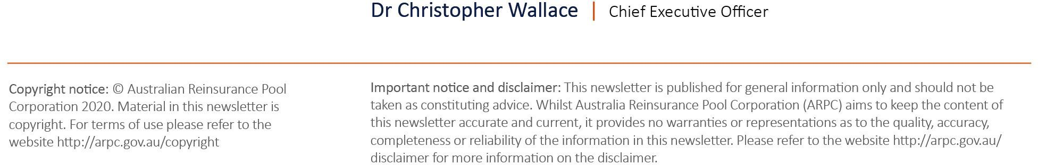

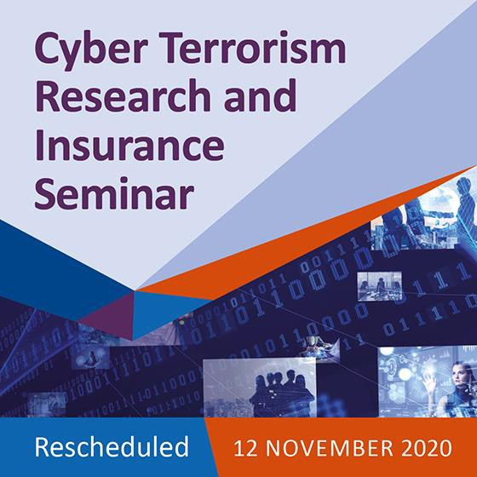ARPC Moves to Desktop Reviews for Cedants
During the COVID-19 crisis, ARPC will continue
‘business as usual’ for our insurer customers (cedants), while remaining consistent with Australian Government and Health Department advice.
For insurer customer reviews, physical office visits will be temporarily replaced by desktop reviews, with additional video calls and conferences scheduled as required, to ensure you remain connected and informed.
This situation is changing rapidly, and ARPC is well- equipped to respond accordingly. Please contact us at enquiries@arpc.gov.au if you have any enquiries or concerns.

ARPC Completes Cyber Terrorism Research Project
ARPC has completed its cyber terrorism research project, ‘Insurance risk assessment of cyber terrorism in Australia’, marking the end of a successful
collaboration with the OECD and Cambridge.

The key findings include that cyber terrorism is not covered by commercial property insurance in Australia and the terrorism reinsurance scheme administered by ARPC excludes cover for cyber terrorism.

The scenario analysis shows the average expected losses of two modelled scenarios are consistent with the expected losses from a traditional explosive blast attack in Sydney CBD and are within the capacity of the scheme. However, the maximum losses from these cyber attacks exceed the capacity of the scheme.
We expect the findings to inform development of government policy, including the three-year review of the terrorism insurance scheme by the Treasury.

The research is available to stakeholders via a digital request form on our website and will be discussed in detail at our November Seminar.
ARPC Cyber Terrorism Research and Insurance Seminar rescheduled
ARPC has rescheduled its Cyber Terrorism Research and Insurance Seminar to Thursday, 12 November 2020, to share detailed findings of ARPC’s cyber terrorism research project titled: ‘Insurance Risk Assessment of Cyber Terrorism in Australia’. The seminar will take place at NSW Parliament House, Sydney.

Please note: if you were registered for the March Seminar, you have been automatically pre-registered for the 12 November Seminar.

Speakers:

- Professor Paula Jarzabkowski, high profile insurance academic, author and International Forum of Terrorism Risk (Re)Insurance Pools (IFTRIP) presenter will chair the event.

- Dr Christopher Wallace, ARPC CEO, will present an updated ARPC cyber terrorism research paper: ‘Cyber Terrorism and
Australia’s Terrorism Insurance Scheme’.

- Mr Simon Ruffle, Director of Research & Innovation, Centre for Risk Studies, Cambridge Judge Business School, University of Cambridge, will be in Sydney to present
Cambridge’s 2020 research findings on current and near-term cyber terrorism threats, plausible cyber terrorism scenarios and a range of insured and economic losses.

Risk Mitigation Handbook Publication
ARPC is pleased to report that Standards Australia is making steady progress on the publication of the Physical Protective Security Controls for Buildings Handbook (HB-188) with the anticipated publication date set for July. ARPC is the sponsor for the Handbook.
Approved by peak Australian standards development body, Standards Australia, the Handbook will support proactive risk management of large-scale infrastructure by assisting commercial property owners and
operators assess their risks and plan and implement treatment measures to protect valuable assets against terror attacks and other malicious acts.
Standards Australia have this week announced the commenting period for the draft will open in the coming weeks. All relevant stakeholders will be notified of the opening and Standards Australia will be welcoming comments and feedback on the draft Handbook for a period of 6 weeks.

The Handbook aligns with ARPC’s strategic priorities to support and promote terrorism risk mitigation and to provide a world class response to terrorism incidents.

ARPC Team to Attend IFTRIP Conference

The International Forum of Terrorism Risk

Definitions of ‘Eligible Insurance’ Amended in
Terrorism Insurance Act Regulations
The Terrorism Insurance Act Regulations 2003 have been adjusted to clarify that ARPC insurance scheme coverage of high value multiple building contracts applies where the total sum insured, including those covered by one policy or strata plan, is $50 million or more.
The amendments are contained in items 32, 34, 35 and 36 of Schedule 1 to the Treasury Laws Amendment (Miscellaneous Amendments) Regulations 2019.

The main change to the exclusions is that exclusions 2(a) and 2(b) of Schedule 1 of the Regulations have been adjusted to exclude:
- destruction or damage to a mainly residential building (unless the contract is a high-value multiple building contract); or
- loss or damage to the contents of a mainly residential building (unless the contract is also a high-value multiple building contract).

High value multiple building contracts are defined as a contract of insurance that provides cover (whether or not cover is restricted) for destruction or damage to 2 or more buildings, if the total sum insured value of the buildings is $50 million or more.

The complete regulations amendment document, which has a registration date of 13 February 2020, can be viewed here.

(Re)Insurance Pools (IFTRIP) will take place in the United States capital, Washington DC on 13-14

October. 2020 IFTRIP president, Dr Christopher Wallace CEO, will join industry experts to discuss new and emerging trends in terrorism insurance risk. Dr Wallace will travel to Washington DC with Chief Operating Officer, Helen Williams; and Communications Manager, Anna Fenech.

IFTRIP is the largest gathering of terrorism (re)insurers, experts, academics and thought leaders from all four continents. IFTRIP has improved cooperation and goodwill between national terrorism insurance pools for years, and especially at a time of rapidly evolving terrorism trends. Discussion points will include the link between capital markets, reinsurance risk and terrorism.

ARPC Welcomes Newly Appointed Staff

ARPC is pleased to announce the appointment of Thiri Read to our underwriting team.
Thiri joins ARPC from Aon Banfield where she gained extensive experience as a claims and technical accounts
specialist in Life and General Reinsurance.

Thiri will be processing all new and existing reinsurance
contracts within ARPC’s underwriting guidelines and

service standards, as well as managing incoming and outgoing reinsurance, agreements and endorsements.

We would also like to warmly welcome our newly appointed Terrorism Risk and Underwriting Projects Manager, Cait Foxwell. Cait is progressing our projects on terrorism risk mitigation
and terrorism catastrophe modelling. She joins us from Gow Gates where she worked in account management with the Equine Team, providing advice and service across a variety of insurance products.
Kiah Frankel has joined ARPC in the role of Communications Officer. Kiah holds undergraduate degrees in Media and International Studies and has worked in marketing and journalism.
Kiah will support the Communications team in the production of internal and external communications, including stakeholder engagement.

Premium Submissions due

Premium submissions for the third quarter (1 January – 31 March) of the 2019-2020 financial year are due on the 30 April 2020. All premium submissions, including nil submissions, must be lodged.

To submit a premium please log into http://rise.arpc.gov.au and select
‘download templates’. For further instructions, please
refer to page 27 of the RISE Cedant User Manual here.

Q. As an insurer customer (cedant), who can I contact if I have a question in relation to ARPC submissions?
A. For all enquiries about premium submissions, contact ARPC Underwriter, Thiri Read at enquiries@arpc.gov.au.

Q. As an insurer customer (cedant), what
should I do if I haven’t processed any ARPC eligible insurance contracts?
A. Within 30 days of the end of each quarter, insurer customers (cedants) must submit a statement to ARPC setting out the total amount of premium payable to ARPC in respect of all eligible insurance contracts which are processed during the quarter.

If an insurer customer (cedant) has not processed any eligible insurance contracts during the quarter, a ‘NIL’ submission in RISe is required.

If you have any questions, please contact
enquiries@arpc.gov.au, or call +61 8223 6777.

