ARPC has welcomed Helen Williams to the position of Chief Operating Officer.
Helen brings deep leadership, technology operations and stakeholder engagement experience to ARPC. It’s great to have Helen on board and I look forward to her contributions to the leadership team.
In October, I attended the International Forum of Terrorism (Re)insurance Pools (IFTRIP) Congress in Brussels, Belgium, where I provided an update on ARPC’s cyber terrorism research project and our project with Standards Australia to produce a risk mitigation Handbook.
IFTRIP exists to help national terrorism pools from around the world share expertise and experience to mitigate the threat of economic loss from terrorism.
Chief Underwriting Officer Michael Pennell and I have recently returned from ARPC’s annual retrocession trip where we met with reinsurers in key overseas markets and negotiated the renewal of ARPC’s retrocession program. The program terms will be finalised shortly. We are grateful for the support of our global panel of over 70 reinsurers.
ARPC ‘s 2018-19 Annual Report has been tabled in Parliament and is available on our website here.

- ARPC welcomes new Chief Operating Officer
- ARPC publishes 2018-19 Annual Report
- ARPC CEO appointed 2020 IFTRIP President
- Premium Submissions due
- ARPC engages with senior police on the impact of exclusion zones
- Q+A
- Postcode update

DECEMBER 2019

Welcome to the Summer edition of our newsletter

ARPC welcomes Chief Operating Officer Helen Williams
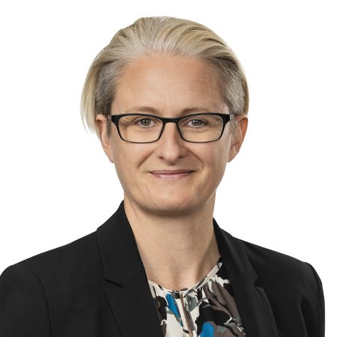
Helen Williams, ARPC Chief Operating Officer
ARPC has welcomed Helen Williams to the position of Chief Operating Officer. Helen has extensive multidisciplinary experience in strategy, technology operations and defence.
She joins ARPC from the strategy consulting firm Strategy& (part of the PwC network), where she has been a strategy consultant since 2014. Prior to her work at Strategy&, Helen had more than 12 years technology operations leadership experience with Lucent Technologies, Alcatel and Nokia Siemens Networks.
Her career also includes service with the Australian Army as a Commissioned Officer.
Helen holds a Bachelor of Arts (Honours) from the University of Adelaide.

ARPC publishes its 2018-19 Annual Report
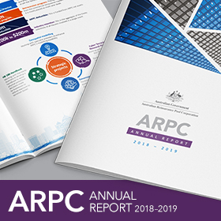
ARPC’s 2018-19 Annual Report was tabled in Parliament in October 2019 and has been published on our website. The Report reflects ARPC’s excellent operational and financial performance over the year.
ARPC has 220 insurer customers which insure $3.46 trillion sum insured for commercial property and business interruption policies.
During 2018-19, ARPC had funding capacity for claims of $13.6 billion. This capacity was provided through a combination of $461 million ARPC net assets, $3.315 billion retrocession cover purchased from 71 global reinsurers and the $10 billion Commonwealth guarantee.
To read the full 2018-19 Annual Report, please visit our website here.

ARPC CEO Dr Christopher Wallace appointed 2020 IFTRIP President
Dr Christopher Wallace, ARPC CEO, has been appointed incoming President of the International Forum of Terrorism (Re)Insurance Pools (IFTRIP) and will assume his new role in January 2020.
IFTRIP is an international forum of national terrorism insurance pools which provides members with access to shared expertise to help combat potential major economic loss resulting from terrorism.
Dr. Wallace said he feels honoured to be appointed President of IFTRIP.
“During my tenure as President, I look forward to extending IFTRIP’s membership outreach to Asian insurance markets and highlighting the human impact of terrorism,” Dr. Wallace said.
The next annual IFTRIP Congress will take place in Washington DC on 2-3 June 2020.

Premium Submissions due
Premium submissions are due by 30 January for the second quarter (1 October – 31 December) of the 2019-20 Financial Year. All premium submissions, including nil submissions, must be lodged.
The premium return template is available in RISe and must be used to submit all premium returns.
If you have any questions, please contact enquiries@arpc.gov.au or phone +61 2 8223 6777.

ARPC engages with senior police on the impact of exclusion zones
Michael Pennell PSM, ARPC Chief Underwriting Officer
This year, ARPC undertook a comprehensive engagement program with senior counter terrorism and incident control police across Australia to demonstrate ARPC’s blast modelling capability as well as the cost impacts of exclusion zones that are established for public safety and incident control.
Led by Chief Underwriting Officer Michael Pennell, ARPC developed and delivered this program to raise awareness of ARPC modelling tools and to ensure state police forces have an additional source of information when assessing and managing incidents.
The program was well received by police across the country. There was an appreciation that while public safety is paramount, an understanding of the financial impacts of exclusion zones and additional modelling tools is of great use to police agencies.
As a result of this program, ARPC has been invited to present at various state police-sponsored forums for corporate audiences including at Crowded Places forums in Melbourne and Perth and the Leadership in Counter Terrorism forum (LinCT) in Sydney in December 2019.

Q & A
Q Do I need to pay GST for my quarterly premium submission?
A Only cedants that are “residents for tax purposes and registered for GST in Australia” are required to pay GST.

Postcode Update
Please ensure that your company’s master postcode tables are updated to include the addition in the table below. Only use ARPC-authorised postcodes in all underwriting of eligible classes (e.g. premium rating and aggregate reports).
New postcode
6219 | WA | C

