ARPC held its 4th annual Terrorism Risk Insurance Seminar at NSW Parliament House last month, attracting more than 100 delegates from the government and re/insurance industry.
Speakers included ASIO’s Counter Espionage and Foreign Interference Division; John Macpherson, Senior Partner at Control Risks; Deakin University’s Professor Greg Barton; Alex Hill from the Australian Government’s Defence, Science and Technology Group; and ARPC Chief Underwriting Officer Michael Pennell PSM.
ARPC recently announced a new appointment to its senior executive team with Janice Nand, formerly ARPC Senior Manager, Governance, Compliance and Board Secretariat, being promoted to the new position of General Counsel.
ARPC has appointed Helen Williams as Chief Operating Officer. Ms Williams has extensive multi-disciplinary experience in strategy and technology operations.
Next month, I will attend the International Forum of Terrorism (Re)insurance Pools (IFTRIP) Congress in Brussels, Belgium. As part of that event, I will provide an update on ARPC’s cyber terrorism research project and our project with Standards Australia to produce a risk mitigation Handbook.
IFTRIP exists to help national terrorism pools from around the world share expertise and experience to mitigate the threat of economic loss from terrorism.
ARPC has published its 2019-23 Corporate Plan which commenced on 1 July 2019 and spans the four reporting periods to 30 June 2023. Please read the Corporate Plan here.

- General Counsel appointed
- ARPC welcomes ANAO Performance Audit report
- 4th annual Terrorism Risk Insurance Seminar
- ARPC publishes 2019-23 Corporate Plan
- Retention information due
- Premium submissions due
- ARPC wins Bronze in the Australasian Reporting Awards
- Tom Cornock wins 2019 RDG Scholarship
- Q&A
- 2019 IFTRIP Congress in Belgium
- Postcode update

SEPTEMBER 2019

Welcome to the Spring edition of our newsletter

New appointment – General Counsel
Janice Nand, ARPC General Counsel
Ms Janice Nand has been promoted to the new position of General Counsel on the ARPC senior executive team.
Ms Nand joined ARPC in February 2019 as Senior Manager, Governance, Compliance and Board Secretariat.
As General Counsel she brings a valuable legal skillset to the team which will strengthen ARPC’s organisational governance and leadership.
For more information, please read our full ARPC media release ere.

ARPC welcomes ANAO Performance Audit Report
ARPC has welcomed the Performance Audit Report: Management of the Terrorism Reinsurance Scheme, by the Australian National Audit Office (ANAO). The ANAO is the national auditor for the Australian Government.
The performance audit concluded that ARPC is effective in managing the terrorism reinsurance scheme and that governance arrangements allow effective oversight and management of the scheme.
The ANAO performance audit report made one recommendation: that the Treasury reviews options available to rebuild ARPC’s capital following an event leading to significant claims on the scheme, in order to minimise the need for premium increases. The Treasury agreed to this recommendation.
The full ARPC media release can be read here.
ARPC hosted its 4th Terrorism Risk Insurance Seminar
ARPC’s annual seminar was held on Thursday, 29 August 2019 at NSW Parliament House, Sydney.

Themed The Terrorism Landscape, more than 100 delegates heard presentations on local and global terrorism threats, espionage and foreign interference, cyber terrorism, the financial loss caused by exclusion zones that follow terror attacks and CBRN weapons.

Keynote speakers represented ASIO’s Counter Espionage and Foreign Interference Division; Control Risks; the Australian Government’s Defence, Science and Technology Group (DSTG); and ARPC.

Below (L-R): John Macpherson, Control Risks; Professor Greg Barton, Deakin University; ARPC CEO Dr Chris Wallace and ARPC Board member Janet Torney; NIBA CEO Dallas Booth and ARPC Board member Elaine Collins.

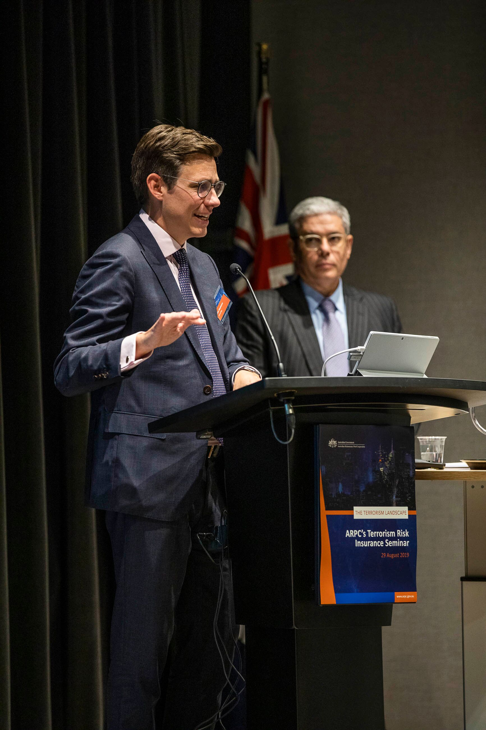
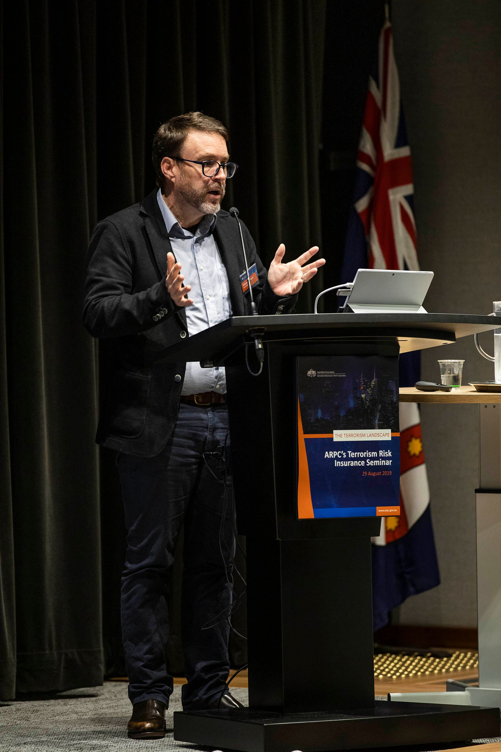

ARPC publishes its 2019-23 Corporate Plan
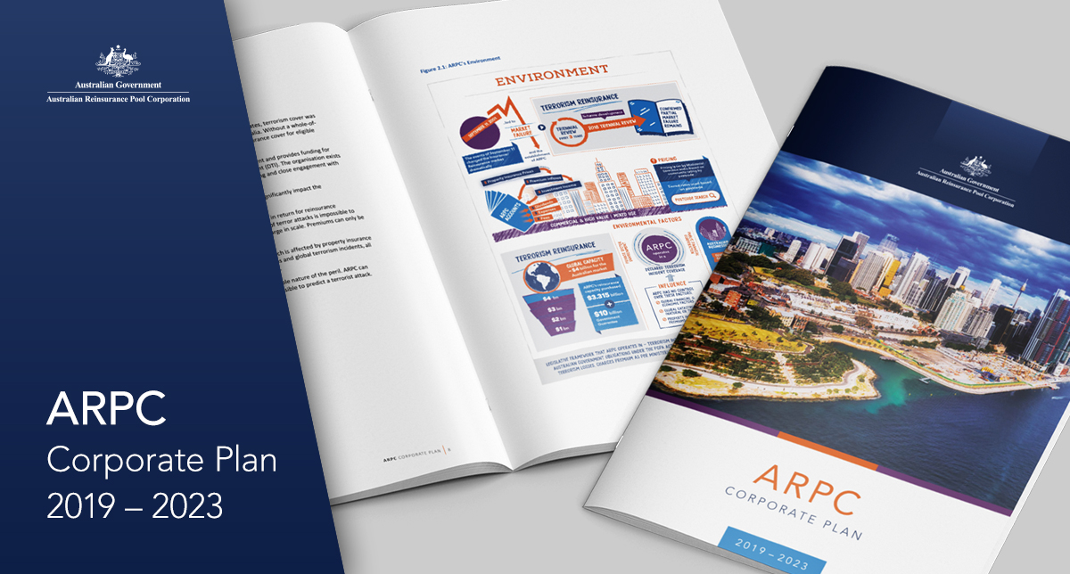
ARPC has published its new Corporate Plan which commenced on 1 July 2019 and spans the four reporting periods to 30 June 2023.
ARPC’s Corporate Plan outlines its strategic priorities for this period, which are to:
- extend thought leadership and expertise;
- engage, understand and collaborate with stakeholders;
- provide a world class response to terrorism incidents;
- embrace and evolve to a changing market environment; and
- embrace and strengthen the resilience and preparedness of our people and organisation.
ARPC’s Corporate Plan is the primary planning document for ARPC and addresses the organisation’s purpose, environment, capabilities, risk management and performance.
To read the full 2019-23 Corporate Plan please visit our website here.

Retention information is due
ARPC would like to remind insurer customers that they are required to submit Gross Written Premium (GWP) information for the 2018-19 Financial Year.
The GWP submission was due on 31 August 2019 for non-APRA registered insurers and will be due on 30 September 2019 for APRA-registered insurers.
This submission will set each insurer’s retention for the current retention period (which aligns with the Australian financial year). Failure to meet these deadlines means the default retention of $12.5 million will apply.
The Fire and Industrial Special Risks (ISR) GWP reporting applies to all eligible and ineligible Fire and ISR policies, not just those already reported through quarterly premium returns. For APRA-registered insurers, this figure will be the same as that reported to APRA (GRF 310.1), which is also due on 30 September each year.
If you are experiencing difficulties using ARPC’s RISe system, please refer to our website for the online manual here or contact ARPC at enquiries@arpc.gov.au or phone +61 2 8223 6777.

Premium Submissions due
Premium submissions are due by 30 October for the first quarter (1 July – 30 September) of the 2019-20 Financial Year. All premium submissions, including nil submissions, must be lodged.
The premium return template is available in RISe and must be used to submit all premium returns.
If you have any questions, please contact enquiries@arpc.gov.au or phone +61 2 8223 6777.

ARPC wins Australasian Reporting Award

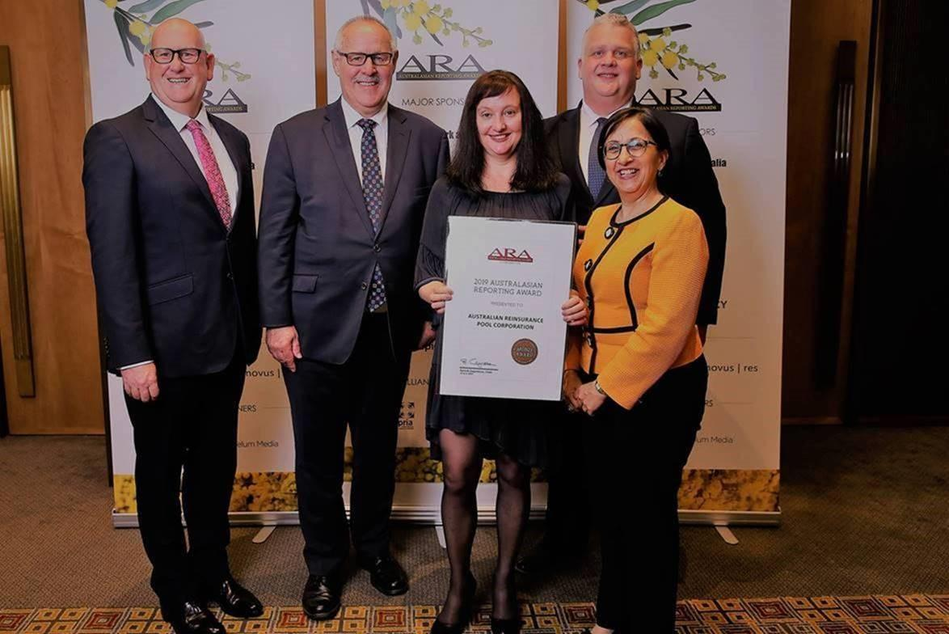
L-R: ARPC CFO John Park, Board member John Peberdy, Communications Manager Anna Fenech, Jonathan Champ from Meaning Business and ARPC General Counsel Janice Nand.
ARPC has won a Bronze Award for its 2017-18 ARPC Annual Report in the Australasian Reporting Awards.
This was ARPC’s first entry into the ARA which exists to improve reporting standards.
To receive the award ARPC presented quality disclosures in major areas and provided satisfactory coverage of ARA criteria.
The award was collected by ARPC colleagues John Park, John Peberdy, Anna Fenech, Janice Nand and ARPC consultant Jonathan Champ.

ARPC’s Tom Cornock wins 2019 RDG Scholarship
Tom Cornock, ARPC Risk, Crisis Response and Governance Analyst
In July, Tom Cornock, ARPC Risk, Crisis Response and Governance Analyst, attended the Willis Re Academy in Singapore for one week after being awarded the 9th Annual RDG Scholarship.
To enter, Mr Cornock was required to submit a picture representing “TRUST” together with a 150-word entry on the impact of trust on the insurance or reinsurance industry.
Points were awarded for originality, imagination and humour.
Mr Cornock said the one-week training program developed individuals who were relatively new to reinsurance and wanted to broaden their knowledge of reinsurance business and the industry.

Q What should insurer customers include in their annual GWP submission?
A Insurer customers must include their Gross Fire and ISR premium less the amount of the Fire Service Levy component which the insured has remitted. The calculation of this amount and documents verifying the calculation must be submitted to ARPC by 30 September each year

2019 IFTRIP Congress
The International Forum of Terrorism (Re)insurance Pools will host its 2019 Congress in Brussels, Belgium from 8-10 October.
The conference will provide an opportunity for greater international collaboration. Attendees will gain exclusive insight into the latest terrorist threats as well as valuable information to help mitigate the risks of terrorism.
IFTRIP was established after an endorsement at the inaugural ARPC-OECD Terrorism Risk Insurance Conference in Canberra in 2016.

Postcode Update
ARPC reminds its insurer customers that changes to ARPC’s postcode tier classifications came into effect on 1 July 2019 for all eligible new and renewal business.
Please use the updated postcode tier classifications in your first quarter premium submissions.
A spreadsheet outlining the changes to the postcode classifications can be accessed by selecting the ‘Download Summary of Changes Effective 1 July 2019 link on the ARPC website in the Postcodes section here.

