SPRING 2018
ARPC would like to thank stakeholders who registered their interest with Standards Australia to participate in developing the Physical Protective Security Treatments for Buildings Handbook. As we informed you in our Winter newsletter, ARPC submitted a proposal to Standards Australia for the development of the Handbook, which was approved. Experts from varied industries were then invited to register their interest in working on the Handbook. ARPC looks forward to the development phase in conjunction with Standards Australia.
ARPC also appreciates the commitment of insurers who made submissions to the Treasury’s 2018 Triennial Review of the Terrorism Insurance Act 2003. Submissions were sought in relation to the Terms of Reference, which includes whether cyber terrorism should be covered by the Scheme and a review of the extent of coverage available for terrorism incidents causing harm to people.
On 29 November, ARPC will host its third Terrorism Risk Insurance Seminar at NSW Parliament House. The Seminar will run from 3.00 pm to 4.30 pm, followed by networking drinks and canapes to 6.00 pm.
ARPC published its 2018-22 Corporate Plan on 31 August. It is available on our website here.
Our Annual Report will be published on 31 October.

2018 Triennial Review submissions closed
Save the Date for the 2018 ARPC Terrorism Risk Insurance Seminar
GWP reports due for submission
International Forum for Terrorism Risk (Re)Insurance Pools Congress to be held in Moscow, Russia
Paolo Zazzara joins ARPC as Senior Manager, Insurance Audit
Q&A

Welcome to the Spring edition of our newsletter.

2018 Triennial Review submissions closed
ARPC would like to thank stakeholders who made submissions to the Treasury relating to the Triennial Review of the Terrorism Insurance Act 2003 (TI Act).
The Review sought stakeholder views on issues outlined in the Terms of Reference, particularly with respect to:
- whether the risk of cyber terrorism causing physical property damage should be included in the Scheme by removing the regulations for computer crime and over-riding policy exclusions for cyber terrorism; and
- the extent of coverage available for terrorism incidents causing harm to people including armed assault.
As in previous reviews, the 2018 Review will consider the need for the Act to continue and opportunities to improve the Scheme.
Recommendations from the 2015 Triennial Review have all been implemented. The Scheme’s coverage was extended to include certain mixed-use buildings and high value buildings and clarified coverage in the event of a Declared Terrorist Incident involving a biological or chemical substance.
Save the Date for the 2018 ARPC Terrorism Risk Insurance Seminar

You are invited to the third ARPC Terrorism Risk Insurance Seminar on Thursday, 29 November 2018 at NSW Parliament House, Macquarie Street, Sydney.
The Seminar will take place from 3.00 pm - 4.30 pm. Networking drinks and canapes will follow. Last year’s event was well received by the 115 delegates who attended.
This year, delegates will hear valuable insights into current and emerging terrorism threats and mitigation measures from experts in terrorism, cyber terrorism, and risk insurance.

For more information, including how to register for the event, please email events@arpc.gov.au or visit www.arpc.gov.au which will be updated with a program in the coming weeks.
Seminar Details
Date: 29 November 2018
Place: Parliament House
6 Macquarie Street
Sydney
Time: 3.00 pm - 6.00 pm

Reports due for submission
Retention information
ARPC would like to remind cedants that they are required to submit their Gross Written Premium information for the 2017-18 Financial Year.
The GWP submission was due on 31 August 2018 for non-APRA registered insurers and will be due on 30 September 2018 for APRA-registered insurers.
This submission will set each insurer’s retention for the current retention period (which aligns with the Australian Financial Year). Failure to meet these deadlines means the default retention of $12.5 million will apply.
The Fire and Industrial Special Risks (ISR) GWP reporting applies to all eligible and ineligible Fire and ISR policies, not just those already reported through quarterly premium returns. For APRA-registered insurers, this figure will be the same as that reported to APRA (GRF 310.1), which is also due on 30 September each year.
If you are experiencing difficulties using ARPC’s RISe system, please refer to our website for the online manual here or contact ARPC at enquiries@arpc.gov.au, or +61 2 8223 6777.
Premium Submissions due
Premium submissions for the first quarter (1 July – 30 September) of the 2018-19 Financial Year are due on 30 October 2018. All premium submissions, including nil submissions, must be lodged.
The premium return template is available in RISe and must be used to submit all premium returns.
If you have any questions, please contact enquiries@arpc.gov.au, or call +61 2 8223 6777.

International Forum for Terrorism Risk (Re)Insurance Pools Congress to promote collaboration between national terrorism pools
On 9-10 October 2018, the annual Congress of the International Forum for Terrorism Risk (Re)Insurance Pools (IFTRIP) will be held in Russia for the first time.
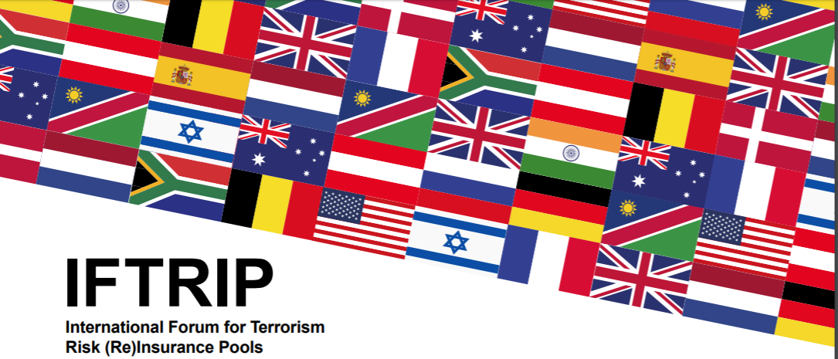
IFTRIP exists to help national terrorism pools from around the world share expertise and experience to combat the threat of economic loss from terrorism and to mitigate it.
More than 200 insurance industry professionals will attend from around the world. Topics include insuring and reinsuring terrorism and sabotage risks, as well as political violence and cyber risks.
The Congress will be held in Moscow on 9-10 October.
IFTRIP Russia Congress – Program extract
- The nature and level of the terrorism threat
- Economic cost of terrorism
- Best practices in terrorist attack prevention
- National terrorism schemes: adapting to a changing environment. Is returning to a normalised market any closer?
- The role of (re)insurers in Public Private Partnerships
- Trends in terrorism risk insurance
- Cyber terrorism coverage and scenarios
- The optimum risk sharing model for terrorism
- How do terrorism re/insurance pools ensure their continued relevance?
- New threats and emerging gaps

For more information on the IFTRIP Congress,
please visit: www.iftrip.org.

Paolo Zazzara joins ARPC as Senior Manager, Insurance Audit
Paulo Zazzara

ARPC would like to welcome Paulo Zazzara who has joined the team as Senior Manager, Insurance Audit.
Paolo will be responsible for managing the Cedant Review Program.
Paolo has joined ARPC from Allianz Australia where he worked in a range of internal audit compliance roles. Prior to this, Paolo worked in the internal audit departments of Zurich, Generali and other large insurance companies both locally and overseas.
Paolo is a Certified Public Accountant (CPA) and has 10 years’ experience in the assurance and risk space within the financial services industry.
“I am looking forward to working with many of you personally,” said Mr Zazzara.
“In the meantime, please feel free to reach out with any questions or concerns regarding ARPC’s Cedant Review Program.”

Q What tier rate is applied to a construction policy that is extended, which is not a new policy or a renewal?
A If the inception date of the policy is prior to 1 April 2016, the old tier rate will apply. The new tier rate only applies to those policies that started or renewed on, or after, 1 April 2016.
Q Does the Fire and Industrial Special Risks (ISR) GWP reporting apply only to Fire and ISR policies already reported through quarterly premium returns?
A No. The Fire and Industrial Special Risks (ISR) GWP reporting applies to all eligible and ineligible Fire and ISR policies, not just those already reported through quarterly premiums.

