Summer 2017 Under the Cover

- Premium submissions due
- Terrorism Risk Insurance Seminar Highlights
- Q&A
- Postcode tier classification changes
- ARPC’s Cedant Review Program
- Postcode update

Message from the CEO
Welcome to the Summer edition of our newsletter.

October was a busy month for ARPC, with our Terrorism Risk Insurance Seminar taking place on 5 October and the launch of our new website.
About 115 delegates attended the Seminar at NSW Parliament House, Sydney, to hear insights into terrorism threats and mitigation measures from an impressive line-up of expert speakers covering terrorism, cyber terrorism and risk insurance. Most delegates described the Seminar as ‘excellent’ (the highest rating) or ‘good’ (the second highest rating) in a feedback survey.
ARPC’s website has been redesigned to modernise its appearance, make it mobile and browser responsive, and to provide our stakeholders with a more seamless user journey. All content on our previous site, including the RISe Claims system, has been transferred to the new site, so you can continue your business as usual online. ARPC commissioned Sydney-based web designers G Squared to develop the new website, after a comprehensive tender process.
I, and ARPC Chief Underwriting Officer Michael Pennell, have recently returned from an annual trip where we met with reinsurers in key markets on the renewal of our retrocession program for the 2018 calendar year. The terms of the program will be finalised shortly. We are grateful for the support of our global panel of almost 65 reinsurers.
ARPC has published our Annual Report for the 2016-17 financial year which is available on our new website here.
Dr Christopher Wallace,
Chief Executive Officer

Premium submissions due
Premium submissions for the second quarter (1 October – 31 December) of the 2017-2018 financial year are due by 30 January 2018. All premium submissions, including nil submissions, must be lodged by this date.

To submit a premium please log into http://arpc.gov.au/our-customers/rise-login/ and select download templates. For further instructions, please refer to page 27 of the RISe Cedant User Manual here.

If you have any questions please contact accounts@arpc.gov.au or call +61 2 8223-6777.

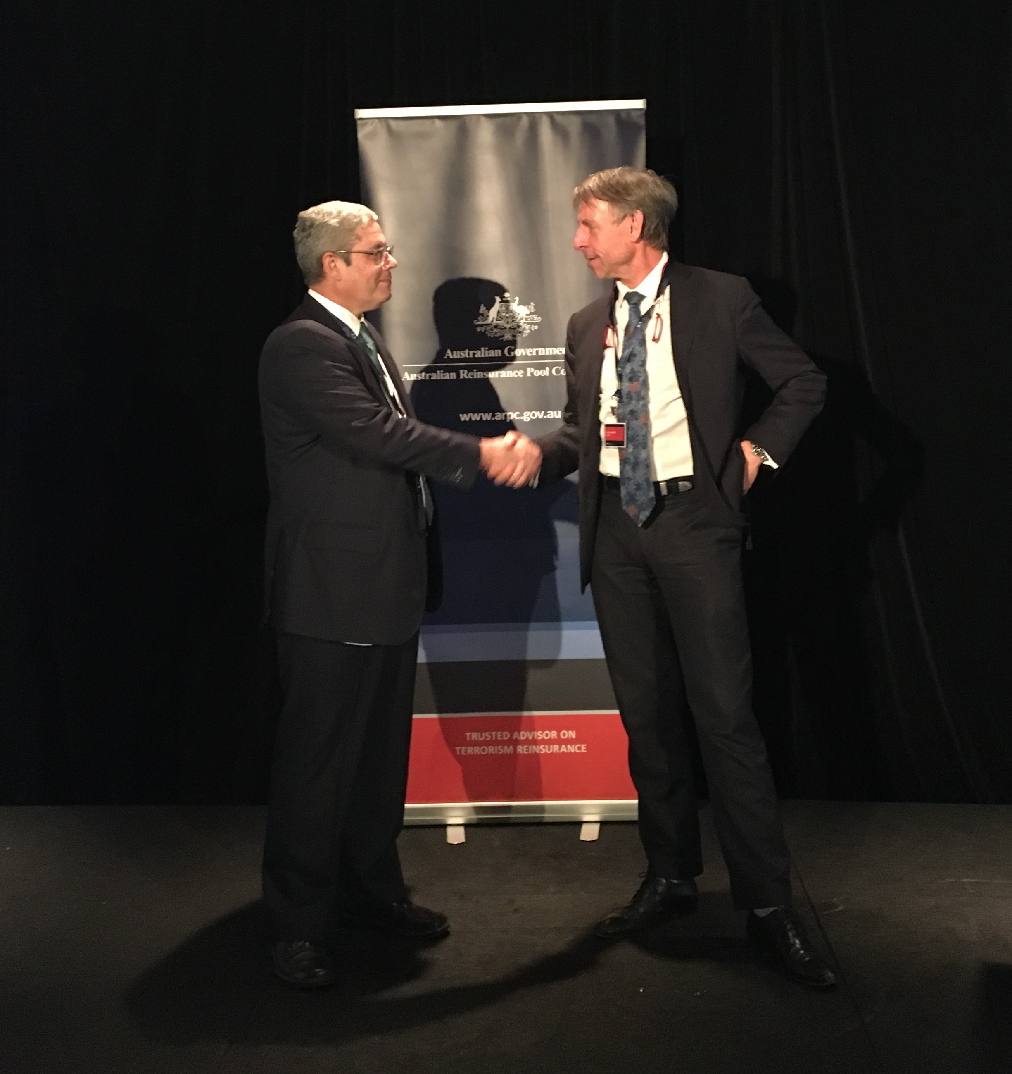
Above: ARPC CEO Dr Christopher Wallace and ARPC Chair Ian Carson AM opening the ARPC Terrorism Risk Insurance Seminar.

Terrorism Risk Insurance Seminar highlights
ARPC hosted its second Terrorism Risk Insurance Seminar at NSW Parliament House, Sydney in October.
Delegates found presentations by the Lowy Institute’s Anthony Bubalo and the Australian Strategic Policy Institute’s Dr Anthony Bergin particularly interesting. A presentation by Levi West from Charles Sturt University was highly regarded for its insights into terrorist offensive cyber capabilities.
A conversation between ARPC CEO Dr Christopher Wallace and HDI Global’s Head of Crisis Management and Cyber Underwriting Karina Rodriguez Diaz was thought provoking for its commentary on the private re/insurance sector’s coverage of terrorism and related events.
ARPC posted several Seminar presentation articles on our new ARPC Linkedin page, which can be viewed here.
ARPC would like to thank all Seminar attendees for their support. We would also like to thank those who took the time to complete the feedback survey, which will assist us in making the event even better next year.

Q&A
Q: In an Event Cancellation Policy, does an insured have to occupy eligible property in order to be covered, in the event of a Declared Terrorist Incident (DTI), by the Terrorism Insurance Act 2003 (the Act)?
A: For an Events Policy to be an eligible insurance contract under the Act, the policy must cover business interruption and consequential loss arising from the inability to use eligible property occupied by the insured. The insured must be in actual possession of the eligible property. The phrase “is occupied” refers to the present tense (in actual possession) and not future tense (will be occupied).

From left: ARPC’s Advisor, Insurance Audit and Claims Jessie Khan and ARPC’s General Manager Insurance Audit and Claims, Michael Stallworthy.

Explaining ARPC’s Cedant Review Program
ARPC introduced its Cedant Review Program to help our insurers meet their obligations under the Reinsurance Agreement as well as to strengthen ARPC’s relationship with them. This is done through helping cedants understand the process involved in identifying eligible insurance contracts, premium calculation and premium remittance. ARPC appreciates the welcome extended to its review team – Advisor, Insurance Audit and Claims Jessie Khan and ARPC’s General Manager, Insurance Audit and Claims Michael Stallworthy – and thanks clients for their cooperation.
The review team typically reviews the following areas:
- Premium returns: This is to ensure that the quarterly premium return submitted to ARPC matches the insurance and financial records of the cedant.
- APRA and ARPC returns: The reconciliation of APRA and ARPC returns assists in verifying the Gross Written Premium (GWP) which is used to calculate the cedant’s retention level under the Reinsurance Agreement.
- Claims management: The team reviews the claims manual to ensure cedants are completely aware of ARPC’s unique requirements for reinsurance loss and claims reporting in the event of a DTI.
- Aggregate reporting: ARPC checks how the sum insured and risk numbers are generated for each postcode for submission of the Annual Aggregate Report. ARPC also checks details for the street address report for CBDs. ARPC seeks to ensure that the aggregate information by postcode goes down to risk level.
- Emergency procedures: This includes business continuity and disaster recovery plans to ensure that, if an incident occurs which affects a cedant’s ability to conduct its business, the client will still be able to report potential terrorism-related losses to ARPC in a timely manner and, in the event of a DTI, report claims.
- Policy wording: ARPC checks the policy wording to confirm the appropriate terrorism exclusion clause is applied.

Postcode tier classification changes to take effect in January
As outlined in in our July cedant email, ARPC’s most recent review of Australian postcodes resulted in tier classification changes, which come into effect on 1 January 2018. The review was undertaken with the assistance of our actuarial consultants and is based on current population statistics.
The adjustments are as follows:
- Newly classified urban region – Toowoomba and Cairns now meet the definition of an urban area. Therefore one postcode in Toowoomba and five postcodes in Cairns that were classified as Tier C have been reclassified as Tier B postcodes.
- New urban fringes – 61 postcodes at the borders of urban areas that are now undergoing substantial development have been reclassified as Tier B. The most notable changes are south of Perth where the Rockingham area has now been included.
- New postcodes – there are 13 new postcodes that have now been classified. Please note that the University of Adelaide has now been given its own postcode which is classified as Tier A.
- Corrections – we have revised the tier for five postcodes. This includes adjusting university postcodes from Tier C to Tier B, attributed to their location.
The complete, updated postcode table, effective 1 January 2018, is available on the ARPC website here. This table is used to determine the correct terrorism premium tier rate for all eligible new and renewal business from this effective date. Please ensure your underwriting and other rating systems are updated accordingly.
ARPC first issued an email to all cedants in July, informing them of the changes and providing six months’ notice.

Postcode update

There is no postcode update this issue.

