It’s a pleasure to present our final Under the Cover for 2021.
ARPC welcomes the Australian Government’s release of draft legislation and supporting regulations for the Cyclone Reinsurance Pool covering cyclones and cyclone-related flood damage.
We also welcomed the 2021 Triennial Review of the Terrorism Insurance Act 2003 by the Treasury which recommended that ARPC continue to provide terrorism re/insurance covering Australian commercial and high value residential property.
Peak standards development body Standards Australia has published the Physical Protective Security Controls for Buildings Handbook (HB-188). ARPC is the Project Proponent for HB-188 and proposed the project in 2018.
ARPC successfully hosted its 2021 Terrorism Risk and Insurance Webinar on Wednesday 10 November. This event attracted over 135 delegate registrations.
In December, we launched the second annual ARPC Insurer Customer Survey. The survey allows you to share feedback (and suggestions) you may have regarding our interactions with you over the year. It will be open until 21 January 2022. The email with the survey link is from ORIMA Research surveys@orima.com. We would really appreciate your participation.
ARPC’s 2019-2020 Annual Report was tabled in Parliament in October and can be viewed on our website here. The report showcases excellent operational and financial performance during the financial year.
Wishing you a happy, healthy, and safe holiday season.

2020-21 Annual Report published
Draft legislation for Cyclone Reinsurance Pool
ARPC welcomes 2021 Triennial Review Report
New Board Member welcomed
Terrorism Risk & Insurance Webinar
ARPC commences research study on evolving meaning of terrorism
Publication of risk mitigation handbook with Standards Australia
IFTRIP endorses award for terrorism research
Premium submissions due
Q&A

Summer 2021

Welcome to the Summer edition of our newsletter.

ARPC 2020-21 Annual Report published
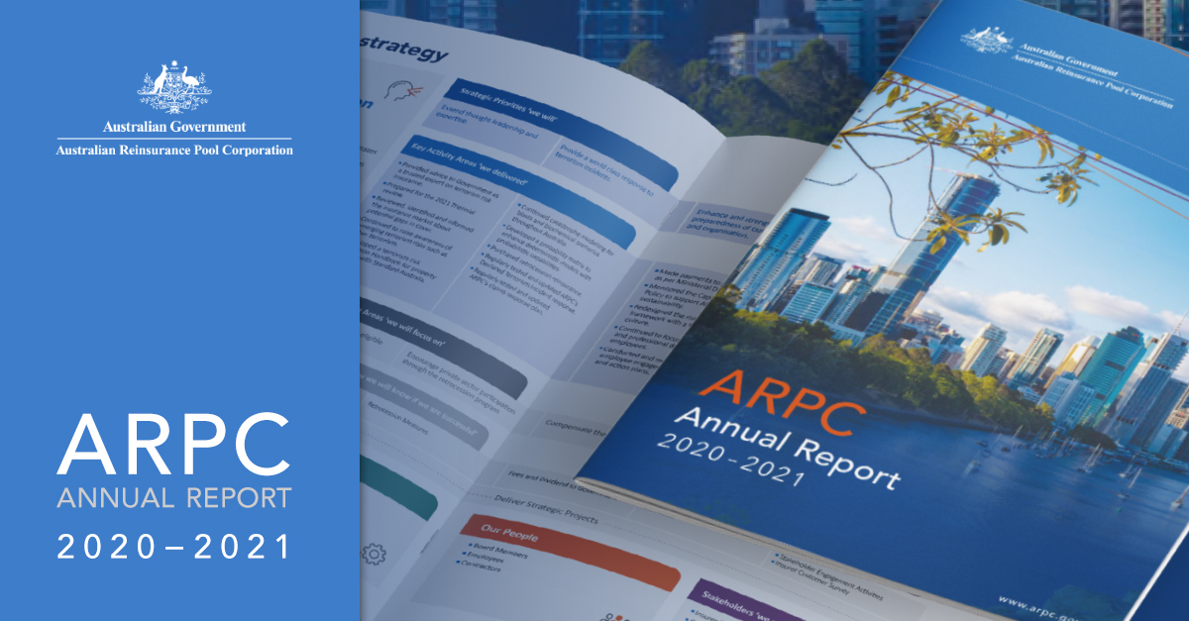
ARPC’s 2020-21 Annual Report shows ARPC achieved excellent performance operationally and financially during 2020-21, according to Dr Christopher Wallace, ARPC CEO. There were 237 insurer customers covered by ARPC for terrorism risk under commercial property and business interruption policies.
The ARPC pool had funding capacity for claims of $13.7 billion. This capacity was provided through a combination of $595 million ARPC net assets, $3.475 billion retrocession reinsurance cover purchased from 73 global reinsurers and the $10 billion Commonwealth guarantee. ARPC performed well against the targets set in the 2020-24 Corporate Plan.
The financial performance for 2020-21 was better than predicted, due to rate increases in underlying commercial insurance premiums, with the operating result (surplus) for the year ending 30 June 2021 at $84.9 million, $29.5 million better than forecast.
ARPC made good progress on strategic projects during 2020-21 including:
- cyber terrorism research project completion and launch to stakeholders
- Standards Australia Handbook for the ‘Base Building Physical Security Handbook – Terrorism and Extreme Violence’, and
- development and Board approval of a risk culture statement as part of the risk management framework redesign.
The full annual report can be viewed on ARPC’s website here:

Draft legislation released for Cyclone Reinsurance Pool
ARPC welcomes the Australian Government’s release of draft legislation and supporting regulations for the Cyclone Reinsurance Pool covering cyclones and cyclone-related flood damage.
The Government has released a draft bill and explanatory memorandum, together with regulations and an explanatory statement, and a Treasury factsheet.
On 4 May 2021, the Government announced its intention to establish a reinsurance pool for cyclones and related flood damage, to commence from 1 July 2022 and be backed by a $10 billion Government guarantee. The pool, to be administered by ARPC, will cover residential, strata and small business property insurance policies in cyclone prone areas, mainly located in Northern Australia.
Following the May announcement, the Treasury commenced a Cyclone Reinsurance Pool Taskforce to consult with industry and community representatives, as well as other interested stakeholders, to develop a final design for the reinsurance pool.
More information:
- The Government media release can be viewed here
- Copies of the draft bill and regulations, and information on how to make a submission, can be viewed here

ARPC welcomes 2021 Triennial Review Report
ARPC welcomes the final report of the 2021 Triennial Review into the Terrorism Insurance Act 2003 (TI Act), by the Treasury.
As a result of this Review, the Treasury recommended ARPC continue to provide terrorism re/insurance covering Australian commercial and high value residential property.
Dr Chris Wallace, ARPC CEO said this will provide confidence to the Australian business sector, the insurance industry, and the broader Australian economy, which would rely on ARPC to financially recover from a Declared Terrorist Incident.
The TI Act requires that a review be conducted once every three years on the need for the ARPC pool to continue. Just like in 2021, previous reviews completed in 2006, 2009, 2012, 2015 and 2018 found there was insufficient terrorism insurance available commercially on reasonable terms and concluded the Act should continue in operation.
ARPC acknowledged the Treasury’s recommendation not to include cyber terrorism in the pool at this time. This is the second time the Treasury has considered the inclusion of cyber terrorism in the pool.
Dr Wallace noted the Treasury’s recommendation that ARPC’s governance arrangements be reviewed if the proposed Cyclone Reinsurance Pool is implemented, including a potential increase in Board size.
The 2021 Review also recommended that the Treasury reviews of the scheme take place every five years, instead of three years.
The full 2021 Triennial Review report and recommendations can be found here.

New Board appointment
ARPC welcomes the Government’s appointment of David Foster (pictured) as a Member. David is a Brisbane-based Non-Executive Director with a diverse portfolio of Directorships and Advisory roles.
ARPC CEO Dr Christopher Wallace said David Foster’s appointment will benefit ARPC as he has extensive financial services experience across banking, insurance, customer strategy, technology strategy, risk management and governance.
David’s last senior executive role was CEO of Suncorp Bank. In addition to five and a half years as CEO of Suncorp Bank, David served in other senior roles including Group Executive, Strategy during the acquisition of Promina – one of Australia’s largest financial services transactions.
Before Suncorp, David worked at Westpac for 14 years in several senior roles in Sydney and Queensland.
He is currently a Non-Executive Director at Youi Insurance, Genworth and Bendigo and Adelaide Bank and Chairman of Motorcycle Holdings Ltd and G8 Education Ltd.
David holds a Bachelor of Applied Science from the University of Southern Queensland and a Master of Business Administration (MBA) from Southern Cross University. He is a Graduate of the Australian Institute of Company Directors (GAICD), a Fellow of the Australian Institute of Management (FAIM) and has attended programs at Wharton, IMD, MIT and INSEAD.

Terrorism Risk & Insurance Webinar success
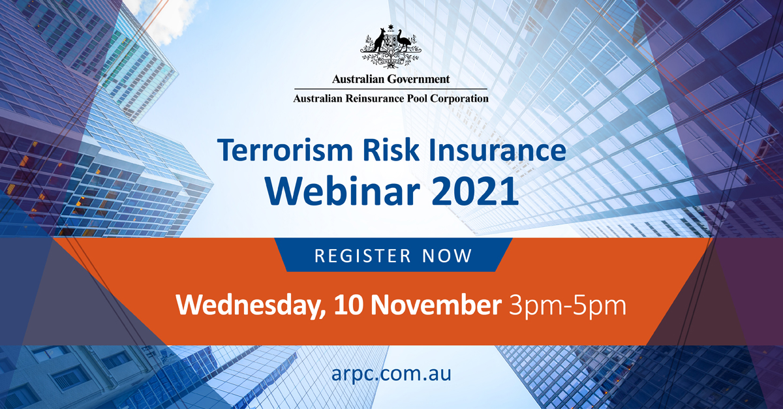
ARPC’s 10 November Terrorism Risk and Insurance Webinar featured highly qualified experts in terrorism risk and insurance, who identified current and emerging terrorism threats and how to mitigate them.
Over 135 individuals registered from across the insurance, reinsurance, modelling, consulting, and government sectors. Below is a summary of the speakers and topics:
- Introduction and welcome:
Speaker – Michael Pennell PSM, Chief Underwriting Officer, ARPC
Michael provided an update on ARPC and the latest terrorism statistics.
- Protection Gap Entities: What are they and why are they essential to terrorism insurance?
Speaker - Paula Jarzabkowski, Professor of Strategic Management, University of Queensland Business School. Paula explained why terrorism Protection Gap Entities (PGEs) such as pools differ from extreme weather PGEs, including knowledge and modelling challenges.
- An update on the Australian terrorism landscape
Speaker - Dr Derek Bopping, Director of SevenSpot Risk Consulting. Derek highlighted key themes in the Australian national security environment.
- An update on the global terrorism landscape
Speaker - Cory Davie, head of Control Risks, a specialist risk consultancy, for the Australia-Pacific region, gave an update on the global landscape.
ARPC commences research study on the evolving meaning of terrorism
ARPC has commenced a research study with the University of Queensland (UQ) Business School on the evolving experience and meaning of terrorism in Australia and internationally. The research study, the second in a series of ARPC/UQ thought leadership papers focused on terrorism, will research how formal definitions of terrorism might evolve over time as experience emerges with various forms of other extremist behaviour and civil unrest.
“Attacks such as mass shootings and knife attacks are occurring outside the extremism which underpinned the September 11 attacks in 2001,” said Professor Paula Jarzabkowski, who is leading the UQ research team on the project.
Dr Christopher Wallace, ARPC CEO, noted that while newer forms of attack and social unrest do not typically fit existing definitions of terrorism, they may still cause loss of life, disruption to business and society and financial losses and social unrest.
ARPC’s strategic priorities include extending thought leadership and expertise and embracing and evolving to a changing market environment – priorities which underpin our support for research like this on terrorism trends, Dr Wallace said.
The UQ Business School team on the research project comprises Professor Paula Jarzabkowski and research fellows Dr Corinne Unger and Dr Katie Meissner.

Publication of risk mitigation handbook with Standards Australia
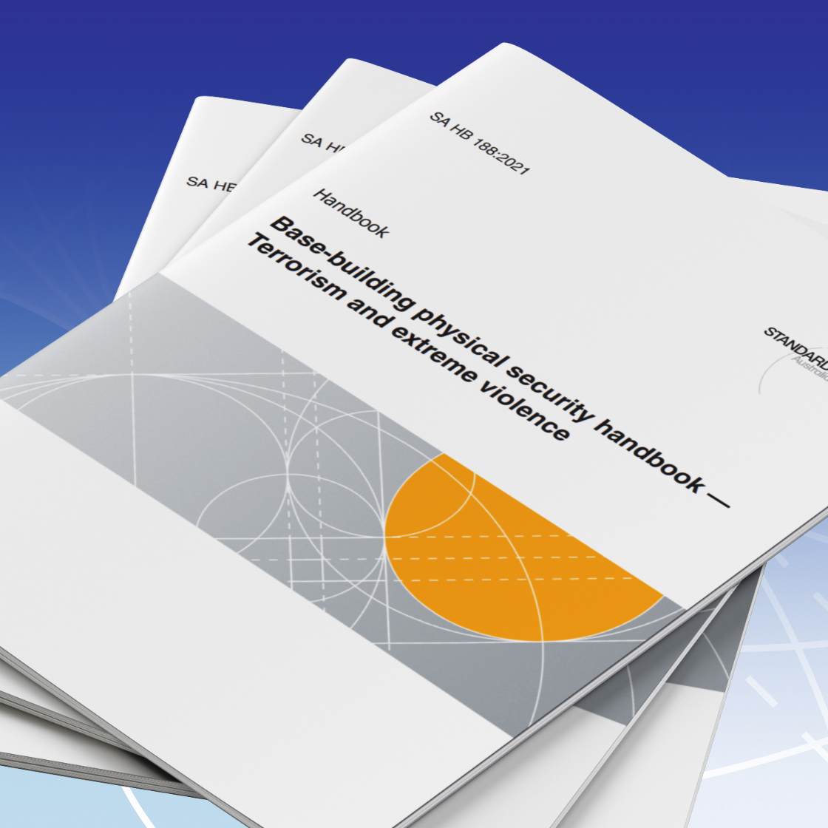
ARPC welcomes peak standards development body Standards Australia’s publication of the Physical Protective Security Controls for Buildings Handbook (HB-188). ARPC is the Project Proponent for HB-188.
The Handbook will help owners and operators of commercial buildings to identify and assess building risks linked to terrorism and other acts of extreme violence, and to apply suitable controls to mitigate the risks, said Dr Christopher Wallace, ARPC Chief Executive.
In 2018, ARPC submitted a proposal to Standards Australia for the development of a handbook to support proactive risk management of large-scale infrastructure (commercial buildings).
The Physical Protective Security Controls for Buildings Handbook (HB-188 supports ARPC’s strategic priority to extend thought leadership and expertise on terrorism, Dr Wallace said. “I sincerely thank all of our stakeholders who kindly assisted us in the Handbook process by providing content and reviews,” he said.
The draft Handbook was available for public comment for six weeks in 2020, allowing industry professionals, consultants, organisations, and other government bodies to provide feedback. ARPC also worked with ASIO Outreach - leaders in the field of protective security - to submit additional material for the Handbook.
The 85-page Handbook is on sale at Standards Australia. Hard copy and soft copy options are available for purchase online from Standards Australia Store and SAI Global.

IFTRIP President endorses award for terrorism research

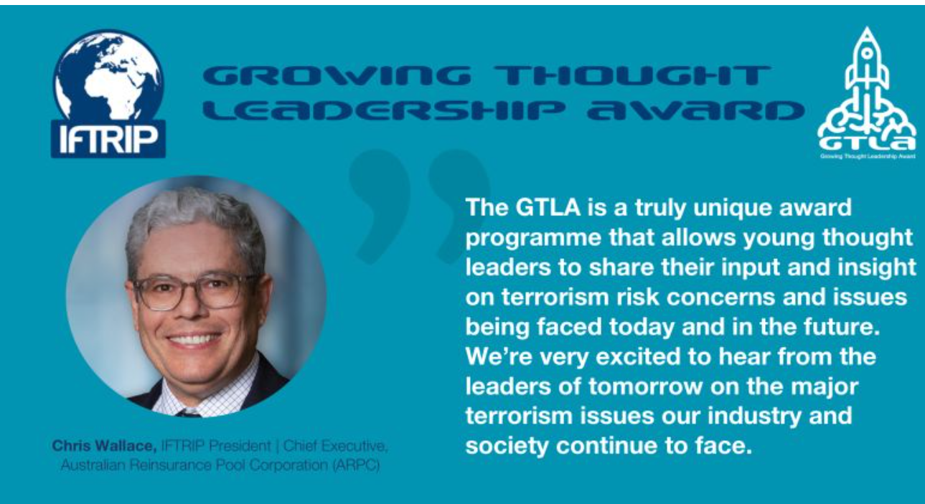

IFTRIP President and ARPC CEO Dr Christopher Wallace has endorsed the Growing Thought Leadership Award,
an international award program which provides a platform for motivated university students to showcase their ideas, insights, and observations with a global audience of industry professionals.

The GTLA is an initiative of IFTRIP, the International Forum of Terrorism Risk (Re)Insurance Pools.

The GTLA is open to undergraduate and post-graduate students worldwide aged between 18-30 years and will be awarded to the best original paper that presents an observational study or investigative research under one of the six terrorism-related topics:

- Cyberterrorism.
- Bioterrorism.
- Pandemic Insurance.
- Pooling Risks: Are There Opportunities to Expand this Insurance Model?
- Climate Change: From an insurance or a Terrorism Threat Perspective.
- Parametric Insurance: A Potential Solution for Difficult to Insure Risks.

There is a cash prize, mentoring and showcase rewards. Click the link below for more information.
GTLA web page

Premium Submissions due
Premium submissions are due by Monday, 31 January 2022 for the second quarter (1 October – 31 December) of the 2021-22 Financial Year. All premium submissions, including nil submissions, must be lodged.
The premium return template is available in RISe and must be used to submit all premium returns. If you have any questions, please contact enquiries@arpc.gov.au or phone +61 2 8223 6777.

Q. As an insurer customer (cedant) how can I update my client profile details?

A. Insurer customers can manage their profile and notify changes to ARPC in the “Manage Profile” section of RISe

