-
ARPC hosted its highly anticipated Cyber Terrorism Research & Insurance Webinar this month, proving digital channels can be just as interactive as ARPC’s pre-COVID seminars. I would like to thank all those who attended, including our international speakers, for an interesting and thought-provoking discussion on ARPC’s cyber terrorism research project, ‘Insurance Risk Assessment of Cyber Terrorism in Australia’.
In August, ARPC published its Corporate Plan which outlines our strategic priorities, key activities and projects, and how results will be measured over the 4-year period 2020-2024. The Corporate Plan is located on our website here.
In mid-October, ARPC will publish its 2019-20 Annual Report, which will report back on activities, projects and targets highlighted in the previous 2019-2023 Corporate Plan.
We are pleased to have been awarded Silver in the Australasian Reporting Awards (ARA) for ARPC’s 2018/19 Annual Report. These awards allow ARPC to benchmark our annual reports with world’s best practice in reporting. This is a true cross functional team effort, with particular credit to our finance and communications teams.
To our cedants, we thank you for your cooperation and patience with remote desktop reviews and aggregate submissions. Please find dates and submission information in the pages to follow.
Stay well.
SEPTEMBER 2020
Cyber Terrorism Research & Insurance Webinar
Australasian Reporting Awards: ARPC Wins Silver
Risk Mitigation Handbook
Corporate Plan & Annual Report
RISC Reimagined Course
Insights
Retention Information Due
Premium Submissions Due

Welcome to the Spring edition of our newsletter.

Cyber Terrorism Research & Insurance Webinar
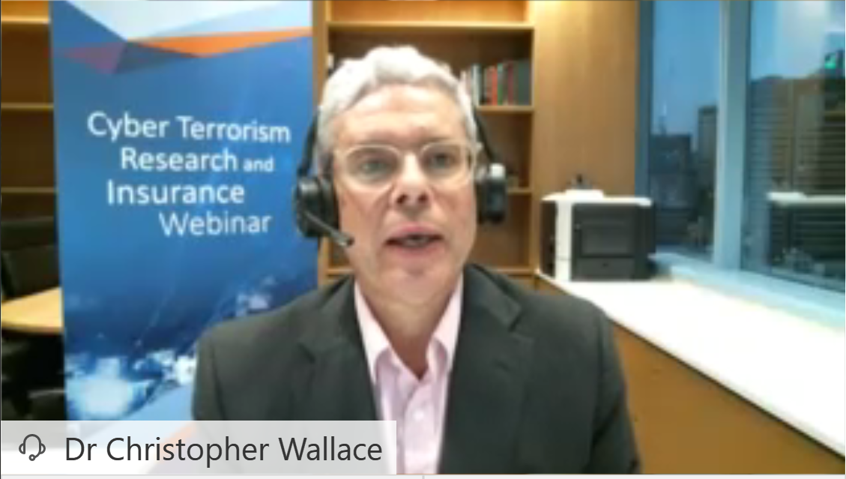
Thank you to all those who attended our Cyber Terrorism Research & Insurance Webinar on Thursday, 3 September. We were pleased to host approximately 135 attendees and were delighted with the positive feedback we received on the interactivity of the webinar, made possible by the open chat box, live polls, and discussion panel.

This is the first time ARPC has hosted a webinar. The general feedback highlighted the variety and credibility of the speakers, engaging content and efficient timing.
Missed the live event? Click here for a recording.
Attendees are eligible for 2 ANZIIF CIP points.

Australasian Reporting Awards: ARPC Wins Silver
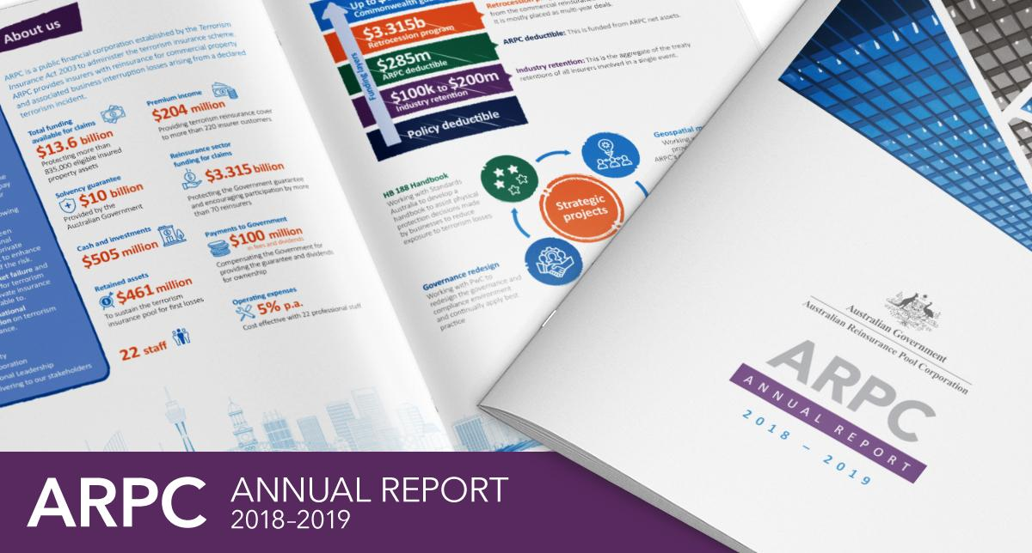
ARPC proudly accepted Silver in the 2019 Australasian Reporting Awards for our 2018-19 Annual Report. This result builds upon our 2018 Bronze award for the 2017/18 ARPC Annual Report, the first year we entered the awards.
The ARA Awards provide a great opportunity for ARPC to benchmark our annual reports against world best practice criteria and to receive constructive feedback and advice on how to improve future reports.

Risk Mitigation Handbook
In 2018, ARPC submitted a proposal to peak standards development body, Standards Australia, for the development of a handbook to support proactive risk management of large-scale infrastructure (commercial buildings).
The draft Handbook was opened for Public Comment for a period of six weeks spanning April and May 2020, which allowed various stakeholders including industry professionals, consultants, organisations and other government bodies, the opportunity to review the draft and provide feedback.
The draft was met with a high degree of interest by leaders in the field of protective security. ARPC has assisted in collating the extensive feedback received and worked with the experts to recommend significant revisions to the original draft.
Standards Australia is considering if it will accept these recommendations and revisions, which, if so, will extend the project into 2021. This will however result in a best practice document.
Furthermore, the working title of the Handbook has since been updated from Physical Protective Security Treatment for Buildings Handbook to Base-building Physical Security Handbook – Terrorism and Extreme Violence.
Upon its publication, ARPC will undertake a series of market presentations and seminars to promote industry integration of the recommendations contained within the Handbook.

Corporate Plan & Annual Report
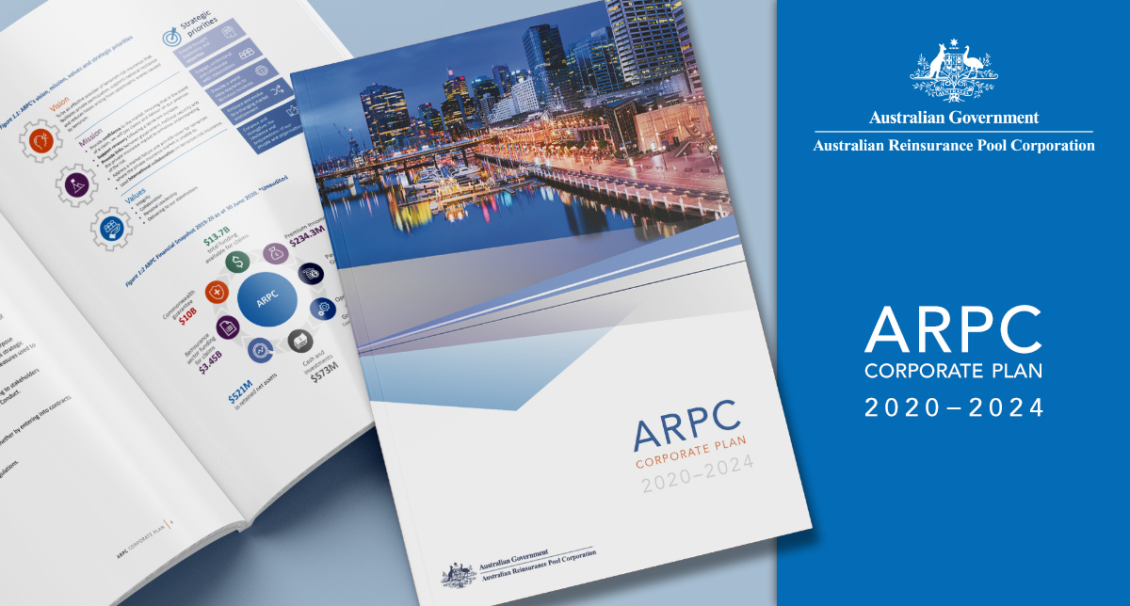
ARPC has published its 2020-2024 Corporate Plan which is the organisation’s primary planning document. The document sets out key activities and explains how performance will be measured and assessed over four reporting periods.
Work on ARPC’s 2019/20 Annual Report is well underway. ARPC’s Annual Report will outline ARPC’s strategy, progress on recent projects and initiatives, and our financial performance in the previous financial year.
View our Corporate Plan here.

ANZIIF RISC Reimagined 2020
ARPC Chief Underwriting Officer, Mike Pennell PSM will be guest lecturing at ANZIIF’s Reinsurance International Study Course (RISC), presented by leading industry experts from 12 October – 6 November.
Traditionally a three-day, face to-face course, this year RISC Reimagined comprises 10 hours of virtual presentations taking place over four weeks. Syndicates will be asked to digest a case study on a fictional insurance organisation and then address the related questions and learning outcomes.
Michael Pennell PSM, ARPC Chief Underwriting Officer
ARPC is proud to be a portfolio sponsor of the course. Potential candidates can enrol here.

ARPC calls for clarity on ‘computer crime’ exclusion in Terrorism Insurance Act 2003

The ‘computer crime’ exclusion in the Terrorism Insurance Act 2003 can have the effect of removing cover for physical property damage and business interruption from acts of cyber terrorism, Dr Christopher Wallace, ARPC CEO, told delegates at the 3 September ARPC Cyber Research and Insurance Webinar. ARPC believes the term ‘computer crime’ should be clarified in future reviews of the ARPC scheme. The research ARPC undertook with OECD and Cambridge Centre for Risk Studies, presented at the webinar, will also inform those reviews. ARPC will explain its position on computer crime further in a special issue of UTC.
‘Cyber War and Terrorism: Towards a common language to promote insurability’
Dr Christopher Wallace, ARPC CEO

A new joint report by the International Forum for Terrorism Reinsurance Pools (IFTRIP), the UK’s terrorism pool, Pool Re, and the Geneva Association, proposes a new term, ‘Hostile Cyber Activity’ (HCA), to describe potential malicious behaviour that sits between terrorism and warfare.
Read the full report here.

Masterclass: ‘Pandemic and Insurance’
In this masterclass, Professor Paula Jarzabkowski, Professor of Strategic Management at the Cass Business School, City University of London, explores the implications of the COVID-19 pandemic for future insurance coverage, including public/private risk-sharing mechanisms. Professor Jarzabkowski is an expert in (re)insurance markets. View it here.

Retention Information is Due
ARPC would like to remind insurer customers that they are required to submit Gross Written Premium (GWP) information for the 2020-21 Financial Year. The GWP submission was due on 31 August 2020 for non-APRA registered insurers and will be due on 30 September 2020 for APRA-registered insurers. This submission will set each insurer’s retention for the current retention period (which aligns with the Australian financial year).
Failure to meet these deadlines means the default retention of $12.5 million will apply. The Fire and Industrial Special Risks (ISR) GWP reporting applies to all eligible and ineligible Fire and ISR policies, not just those already reported through quarterly premium returns. For APRA-registered insurers, this figure will be the same as that reported to APRA (GRF 310.1), which is also due on 30 September each year. If you are experiencing difficulties using ARPC’s RISe system, please refer to our website for the online manual here or contact ARPC at enquiries@arpc.gov.au or phone +61 2 8223 6777.

Premium Submissions Due
Premium submissions are due by 30 October for the first quarter (1 July – 30 September) of the 2020-21 Financial Year. All premium submissions, including nil submissions, must be lodged. The premium return template is available in RISe and must be used to submit all premium returns. If you have any questions, please contact enquiries@arpc.gov.au or phone +61 2 8223 6777.
RISe login here.

Q: Are cedants required to include sub-limits in the Annual Aggregate Report?
Examples of sub-limits include: Fire Removal of Debris, and Fire Rewriting of Records; and Business Interruption such as BI Total Limit of Liability, BI AICOW, BI Claims Preparation Costs, BI O/S Accts Receivable, BI Rent Receivable.
A: Cedants are not required to submit building sub-limits or BI sub-limits in the Annual Aggregate Report.

