Welcome to the Winter edition of our newsletter. In these uncertain times, I would like to extend my gratitude to our insurer customers and stakeholders who have so quickly responded to the ‘new normal’ of virtual desktop cedant reviews and stakeholder meetings.
I am pleased to welcome the Government’s reappointment of Ian Carson AM as ARPC Chair, Robin Low as Member and the appointment of Maria Fernandez PSM as a new Member. Maria has extensive Government experience and a deep understanding of the terrorism threat. ARPC is fortunate to be able to attract and retain such high calibre Board members.
ARPC has launched the first in a series of new website designs, a project which will significantly enhance our communication with customers and stakeholders.
Work on the HB-188 Handbook with Standards Australia is progressing well. Following the Public Comment phase and the integration of feedback into the draft, ARPC will plan a launch of the Handbook to insurers and property owners.
Despite the difficulties presented to us during this time, ARPC remains well-positioned to deliver on its purpose in the event of a Declared Terrorism Incident.

JUNE 2020
ARPC Welcomes New Board Appointments
HB-188 Nears Completion
Gaps Paper
Website Refresh
Virtual Desktop Reviews
IFTRIP 2020
Annual Report & Corporate Plan
Cyber Terrorism & Insurance Seminar
Reports & Premium Submissions
Q&A

Welcome to the Winter edition of our newsletter.

ARPC Board Appointments Update
Maria Fernandez PSM
Robin Low
Ian Carson AM
ARPC has welcomed the reappointment of Ian Carson AM as ARPC Chair for a further three-year term. Ian brings strong and continuing leadership for ARPC and our stakeholders.
The Government has also announced the reappointment of Robin Low for three years, and the appointment of Maria Fernandez PSM as a new Member. Maria is an eminent leader with a distinguished career in the public sector. Her experience also includes the cyber threat environment through an earlier role as Deputy Director Intelligence at the Australian Signals Directorate.

HB-188 Handbook Nearing Completion
Work on the ‘HB 188: Physical Protective Security Controls for Buildings’ has gained momentum in recent months, with the draft Handbook receiving significant feedback from various stakeholders and other government bodies in April and May.
Standards Australia’s Drafting Committee is conducting meetings throughout June to consider feedback received during the Public Comment phase.
It is expected the Handbook will be published next year. Following publication, ARPC will contact key stakeholders to arrange meetings. There will also be general market presentations on the Handbook.
The Handbook will provide guidance to owners and operators of commercial buildings to identify and assess sources of building risk associated with terrorism and other deliberate acts of violence (such as civil unrest and commotion), and implement suitable controls to mitigate such risk.

ARPC Commissions Paper on Insurance Gaps

ARPC has initiated the development of a research paper with the University of Queensland on insurance market gaps in relation to terrorism.

The research paper will be developed by Paula Jarzabkowski (pictured), a Professor of Strategic Management at the University of Queensland.

Professor Jarzabkowski is an expert in insurance and reinsurance markets, having led international teams in studying different aspects of the global industry. She has published industry reports, academic papers and a book ‘Making a Market for Acts of God’ with Oxford University Press in 2015. Her current research (aside from the project with ARPC) examines how governments and markets are working to address natural and man-made disasters.

The ARPC paper, which is titled: ‘Analysis of identified gaps in Australia’s Terrorism Environment, Thought Leadership Paper’, will be published soon.

The project with Professor Jarzabkowski and the University of Queensland accords with ARPC’s strategic priorities which include: extend thought leadership and expertise, and provide a world class response to terrorism incidents.

Website Refresh
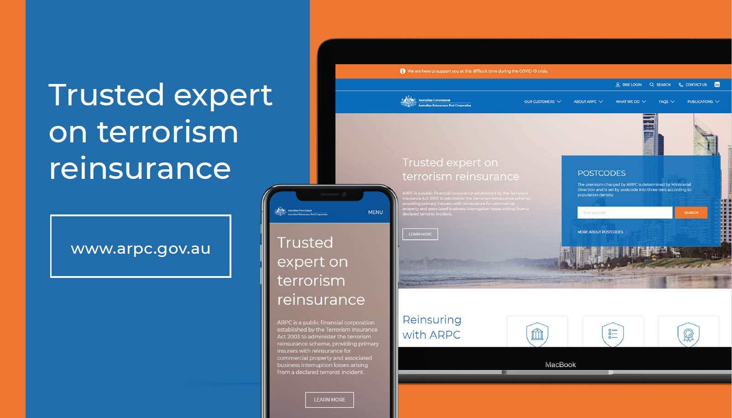
ARPC has launched the first in a series of new website designs. The new look website is designed to optimise the user journeys of our insurer customers and Government stakeholders, providing easier access to postcodes, premium submission platform RISe, as well as news, regular publications and research reports.
Over the coming months, ARPC will embark on further enhancements to improve archiving and backend functions. We expect that a more contemporary site will greatly enhance the experiences of our customers and stakeholders. A more refined layout will also give better visibility to project updates, any postcode changes and important event information.
Take a look around: http://arpc.gov.au/

A Smooth Transition to Desktop Reviews
ARPC has completed a number of virtual desktop cedant reviews over the past few weeks, with our normal procedure slightly amended to give our customers more flexibility during this time. We understand COVID-19 has brought challenges for many businesses, and our Insurance Audit team remain dedicated to extending the review periods wherever necessary.
ARPC will advise customers when face-to-face desktop reviews will again take place. In the meantime, we appreciate your responsiveness to this new ‘business as usual’.

IFTRIP
The International Forum of Terrorism Risk (Re)Insurance Pools (IFTRIP) annual conference has been rescheduled tentatively to 13-14 October in Washington DC. As you may be aware, the Conference was postponed due to the COVID-19 Pandemic.
IFTRIP 2020 is a two-day global event for those either working in, or advising on, terrorism (re) insurance and risk. The main Conference brings together sovereign-backed terrorism reinsurance pools, industry experts and the wider counter-terrorism community.
The Conference is designed to facilitate conversations around the ‘big questions’ in the terrorism risk industry. IFTRIP coordinates and contributes to international and cross-sectoral working groups on a variety of topical issues, from cyber terrorism to the definition of terrorism.

For more information, please go to: https://iftrip.org/

Annual Report & Corporate Plan

Work has commenced on our Corporate Plan which is required under the Public Governance, Performance and Accountability Act 2013 (PGPA Act) and must be published by 31 August each year.

Preparation has also begun on our 2019-20 Annual Report to be published at the end of October, 2020.

Cyber Terrorism Research and Insurance Seminar

As you may be aware, ARPC’s Cyber Terrorism Research & Insurance Seminar has been rescheduled, with a new date to be announced soon. At the Seminar/Webinar, ARPC plans to launch the completed cyber terrorism research project which ARPC undertook with the Organisation for Economic Cooperation and Development and Cambridge Centre for Risk Studies at the University of Cambridge’s Judge Business School.

The research paper, which has been compiled in an A4 Compendium, is available in the interim by filling in a digital form on our website.

Reports Due
30 June is the end of the financial year, meaning various reports are due to be submitted to ARPC. The table below highlights the reports due in the next three months.
What’s Due | Due Date
Premium reports and payments for the period ending 30 June | 30 July 2020
Annual aggregate reports as at 30 June | 30 August 2020
Annual gross written premium declarations | 30 September 2020

Annual Aggregate Exposure Reports
The annual aggregate reports are a snapshot as at 30 June and are due by 30 August each year. When compiling these reports, please note:
- For ‘all risks ex construction works’, we require clients to split sums insured between the building and contents components. Clients should not be entering amounts in the combined building and contents column amounts without contacting ARPC.
- Policies without a building risk, i.e. contents and/or business interruption only policies, should not be included in the ‘all risks ex construction works’ worksheet but should be included in the ‘Street Address’ worksheet. Street address data is required for the following major postcodes within tier A locations:
- 2000 in Sydney
- 3000 in Melbourne
- 4000 in Brisbane
- 5000 in Adelaide
- 6000 in Perth
Business interruption and contents risks (even if not linked to a building) are to be included in the ‘Street Address’ worksheet.
When submitting your annual aggregate return, RISe will compare this year’s submission with last year’s. If there is a variance greater than 10 per cent, you will be asked to review your submission or explain the reason for the change in exposure.
To submit your annual aggregate exposure report, please log into http://rise.arpc.gov.au and click on ‘download templates’.
For further instructions please refer to page 29 of the RISe User Manual. If you have any questions please contact enquiries@arpc.gov.au or call +61 2 8223 6777.

Can ARPC provide advice on the interpretation or application of the Terrorism Insurance Act 2003 (i.e. advise if a policy is eligible or not)?
ARPC does not provide legal advice to insurers (or the public) in relation to the interpretation, construction or application of the Act. ARPC provides general information on its website, in its publications and through its dealings with insurers about the Act, the regulations made pursuant to the Act, and ARPC’s Reinsurance Agreement for Terrorism Risks.
That information does not constitute legal advice.
When in doubt, insurers dealing with or proposing to deal with ARPC should obtain their own legal advice, if that is considered necessary, for the purpose of making decisions.

