DECEMBER 2018
ARPC held its annual Terrorism Risk Insurance Seminar at NSW Parliament House last month, which attracted nearly 90 delegates from the insurance industry and government.
ASIO’s Business and Government Liaison Unit, OECD’s policy analyst Leigh Wolfrom and the Australian Strategic Policy Institute’s Anthony Bergin, gave excellent and well received presentations.
Chief Underwriting Officer Michael Pennell and I have recently returned from ARPC’s annual retrocession trip where we met with reinsurers in key overseas markets and negotiated the renewal of ARPC’s retrocession program. The 2019 program terms will be finalised shortly. We are grateful for the support of our global panel of almost 65 reinsurers.
In October, I attended the International Forum for Terrorism Risk (Re) Insurance Pools (IFTRIP) annual conference in Moscow, Russia, with more than 200 global insurance industry professionals. IFTRIP is a valuable forum for global terrorism pools to share knowledge and expertise. Topics included the economic cost of terrorism, new threats and emerging gaps, insuring and reinsuring terrorism risks, and sabotage, political violence and cyber risks.
ARPC has published its Annual Report for the 2017-18 financial year which is available on our website here.

OECD analyst visits Sydney for ARPC Seminar
ARPC Terrorism Risk Insurance Seminar highlights
ARPC commences cyber terrorism research study
ARPC welcomes 2018 Triennial Review report
ARPC welcomes ANAO performance audit
Premium submissions due
Postcode update
Q&A

Welcome to the Summer edition of our newsletter.

OECD analyst visits Sydney for ARPC Seminar
In late November, ARPC hosted Paris-based OECD analyst Leigh Wolfrom to meet insurers and government agencies and begin industry discussions in support of ARPC’s cyber terrorism research project.
Discussions focused on the cyber risks which are currently covered (including terrorism), types of policies available (such as stand-alone cyber policies and property policies), and the influence of reinsurance.
As previously announced, ARPC has commenced a research study on the threat of cyber terrorism in Australia. This includes the nature and cost of physical damage to commercial property (including business interruption) which may be caused by acts of cyber terrorism.
Mr Wolfrom also addressed the ARPC Terrorism Risk Insurance Seminar on 29 November as a keynote speaker on cyber risks, including terrorism, as well as insurance coverage wordings on these risks in cyber policies and property policies.

ARPC Terrorism Risk Insurance Seminar highlights
ARPC hosted its third Terrorism Risk Insurance Seminar at NSW Parliament House in November, with nearly 90 delegates in attendance.

The Director of ASIO’s Business and Government Liaison Unit gave the opening presentation, which provided valuable insights about the Australian counterterrorism environment.

Dr Anthony Bergin, senior policy analyst at the Australian Strategic Policy Institute (ASPI), presented a recent ASPI report titled Safety in Numbers: Australia’s private security guard force and counterterrorism.

Dr Bergin discussed barriers that block the sector from being an active participant in national counterterrorist plans. He recommended the establishment of a security industry authority in Australia to overcome these issues.

Leigh Wolfrom, OECD analyst, outlined the cyber terrorism threat and examined the availability of insurance coverage for cyber terrorism in Australian and international insurance markets.

ARPC would like to thank all Seminar attendees for their support. We have distributed a feedback survey, the results of which will assist us to organise another great event next year.

If you would like to be sent a Save the Date before our events, please email events@arpc.gov.au.

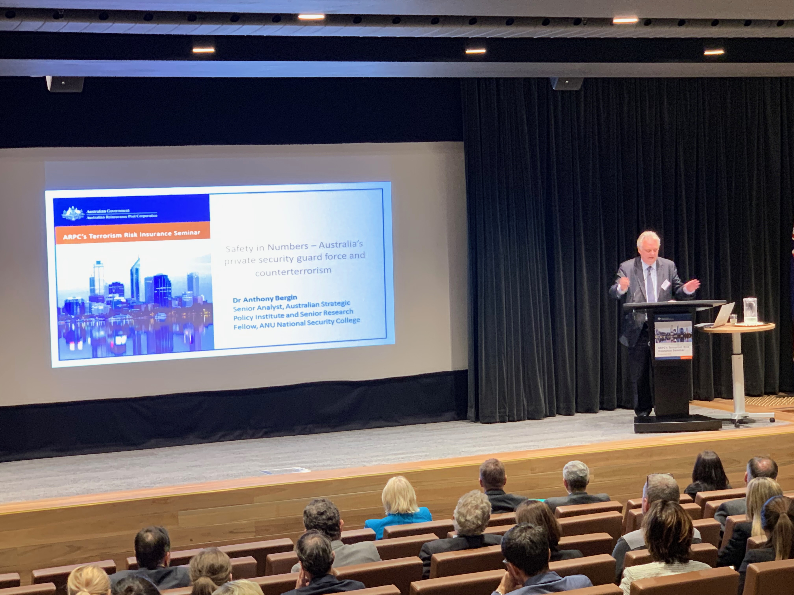
Dr Anthony Bergin, policy analyst from the Australian Strategic Policy Institute and ANU presenting at the ARPC Seminar

ARPC commences cyber terrorism research study
ARPC has commissioned Cambridge Centre for Risk Studies, based at the University of Cambridge in the United Kingdom, and the Organisation for Economic Co-operation and Development, based in France, to undertake a research study with ARPC on the threat of cyber terrorism in Australia.
The 12-month research study, titled ‘Insurance risk assessment of cyber terrorism in Australia’ will identify and explore current prospective threats, plausible scenarios as well as the practicalities of extending insurance coverage to include cyber terrorism in Australia.
Business insurance policies and the ARPC scheme currently exclude coverage for acts of cyber terrorism which affect commercial and high value residential property in Australia.
ARPC expects the cyber research study findings to inform development of government policy in this important area.
For more information, read the full media release here.

ARPC welcomes the 2018 Triennial Review report
ARPC has welcomed the final report of the 2018 Triennial Review into the Terrorism Insurance Act 2003 (TI Act), released this month by the Treasury.
In the 2018 Triennial Review of the TI Act, the Treasury has recommended that ARPC continue to provide terrorism re/insurance covering the Australian commercial and high value residential property market.
This is good news for the Australian business sector, the insurance industry and the broader Australian economy, which would rely on this coverage to recover from the effects of a Declared Terrorist Incident.
The full list of recommendations and findings are:
Recommendation 1: That the Act remains in force.
Recommendation 2: That the ARPC pays an additional temporary dividend of $10 million a year for three years commencing in 2018-19 and terminating in 2020-21, with the Government to consider again the appropriate level of payments when this dividend ceases.
Recommendation 3: The current structure of pricing for the range of risks currently covered by the Act and the approach to declaring a terrorism incident remains appropriate.
Finding 1: Cyber terrorism is an emerging risk and there is yet to be a clear and evident market failure in relation to physical property damage from cyber terrorism requiring government intervention through the Act at this time.
Finding 2: Coverage is broad for domestic terrorism incidents causing death or serious injury to Australians. There is an array of government schemes under which they could claim some form of compensation or funding, depending on their circumstances. There are also widely available insurance products that do not contain exclusions for terrorism incidents.
Please read ARPC’s full media release in response to the 2018 Triennial Review Report on our website here.

ARPC welcomes ANAO Performance Audit
ARPC has welcomed the terms of reference for the 2018 Performance Audit: Management of the Terrorism Reinsurance Scheme, being undertaken by the Australian National Audit Office (ANAO).
The objective of ANAO’s audit of ARPC is to assess the effectiveness of ARPC’s management of the terrorism reinsurance scheme.
The ANAO proposes to examine for ARPC:
- Are there processes in place that support the effective management of the scheme?
- Do governance arrangements enable effective oversight and management of the scheme?
The final report on ARPC is expected to be tabled in Parliament in June 2019.
For more information, or to make a contribution, please visit the ANAO website here.

Premium Submissions due
Premium submissions for the second quarter (1 October – 31 December) of the 2018-19 Financial Year are due on 30 January 2019. All premium submissions, including nil submissions, must be lodged.
To submit a premium please log into http://arpc.gov.au/our-customers/rise-login and select ‘download templates’. For further instructions, please refer to page 27 of the RISe Cedant User Manual here.
If you have any questions, please contact enquiries@arpc.gov.au, or call +61 2 8223 6777.

Q Why are cedants required to submit a street address details report as part of their annual aggregate submissions and what do we do with this information?
A Cedants are required to submit street address details for insured risks located in the 2000, 3000, 4000, 5000, and 6000 postcodes so that we can more accurately model and assess risks in high-risk locations and verify the location of the risks. We do this by comparing street address details provided in annual aggregate submissions with Good Maps street address and postcode data.

Postcode update

There are no updates in this edition.

