CONTENTS
1. EXECUTIVE SUMMARY 4
2. INTRODUCTION 8
Background 9
Purpose 10
Vision 10
Mission 10
Strategic priorities 10
Key performance areas 11
Scheme structure 12
3. ENVIRONMENT 13
Market gaps 15
Pricing terrorism insurance 15
Purchasing retrocession 15
4. CAPABILITY 16
Delivering ARPC’s strategic priorities 19
Staff Capability 21
ARPC’s structure 21
ARPC’s values 23
5. RISK OVERSIGHT AND MANAGEMENT 24
Enterprise risk management framework 25
Risk appetite and tolerance statements 26
Legislative compliance 26
6. PERFORMANCE 27
Key Performance Indicator (KPI) detail 29

The Hon Josh Frydenberg MP
Treasurer of Australia
Parliament House
CANBERRA ACT 2600
Dear Treasurer
On behalf the Australian Reinsurance Pool Corporation (ARPC) Board, I am pleased to present you with the ARPC Corporate Plan for 2018 and beyond. This plan commences on 1 July 2018 and spans the four reporting periods to 30 June 2022.
This plan has been prepared in accordance with the Public Governance, Performance and Accountability Rule 2014. The plan has been approved by the Accountable Authority (the ARPC Board) as required under paragraphs 35(1) and 35(2) of the Public Governance, Performance and Accountability Act 2013.
In responding to ARPC’s functions under the Terrorism Insurance Act 2003, the Board and executive of ARPC undertake a strategic planning process each year to set the Corporation’s vision, mission, strategic priorities and values. The Corporate Plan is the principal planning document for ARPC and outlines the actions required for successful implementation of ARPC’s strategy. The plan also details key performance indicators to measure progress.
Should you have any questions or require further information please do not hesitate to contact me.
Yours sincerely
(signature supplied)

Ian Carson AM
Chair
cc Senator the Hon Mathias Cormann
Minister for Finance and the Public Service

Correspondence to: PO Box Q1432, Queen Victoria Building, NSW 1230
T +61 2 8223-6777 | F +61 2 9241-1887| E enquiries@arpc.gov.au
www.arpc.gov.au | ABN 7480713687

EXECUTIVE SUMMARY

EXECUTIVE SUMMARY
The 2018-2022 Corporate Plan is the primary planning document for the Australian Reinsurance Pool Corporation (ARPC) and addresses ARPC’s Purpose, Environment, Capability, Risk Oversight and Management and Performance.
The Plan also includes ARPC’s strategic priorities and the activities it will undertake to achieve those priorities together with the performance measures that will be used to determine success.
ARPC complies with the Terrorism Insurance Act 2003 (TI Act), the Public Governance, Performance and Accountability Act 2013 (PGPA Act) the Public Governance, Performance and Accountability Rule 2014 (PGPA Rule), along with other relevant legislation and operates in a changing environment that includes a dynamic global reinsurance market.
ARPC’s functions of corporation under section 10 of the TI Act are;
- to provide insurance cover for eligible terrorism losses (whether by entering into contracts or by other means); and
- any other functions that are prescribed by the regulations.
The key performance areas of ARPC to support its functions of corporation are:
- to provide reinsurance for eligible terrorism losses;
- to encourage private sector participation through the retrocession program;
- to compensate the Government; and
- to maintain financial sustainability and organisational resilience.
These key performance areas measure the delivery of ARPC’s strategic priorities to achieve its Vision and Mission for the coming period. See Figure 1.1.
Figure 1.2 provides an overview of the current strategic environment faced by ARPC and how it plans to respond in the coming period.

Figure 1.1 Vision, Mission and Strategic Priorities for the 2018-22 period
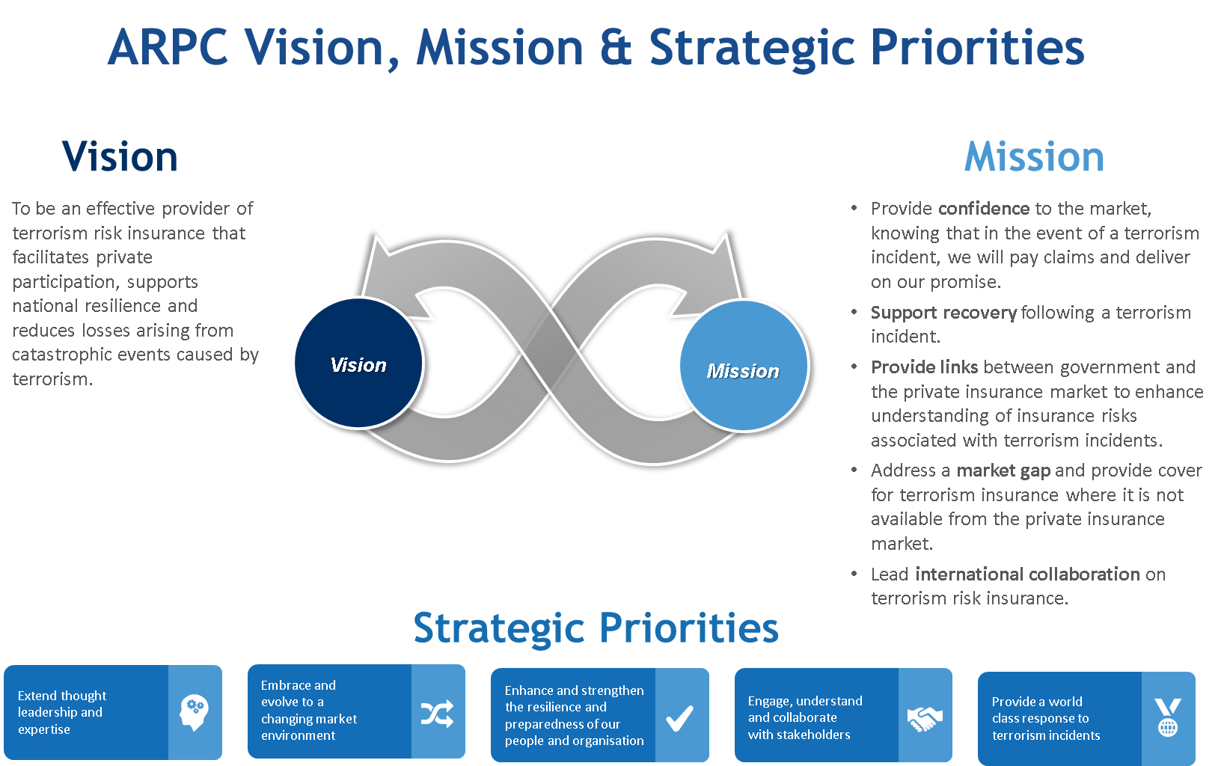
Figure 1.2: ARPC on a page
The following diagram outlines ARPC’s vision, strategic priorities, values, performance areas, risk and performance measures.
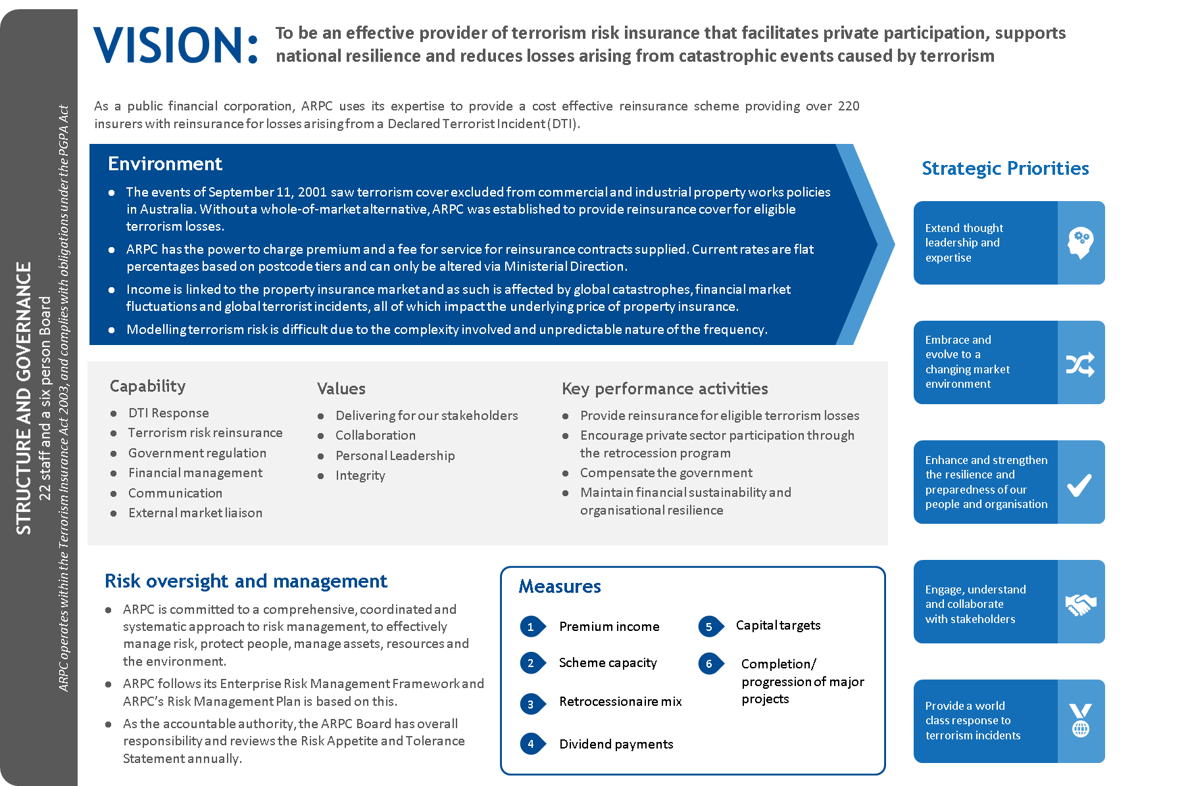

INTRODUCTION

INTRODUCTION

Background
ARPC is a Public Financial Corporation established in July 2003 under the TI Act to administer the terrorism insurance scheme. It was established following the terrorist attacks in the USA on 11 September 2001. After this incident, there was a global withdrawal of terrorism insurance, leaving commercial property in Australia uninsured against terrorist attacks. This gap in the market reduced access to project funding and commercial refinancing which threatened some sectors of the Australian economy.
In the event of a Declared Terrorist Incident (DTI), the TI Act renders terrorism exclusion clauses in eligible insurance contracts invalid in relation to loss or liabilities arising from the DTI. In such a situation, insurers remain liable for eligible losses to insured property assets as a result of the DTI. Insurers can choose to retain the liability they carry for the risk of terrorism losses themselves, reinsure the risk through the private reinsurance sector, or reinsure eligible insurance contracts with ARPC.
ARPC provides cost effective reinsurance and has $13.4 billion in total funding available for claims arising from a DTI, protecting more than 830,000 eligible insured property assets valued at over $3.6 trillion nationwide. Through the purchase of a global retrocession program, ARPC enables risk sharing where there is inadequate terrorism insurance capacity in the Australian commercial market.
Additional information can be found on the ARPC website www.arpc.gov.au
ARPC’s functions of corporation under section 10 of the TI Act are;
- to provide insurance cover for eligible terrorism losses (whether by entering into contracts or by other means); and
- any other functions that are prescribed by the regulations.
The TI Act states that the Corporation has the power to do everything necessary or convenient to be done for, or in connection with, the performance of its functions, including:
- the power to charge premiums in respect of contracts of insurance for which it is the insurer; and
- the power to charge fees for services that it provides in connection with the performance of its functions.
The premiums that ARPC can charge its insurers are set by Ministerial Direction.

Purpose
ARPC’s purpose is expressed through its Vision and Mission, an update of which was approved by the ARPC Board in May 2018.

Vision
To be an effective provider of terrorism risk insurance that facilitates private participation, supports national resilience and reduces losses arising from catastrophic events caused by terrorism.

Mission
- Provide confidence to the market, knowing that in the event of a terrorism incident, we will pay claims and deliver on our promises.
- Support recovery following a terrorism incident.
- Provide links between government and the private insurance market to enhance the understanding of insurance risks associated with terrorism incidents.
- Address a market gap and provide terrorism insurance cover where it is not available from the private insurance market.
- Lead international collaboration on terrorism risk insurance.

Strategic priorities
ARPC’s strategic priorities based on current business objectives include:
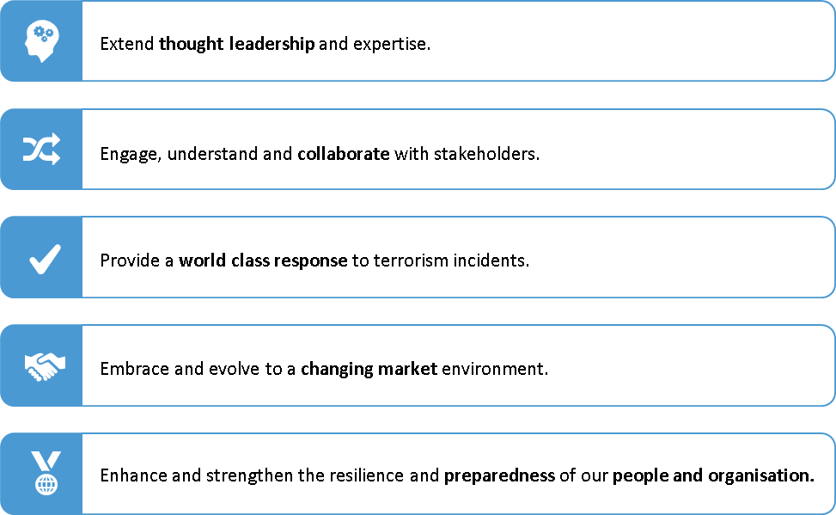

Key performance areas
The key performance areas of ARPC to measure delivery of ARPC’s strategic priorities which support the functions of corporation (as outlined in Section 1, Executive Summary) are:
- to provide reinsurance for eligible terrorism losses;
- to encourage private sector participation through the retrocession program;
- to compensate the Government; and
- to maintain financial sustainability and organisational resilience.

Towards achieving its objectives, ARPC monitors several key metrics covering its four key performance areas. Figure 2.1 illustrates these as at June 2018.

Figure 2.1: ARPC snapshot 2017-18*
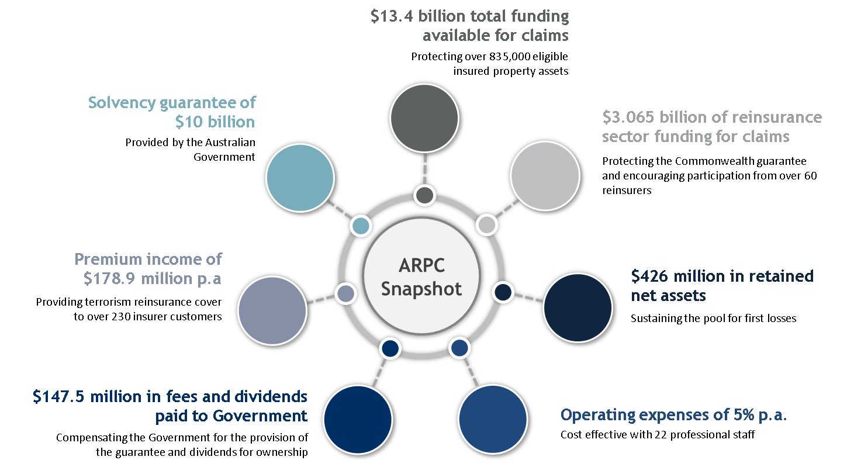
*as at 30 June 2018

Scheme structure
ARPC provides significant reinsurance capacity to insurer clients with $13.4 billion reinsurance cover available in the event of a DTI. Total capacity comprises: insurer or industry retentions; ARPC net assets; retrocession reinsurance (private cover ARPC has purchased from reinsurers) and the Commonwealth guarantee. In the 2018 calendar year, ARPC purchased a $3.065 billion retrocession reinsurance program. Although the maximum amount of funds available to pay claims is $13.4 billion, the insurers who have cover with ARPC in total insure approximately $3.6 trillion in Australian-based commercial property sector assets by sum insured value, up from $3.4 trillion in 2017.
ARPC also increased private reinsurance sector participation in the scheme by lowering the retrocession deductible from $350 million to $285 million. This meant a greater level of capacity was able to be provided by the reinsurance market.

Figure 2.2: ARPC Scheme Structure
This graphic illustrates the funding layers of the ARPC scheme structure.
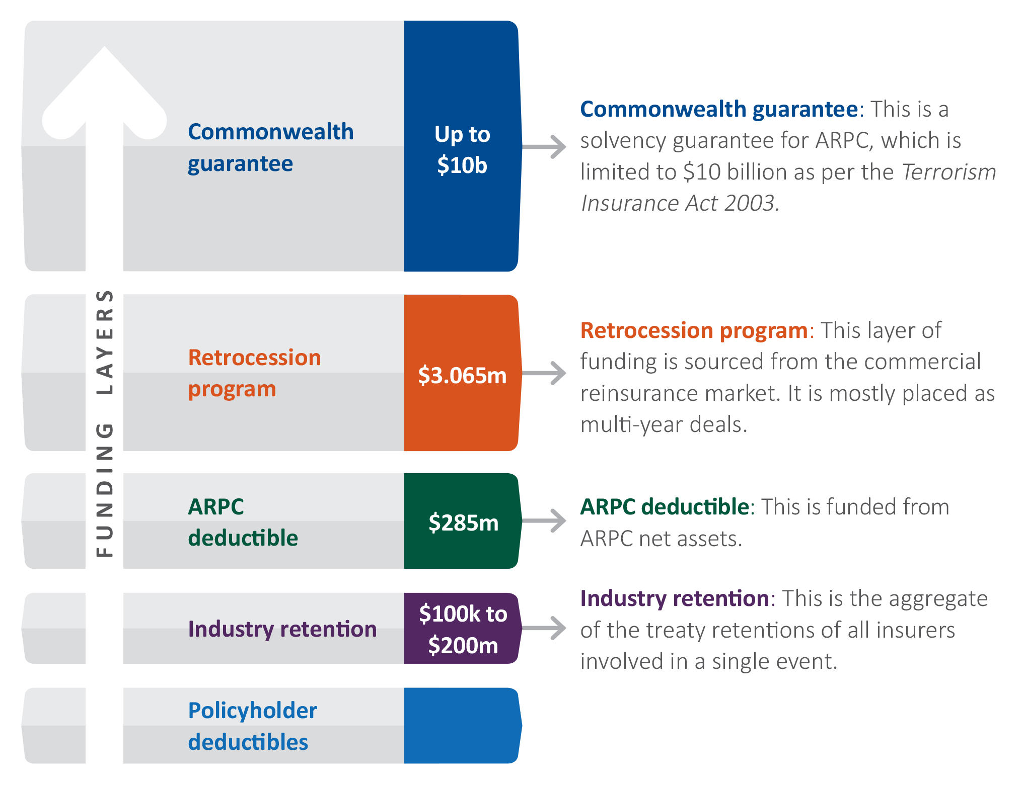

ENVIRONMENT

ENVIRONMENT
ARPC operates in a changing environment and provides funding for eligible terrorism losses arising from declared terrorism incident. The globally available reinsurance capacity for Australia for terrorism losses is approximately $4 billion. See Figure 3.1 below for a pictorial view of ARPC’s environment.
Figure 3.1: ARPC’s Environment
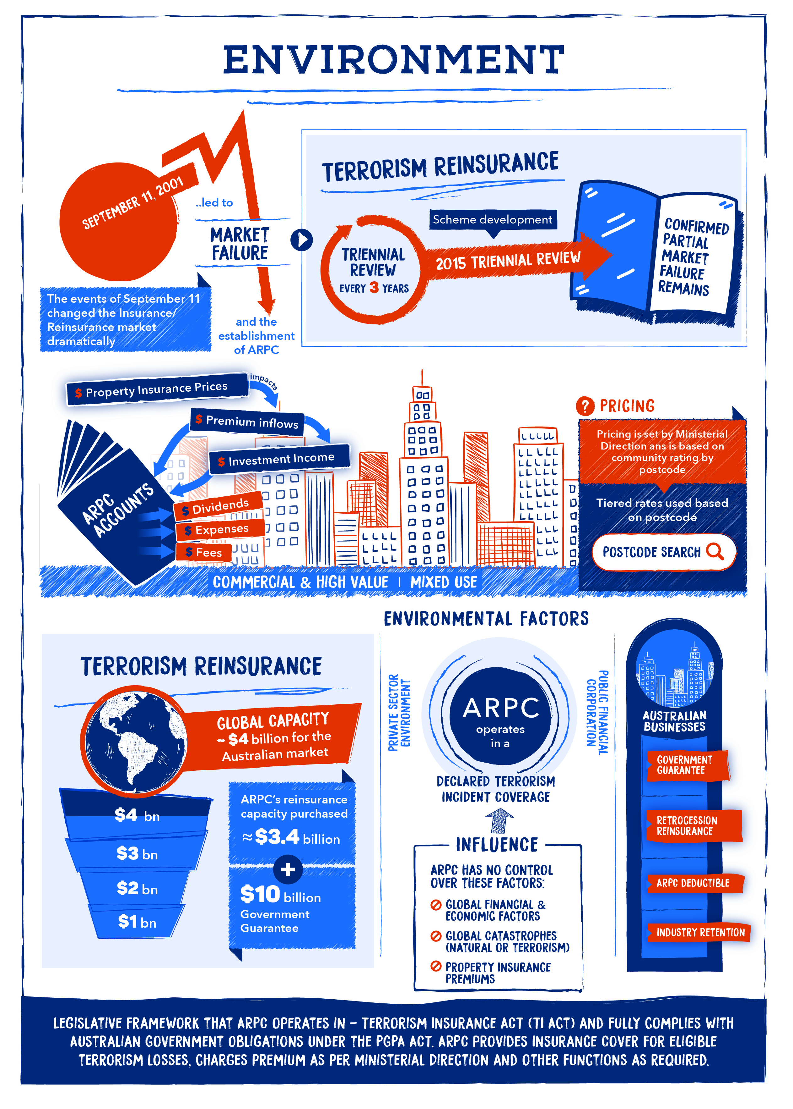

Market gaps
ARPC was established to address market gaps in the terrorism risk insurance market for Australian commercial properties. The 2015 Terrorism Insurance Act Review (the Triennial Review), considered the availability of reinsurance for terrorism risk in detail and concluded that there remains no whole-of-market, sustainable, alternative provider of reasonably priced terrorism reinsurance, and therefore, market gaps still exist.

Pricing terrorism insurance
ARPC is a Public Financial Corporation operating in a private sector environment that is subject to global economic factors. There are often events outside of ARPC’s control that can significantly impact the organisation’s financial sustainability and resilience.
ARPC’s premium rates for terrorism reinsurance are based on community rating by postcode and are set by Ministerial Direction. It is impossible to predict the probability of a terrorist attack, making pricing very difficult. Claims from a terrorism incident could also be very large in scale. ARPC’s pricing is based on population density and is split into city, suburban and other area tiers.
The link between Australian terrorism risk insurance and commercial property insurance premiums leaves ARPC exposed to pricing shifts associated with global catastrophes, financial market fluctuations and terrorist incidents both in Australia and abroad.
Over the past twelve months, ARPC has experienced increased underlying premiums in commercial property insurance, leading to increased premium income for ARPC. This is the first year in the past five years where insurance premiums are predicted to remain relatively stable in the coming period.
All ARPC’s operations are funded (including retrocession premiums and fee and dividend payments to government) from premium income received from insurers and investment income. A fixed percentage of insurers’ premiums is charged and, as a result, premium income is linked to insurer price fluctuations. Additionally, tier rates are based on the applicable postcode of each commercial property and can only be amended through a Ministerial Direction.

Purchasing retrocession
Since 2009, ARPC has placed an annual retrocession program to provide a valuable funding source for rebuilding Australian commercial infrastructure in the event of a major terrorist attack, and to reduce the risk to Government that ARPC will need to draw on the Commonwealth guarantee.

CAPABILITY

CAPABILITY
ARPC’s capability is guided by its strategic priorities and core competencies. ARPC’s strategic priorities support its purpose and are based on current business objectives.

STRATEGIC PRIORITIES
The Strategic Priorities are to:
To deliver against the five strategic priorities and on the original objectives set out under the TI Act, ARPC has several key performance areas. A summary of these key performance areas (KPIs) can be seen in Figure 4.1 with additional detail available in Figure 4.2. Measures against each KPI can be found in Section 6, Performance.

Figure 4.1: Corporate Plan – key performance area detail
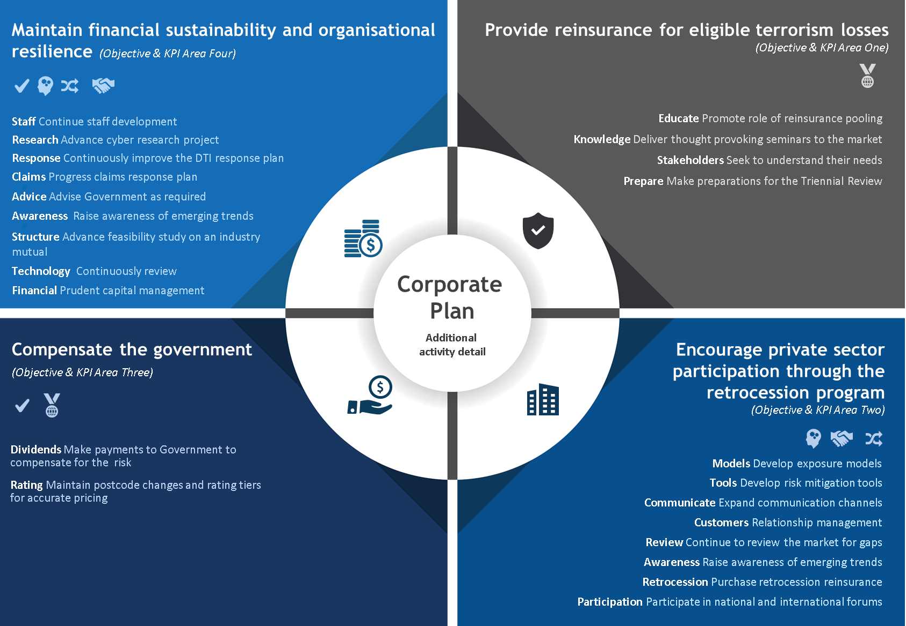

Delivering ARPC’s strategic priorities
ARPC’s key performance areas to measure delivery of strategic priorities to support the functions of corporation are:
- KPI Area One - to provide reinsurance for eligible terrorism losses;
- KPI Area Two - to encourage private sector participation through the retrocession program;
- KPI Area Three - to compensate the Government; and
- KPI Area Four - to maintain financial sustainability and organisational resilience.

Figure 4.2: Mapping of strategic priorities against activities/deliverables
Strategic priority | 2018-2022 Activities / Deliverables
Extend thought leadership and expertise | - Progress risk mitigation work with Standards Australia to develop a risk mitigation Handbook for business *(KPI Area Two)  - Prepare for the 2018 and 2021 Triennial review of the scheme by the Treasury. *(KPI Area One)  - Provide advice to Government as required as a trusted advisor on Terrorism Risk Insurance. *(KPI Area Four)  - Continue to raise awareness of emerging terrorism risks, such as cyber terrorism. *(KPI Area Four)  - Continually review, identify and inform the market about potential gaps in cover. *(KPI Area Two)
Engage, understand and collaborate with stakeholders | - Enhance stakeholders’ understanding of the role of terrorism reinsurance pooling. *(KPI Area One)  - Extend the stakeholder engagement plan to deepen relationships and better understand stakeholder needs. *(KPI Area One)  - Deliver the annual Terrorism Risk Insurance Seminar to drive additional understanding and introduce new and emerging trends. *(KPI Area One)  - Participate in national and international forums on terrorism risk insurance and catastrophe insurance and financing. (KPI Area Two)  - Participate in discussions on terrorism risk with Australian government departments. *(KPI Area Four)  - Participate in the OECD High Level Advisory Board for the Financial Management of Large Scale Catastrophe. (KPI Area Two)
Provide a world class response to terrorism incidents | - Continue loss estimate modelling development for blasts and biochemical events throughout Australia. *(KPI Area Two)  - Purchase retrocession reinsurance to increase ARPC’s total funds available for claims post a DTI, while minimising the need to call on the Commonwealth guarantee. *(KPI Area Two)  - Continuous improvement of ARPC’s DTI Response Procedure. (KPI Area Four)  - Continuous improvement of ARPC’s claims response plan. *(KPI Area Four)
Embrace and evolve to a changing market environment | - Commence cyber terrorism research project to increase understanding of the challenges facing the Australian insurance market and the impact of these challenges. *(KPI Area Four)  - Undertake an ownership model feasibility study to evaluate whether the pool can be transitioned to an industry-owned mutual fund. *(KPI Area Four)  - Continual review and upgrade of the IT environment to maximise operational effectiveness using Cloud services. *(KPI Area Four)  - Maintain postcode changes and rating tiers for accurate pricing. (KPI Area Three)
Enhance and strengthen resilience and preparedness of our people and organisation | - Continue professional development for staff. (KPI Four)  - Expand modelling capability to include Geospatial modelling *(KPI Area Four)  - Review approach to ARPC’s storage (digitisation) and use of Intellectual Property. *(KPI Area Four)  - Update the Capital Management Policy to support ARPC’s financial sustainability. (KPI Area Four)  - Make payments to government as per Ministerial Direction. (KPI Area Three)

Staff Capability
ARPC’s success is heavily dependent on the quality and commitment of staff and their ability to deliver on ARPC’s purpose and strategic priorities.
Workforce and succession planning are undertaken to ensure ARPC has staff with suitable capabilities to undertake core functions during business as usual periods and in the event of a DTI. See Figure 4.3 to view the Organisational Chart as at June 2018.
The primary staff capabilities within ARPC include:
- staff trained to respond to a DTI (for example communications, operations, claims handling, customer interaction, corporate governance and security);
- insurance and reinsurance expertise;
- experienced external market liaison staff;
- government regulations expertise;
- financial management expertise;
- communications expertise; and
- technology expertise (to enable delivery).

ARPC’s structure
ARPC promotes a values-based approach to its workforce and decision-making. ARPC values place an emphasis on ‘Delivering for stakeholders’ and our resulting organisational structure supports a focus on engaging with stakeholders. These stakeholders include the Federal Government, State and Territory governments as well as the insurance, reinsurance, investment and property sectors.
ARPC aspires to connect, develop, and empower all staff to execute meaningful work. The organisational structure has been designed to support this aspiration.

Figure 4.3: Organisational Chart
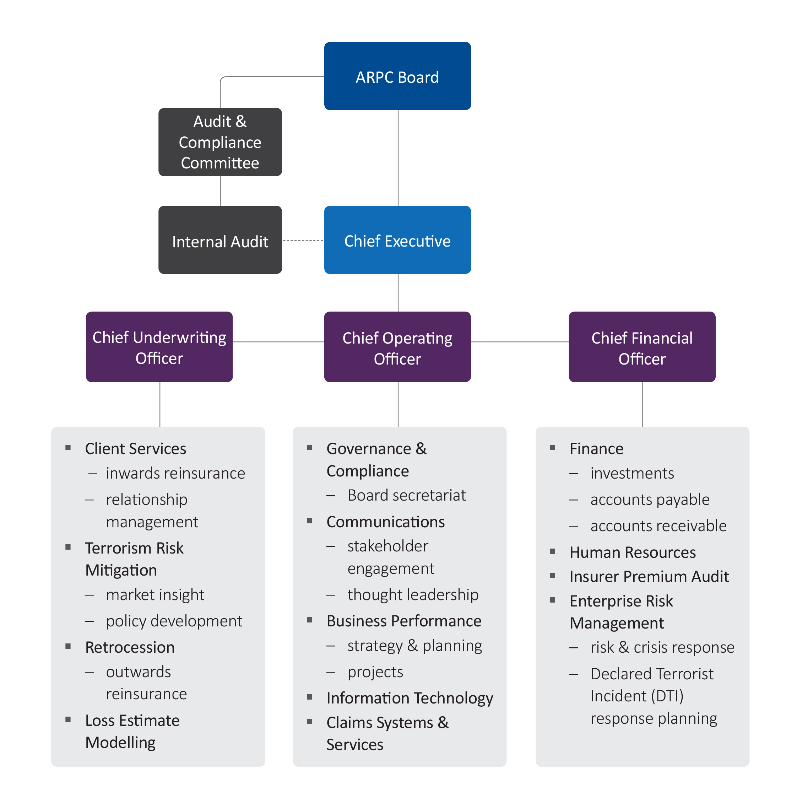

ARPC’s values
ARPC strives for a collaborative and high achieving culture underpinned by integrity, personal leadership and continuous professional development. These values support the strategy and are fundamental to the success of the organisation. These values, outlined in Figure 4.4, also support the ARPC Code of Conduct.

Figure 4.4: ARPC’s Values

RISK OVERSIGHT AND MANAGEMENT

RISK OVERSIGHT AND MANAGEMENT
ARPC is committed to a comprehensive, coordinated and systematic approach to risk management. Effective risk management has a critical role in all organisational decisions.
ARPC’s approach to risk management involves supporting all staff to anticipate uncertain events, identify opportunities and respond appropriately to potential weaknesses. This includes:
- harnessing resources to more effectively manage risks which may prevent ARPC from achieving its objectives;
- protecting people; and
- managing assets, resources and the environment in an efficient, effective, economical and ethical manner.

Enterprise risk management framework
As a Public Financial Corporation under the PGPA Act, ARPC has an obligation to establish risk management systems and controls. The Enterprise Risk Management Framework (ERMF) assists ARPC in meeting its risk management obligations under the PGPA Act. The ERMF includes the Risk Management Strategy, as approved and adopted by the Board, the Risk Management Plan and Risk Policy Statement.
ARPC undertakes a Fraud Risk Assessment at least every two years, which is reviewed by an independent external consultant. This requirement complies with ARPC’s Fraud Control Policy, which also documents the internal controls established within the organisation to mitigate fraud occurrence.
As a Public Financial Corporation, ARPC is not required to comply with the Commonwealth Risk Management Policy, however, APRC’s ERMF has incorporated the Commonwealth’s nine elements of risk management as a matter of best practice. The ERMF incorporates the Risk Management Policy Statement which states that ARPC will manage risk in accordance with the international risk management standard AS/NZS/ISO 31000:2009 Risk Management—Principles and Guidelines.

Risk Management Plan
Based on the ERMF, ARPC has a Risk Management Plan, which specifies the approach, management components and risk management resources to be applied to risk at ARPC. This includes the procedures, practices, assignment of responsibilities and risk management timing and sequencing.

Accountabilities
As the accountable authority, the ARPC Board has overall responsibility for providing strategic direction, risk oversight and setting the organisation’s risk appetite and tolerance. Risk accountability is also outlined in the ERMF.
The ARPC Board has a standing agenda item to examine risk at each Board meeting. Under section 17 of the PGPA Act, the ARPC Audit and Compliance Committee is responsible for reviewing the appropriateness of ARPC’s risk management systems and internal controls. ARPC’s internal controls are routinely reviewed by ARPC’s Internal Auditor which is presently an external organisation. ARPC’s financial statements are audited annually by the Australian National Audit Office and published in the ARPC Annual Report.

Risk appetite and tolerance statements
Each year, the ARPC Board reviews the Risk Appetite and Tolerance Statement as part of the annual strategic workshop held by the Board, together with the Executive Management team. ARPC’s risk register is regularly revised to capture new or emerging risks, as well as changes to the Risk Appetite and Tolerance Statement. Managers review the risk register regularly and monitor risk target levels and ratings for potential changes. The ARPC Board receives regular reporting, sourced from the risk register, on risks which are outside tolerance levels.

Legislative compliance
ARPC staff are made aware of legislative requirements through ongoing information and training. Management provide quarterly attestations on compliance with ARPC’s legislative obligations.

PERFORMANCE

PERFORMANCE
To comply with the PGPA Act, ARPC must remain financially sustainable and manage its public resources in an efficient, effective, economical and ethical manner as it fulfils its purpose.
There are four key performance areas ARPC will measure over the reporting period to facilitate ARPC achieving its purpose. These are to:
- provide reinsurance for eligible terrorism losses;
- encourage private sector participation through the retrocession program;
- compensate the Government; and
- maintain financial sustainability and organisational resilience.
These key performance areas are outlined below in Figure 6.1, together with details on how ARPC measures the success of actions taken to achieve them.
Figure 6.1: Key Performance Indicator (KPI) Summary
KPI Area | Measure | Assessment Criteria | Level of ARPC Influence
- Provide reinsurance for eligible terrorism losses | Measure 1: Income – Gross Written Premium | Gross Written Premium (GWP) against target | Limited
 | Measure 2: Scheme Capacity – Total Funding Available | Purchase of > $2.5 billion in retrocession within approved budget | Moderate
- Encourage private sector participation through the retrocession program | Measure 3: Private sector participation | Number and quality of retrocessionaires in the program | Moderate
- Compensate the Government | Measure 4: Payments to government | Payments made as per Ministerial Direction | High, value of payment Limited
- Maintain financial sustainability and organisational resilience | Measure 5: Net assets against ARPC target and minimum capital | Net assets at or above $400 million | Limited
 | Measure 6: Successful progression or completion of strategic projects | Projects progressed and/or completed according to plan | High

Key Performance Indicator (KPI) detail

KPI 1: provide reinsurance for eligible terrorism losses
Measure 1: Income – Gross written premium
To improve financial sustainability and achieve higher than the target premium in each plan period.
This is ARPC’s functional obligation as prescribed by section 10 of the TI Act. Over the period covered by the Corporate Plan, the success for this activity will be measured by ARPC’s total premium income, with the target premium level for the forecast period being $140 million.
Figure 6.2: Gross written premium
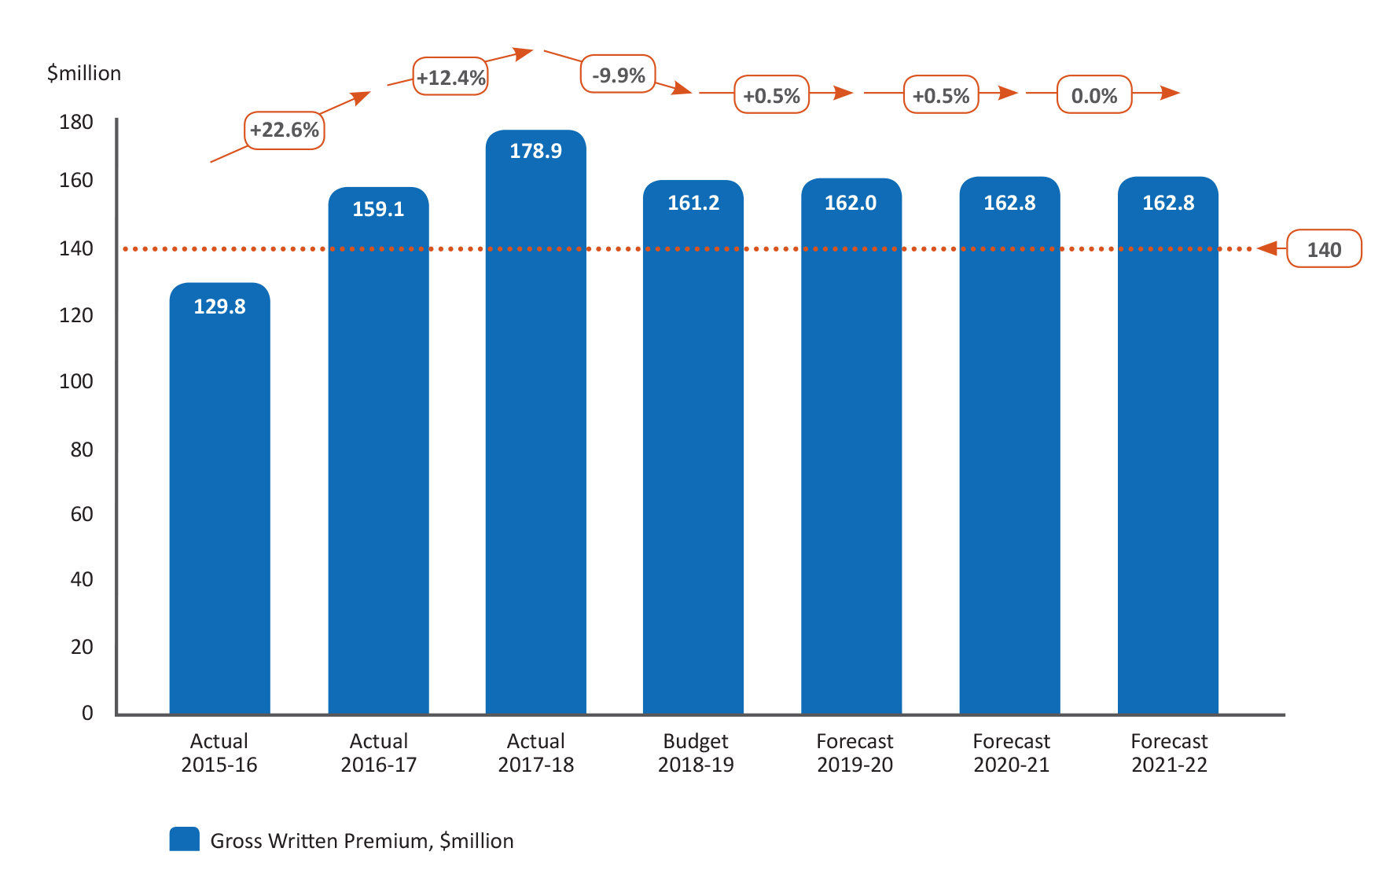
During the current year there has been some increases in commercial property insurance premiums as insurers have raised prices to offset higher reinsurance costs owing to increased global natural catastrophe losses during 2017.

Measure 2: Scheme capacity – Total funding available
To protect the government from losses through the purchase of more than $2.5 billion in retrocession in each program period.
ARPC uses its premium income to purchase retrocession (reinsurance cover from private sector reinsurers) and to compensate the Australian Government for the Commonwealth guarantee. Through ARPC’s retrocession program and the Commonwealth guarantee, ARPC has $13.4 billion in funding available to meet DTI claims as at 30 June 2018.
Since 2009, ARPC has purchased retrocession from global terrorism reinsurers, thereby transferring a large proportion of the risk to the private sector and reducing risk to the Australian Government. For 2018, reinsurers, or ‘retrocessionaires’, provide $3.065 billion private cover for claim payments above the $285 million ARPC deductible and any Industry retentions.
Each year, ARPC negotiates and places a retrocession program with major global reinsurers, seeking a placement that provides value-for-money while encouraging maximum global insurer participation. Participation in the ARPC retrocession program is restricted to reinsurers who hold a Standard & Poor’s (or equivalent) long-term rating of A- or greater.
To measure success in this activity, ARPC measures total retrocession capacity purchased each calendar year and the total purchase cost, while continuing to monitor the number of participating retrocessionaires. See Figure 6.3 Scheme capacity before the Commonwealth guarantee for further information.

Figure 6.3: Scheme capacity (including retrocession) before the Commonwealth guarantee
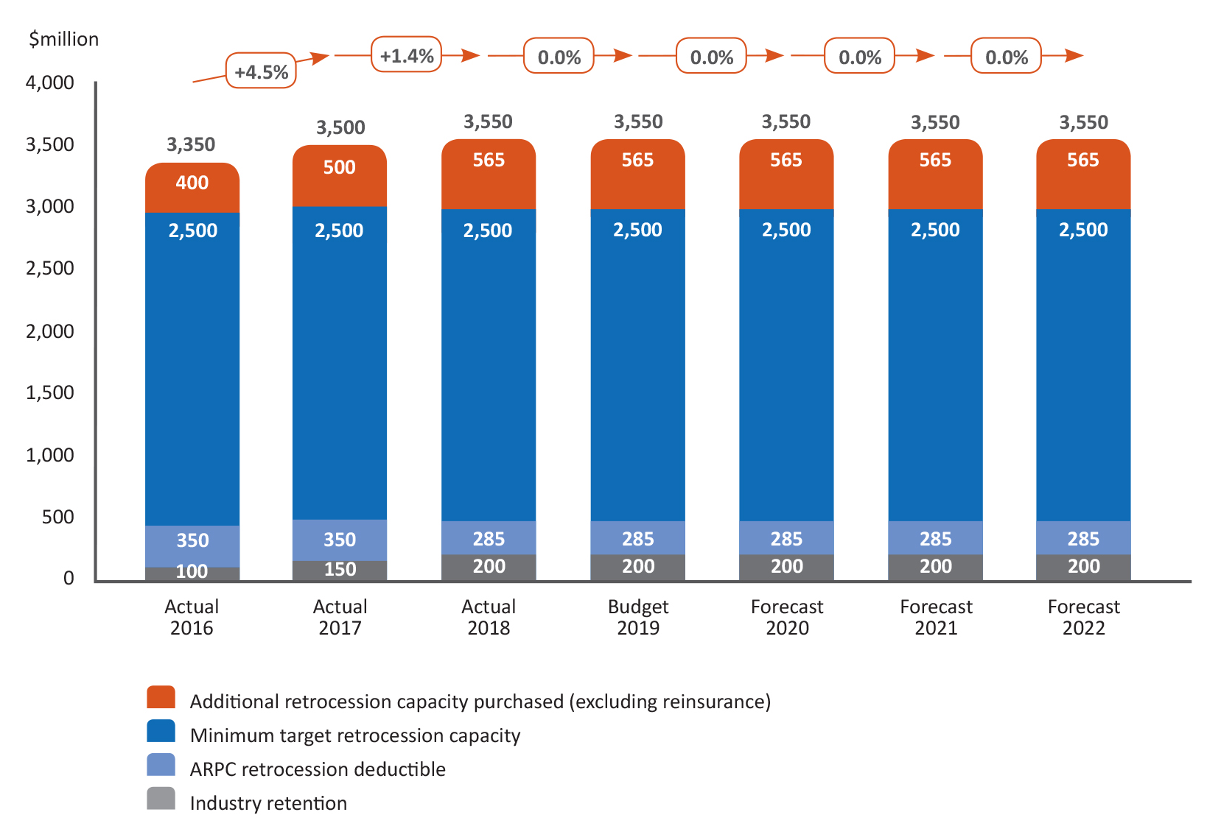

KPI 2: Encourage private sector participation through the retrocession program
Measure 3: Private reinsurance sector participation
The objective is to maximise private sector reinsurance participation in the retrocession program.
ARPC aims to maximise the participation of high credit quality reinsurers in the annual ARPC retrocession program. Each year, ARPC seeks more than 15 high credit quality reinsurers to participate in the program. ARPC also aims to have more than 50 per cent of retrocession scheme capacity provided by APRA regulated reinsurers.
Figure 6.4: Retrocession Program Detail
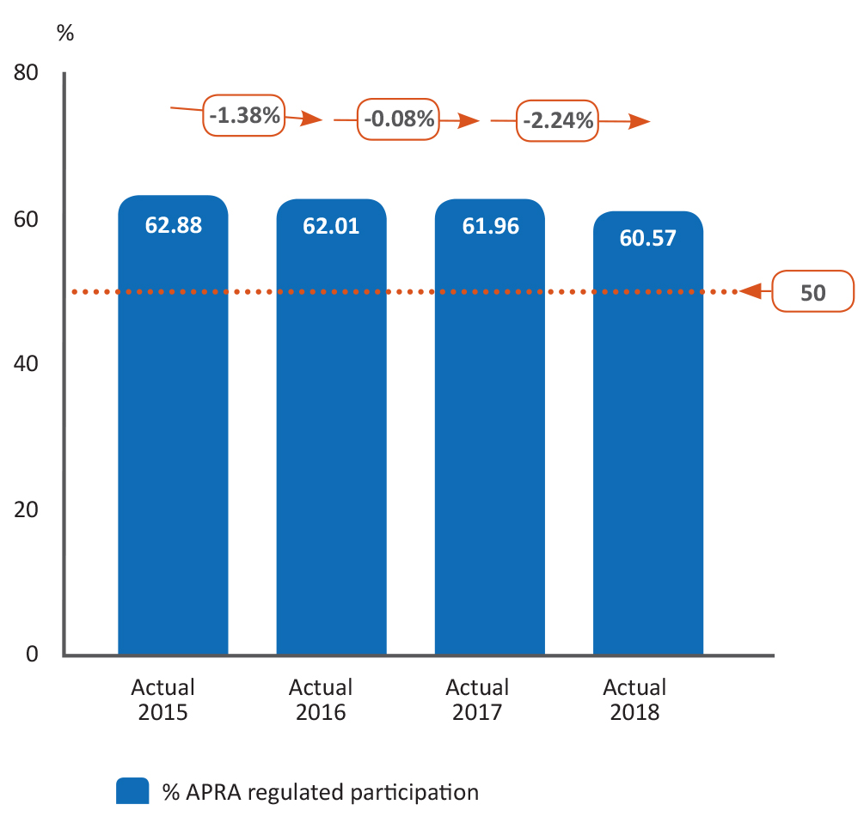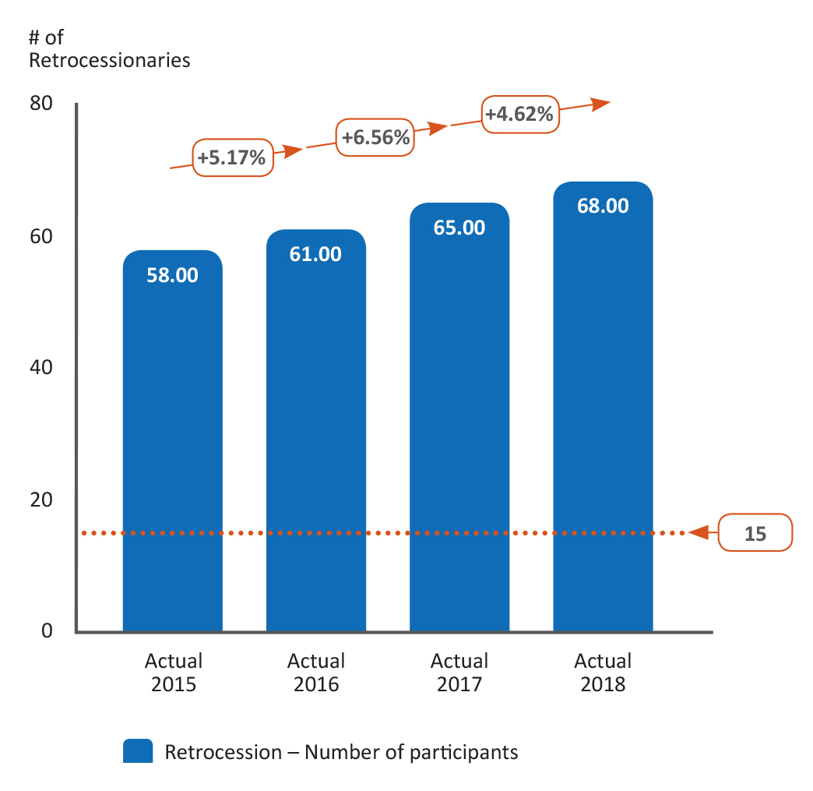

KPI 3: Compensate the Government
Measure 4: Payments to Government
To meet ARPC’s obligations, the target is to deliver the Government payments in each plan period
ARPC pays the Australian Government a fee for provision of the Commonwealth guarantee along with a capital holding fee for the Australian Government’s ownership of ARPC. These payments are outlined in the Federal Budget and implemented through Ministerial Direction.
From 2018/19, ARPC is scheduled to compensate the government annually through a $55 million fee for the Commonwealth guarantee plus a $35 million capital holding fee.
Figure 6.5: Payments to Government
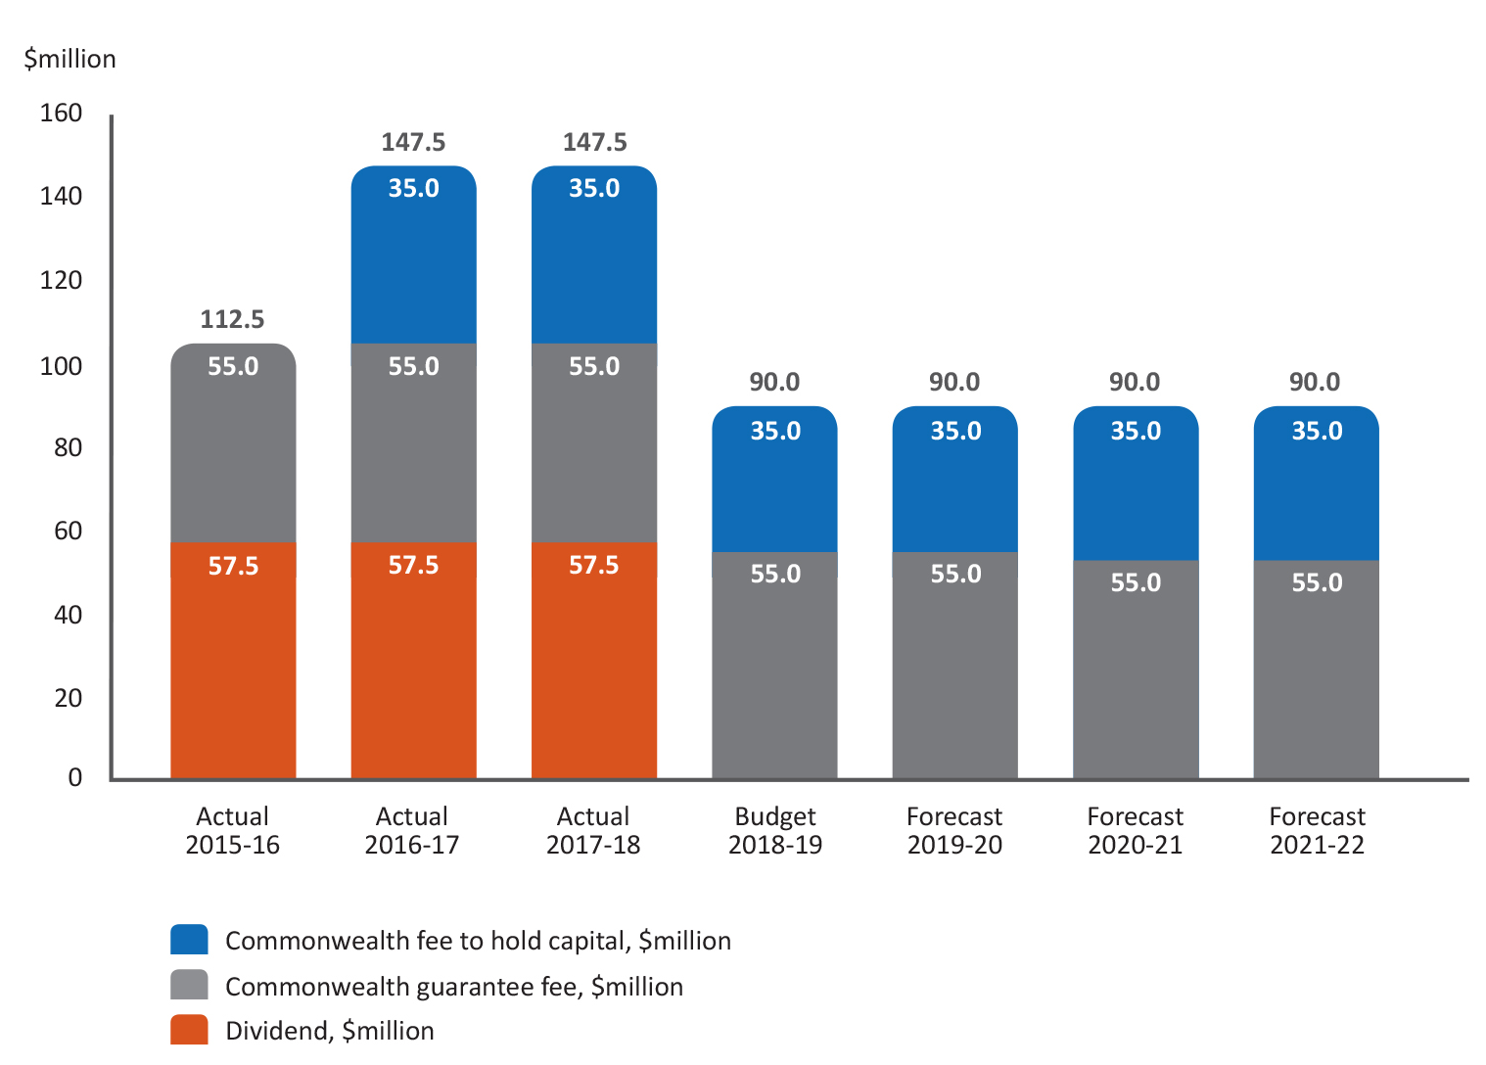

KPI 4: Maintain financial sustainability and organisational resilience
Measure 5: Net assets against ARPC target and minimum capital
Maintain sufficient net assets to support targets within ARPC’s Capital Management Policy

Zone | Actions Required | Monetary Boundaries
Red Zone | Actions are required to return to the Target Zone or Green Zone. | Less than Minimum Capital.  Below $345 million
Yellow Zone  Watch and Act | Actively monitor the capital position and take corrective action where the capital position is forecast to deteriorate further. | Less than the bottom of the Target Zone but greater than Minimum Capital  Between $345 million and $400 million
Green Zone  Target Zone | Monitor and report capital position as business as usual. | Approximately +/- 10% of Target Capital  Between $400 million and $490 million
Blue Zone | Capital Accumulation Zone, where ARPC can accumulate additional capital to provide additional resilience following a DTI. | Greater than the top of the Target Zone and up to Maximum Capital.  Between $490 million and $780 million

Figure 6.6: Projected Net Assets
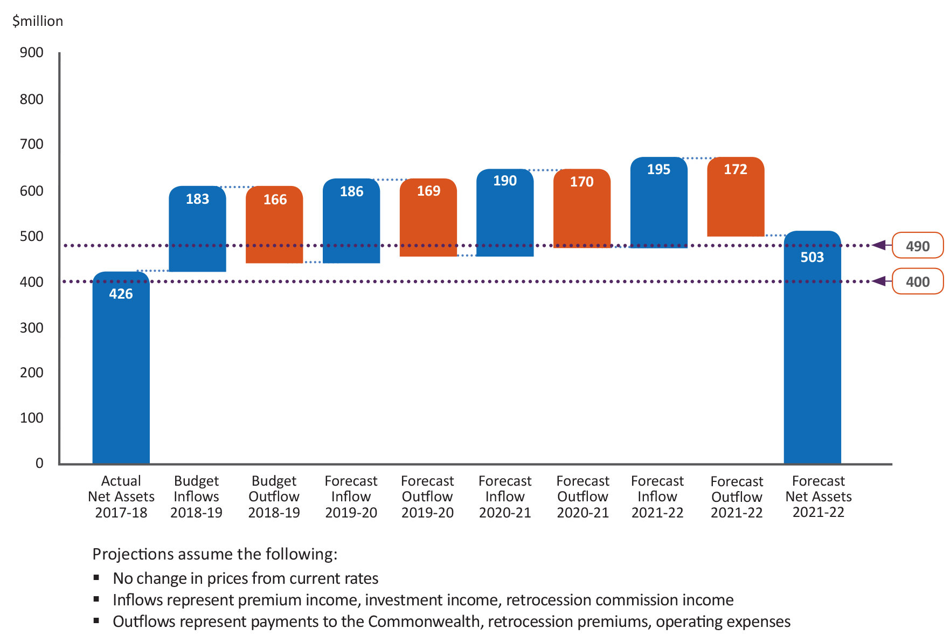
Measure 6: Development activities
Complete and/or progress major projects according to plan to advance ARPC’s strategic priorities
Major Projects for the 2018-21 period
- Geospatial modelling – working with specialist providers to enhance ARPC’s modelling capability.
- Cyber terrorism research project – working with industry and universities to explore issues associated with cyber terrorism.
- Ownership model feasibility study - working with Government, industry and community to assess future structures for ARPC.
- 2018 Triennial Review – working with Government and industry to assess the scheme and comply with obligations under the TI Act.
- Risk mitigation project through Standards Australia - working with industry and community to develop a handbook to assist physical protection decisions made by businesses to reduce exposure to terrorism losses.

The Appendix to the Triennial Review report was prepared by an external consulting firm, Pottinger
Crosses multiple KPIs. Refer to Section 6, Figure 6.1 for KPI areas and details.
Purchase must also be value for money.
Representative of the tranche of cover commencing in that calendar year.
Reinsurers who hold a Standard & Poor's long-term rating of A- (or equivalent) or greater.

