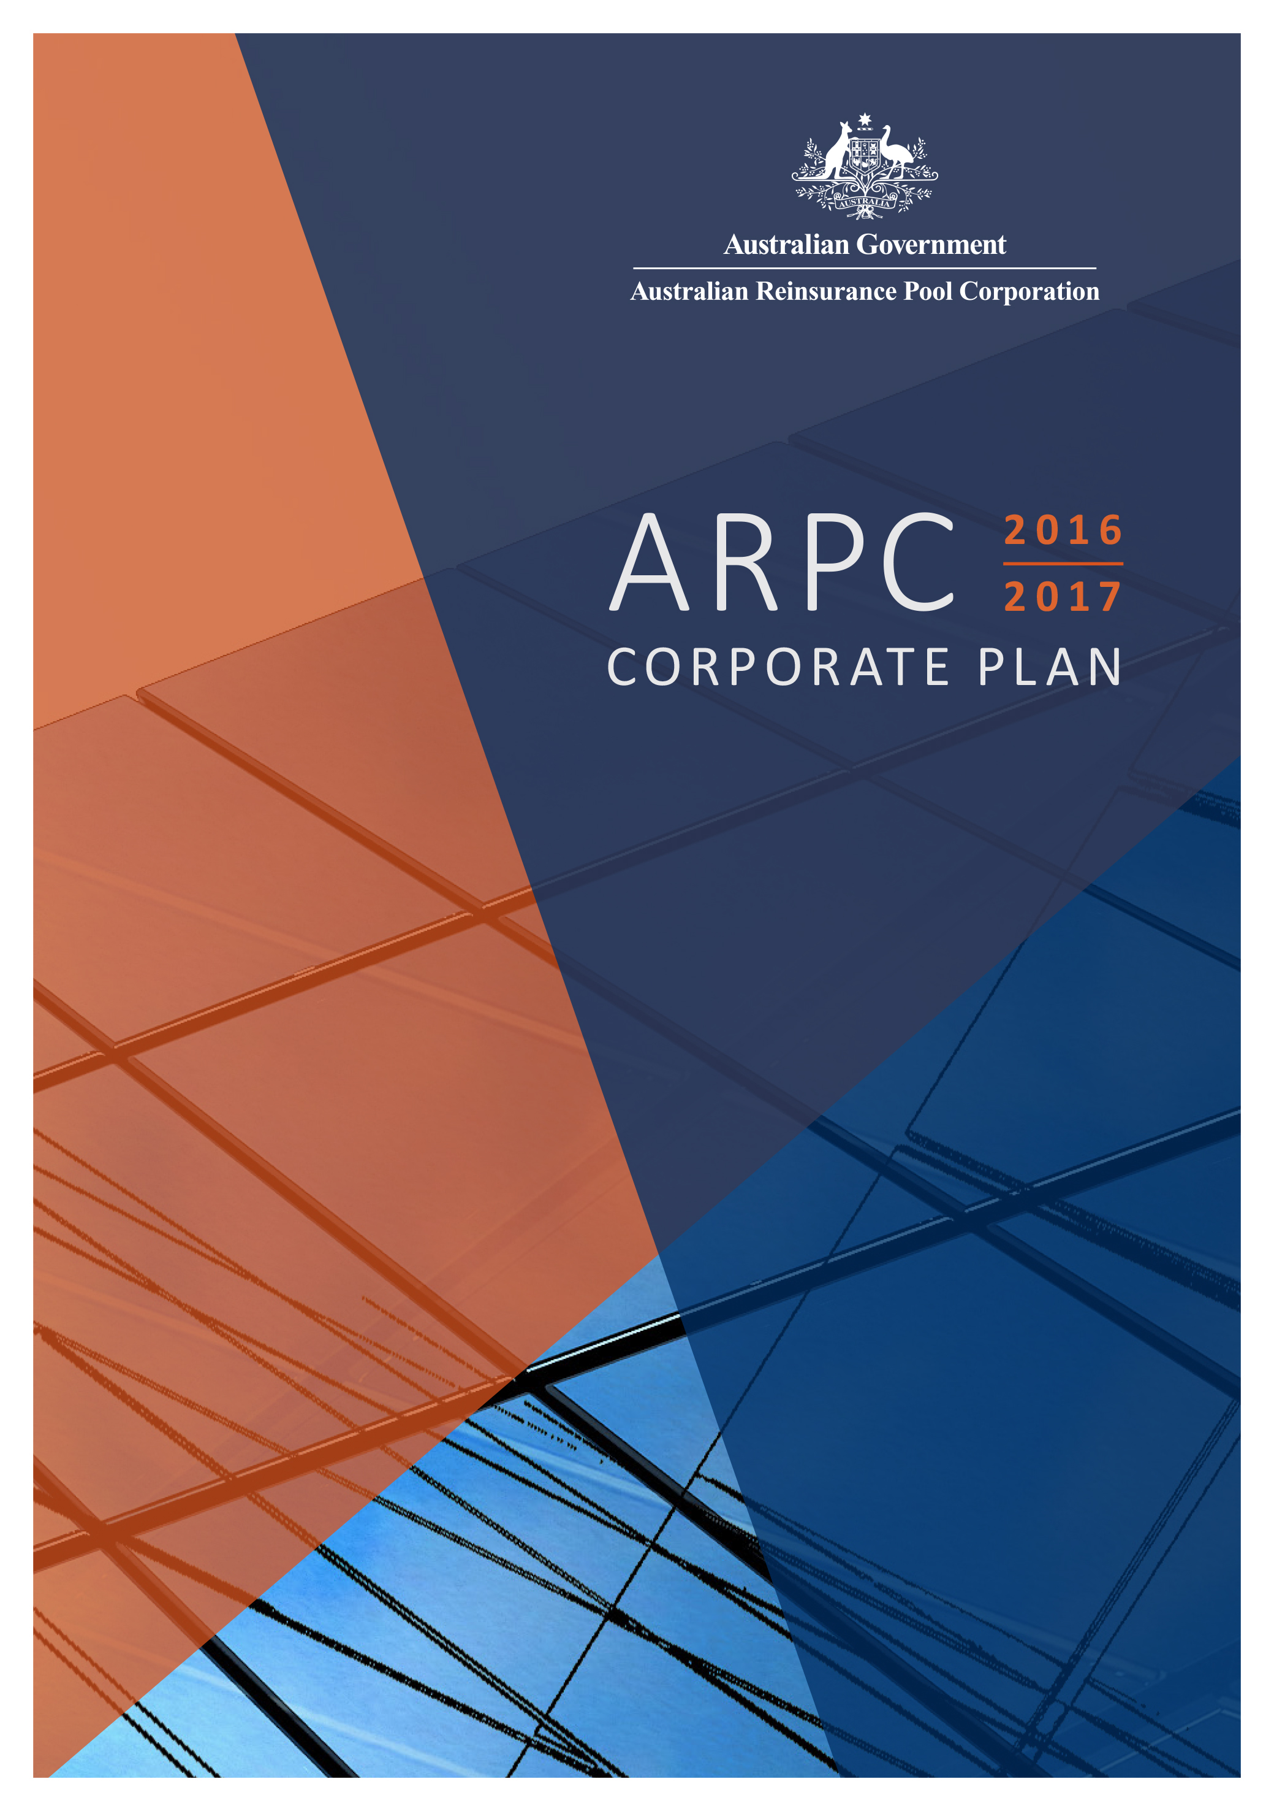

The Hon Kelly O’Dwyer MP
Minister for Revenue and Financial Services
Parliament House
CANBERRA ACT 2600

Dear Minister
I have pleasure in presenting to you the Corporate Plan of the Australian Reinsurance Pool Corporation (ARPC) for the financial year 2016-17 and beyond. The plan commences on 1 July 2016 and spans the three subsequent reporting periods to 30 June 2020.
This plan has been approved by the Board as the Accountable Authority of ARPC, and as required under paragraphs 35(1) and 35(2) of the Public Governance, Performance and Accountability Act 2013 (PGPA Act). The plan is prepared in accordance with the Public Governance, Performance and Accountability Rule 2014 (PGPA Rule).
Each year, ARPC undertakes a strategic planning process in conjunction with the Board and executive to set our purpose and role, values, and strategic priorities for future years. These strategic priorities focus our efforts on activities and initiatives to deliver the Corporate Plan.
Should you have any questions or require further information please do not hesitate to contact me.
Yours sincerely
(signature supplied)
Joan Fitzpatrick BA (Hons), LLB, ANZIIF (Fellow), CIP, GAICD
Chair

cc The Hon Mathias Cormann MP
Minister for Finance

Correspondence to: PO Box Q1432, Queen Victoria Building, NSW 1230
T +61 2 8223-6777 | F +61 2 9241-1887| E enquiries@arpc.gov.au
www.arpc.gov.au | ABN 74807136872

Contents
1. Executive Summary 4
2. Introduction 5
Background 5
Terrorism insurance scheme objectives 5
3. Purpose statement 6
ARPC Strategic Plan 2016–2020 7
Values 7
4. Environment 9
Market failure 9
Legislative framework constraints 10
Three-year review (triennial review) 10
2015 Triennial Review 10
Implementation of triennial review recommendations 11
Pricing constraints 11
Premiums 12
Declining capital 12
Purchasing retrocession 13
5. Performance 14
Providing reinsurance for eligible terrorism losses 14
Encouraging private sector participation through retrocession 15
Compensating Government 18
Maintaining financial sustainability 19
6. Capability 21
Workforce capabilities 21
Operating cost efficiency 21
Key strategies and initiatives 22
7. Risk Oversight and Management 27
Enterprise Risk Management Framework 27
Risk Management Plan 27
Accountabilities 27
Risk appetite and tolerance statements 28
Legislative compliance 28
8. Appendices 29

Executive Summary
Our purpose is to protect Australia from economic losses caused by terrorism catastrophe. Through our role we use our expertise to provide cost effective reinsurance to support the economic resilience of the nation. In order to deliver our purpose and role, in 2016-17 we will:
Protect the Australian economy
$13.4 billion
Total funding for claims
Provide terrorism reinsurance cover
$164
million p.a.
Premiums
Sustain the pool
$465
million
Net Assets
Compensate the
Government
$147.5
million p.a.
Fees and Dividends
Protect the Government and encourage private reinsurance sector participation
$2.9
billion
Private reinsurance sector funding
for claims

Introduction

Background
ARPC is a statutory authority established under the Terrorism Insurance Act 2003 (TI Act). It was created after the US terrorist attacks on 11 September 2001. After this attack, there was a global withdrawal of terrorism insurance cover leaving commercial property in Australia uninsured against terrorism attacks. ARPC was established by the Australian Government with the support of stakeholders in the property, banking, insurance, and reinsurance sectors.
Section 9 of the TI Act established ARPC as a statutory authority, while section 10 prescribed the key function of ARPC, which is to ‘provide insurance cover for eligible terrorism losses (whether by entering into contracts or by other means)’. ARPC is a corporate Commonwealth entity under the Public Governance, Performance and Accountability Act 2013 (PGPA Act). We are subject to the PGPA Act financial and non-financial reporting requirements.
ARPC has $13.4 billion of total funding available for claims arising from a Declared Terrorist Incident (DTI), protecting private commercial assets that have an aggregate sum insured exposure of about $3.4 trillion.
In July 2003, the ARPC terrorism insurance pool (the scheme) was established. If a DTI is declared, the TI Act responds by rendering invalid any terrorism exclusion clause in an eligible insurance contract. Although insurers remain liable for commercial terrorism risks, the scheme is not compulsory. Insurers can choose to carry the risk of terrorism losses following a DTI by reinsuring the risk through the private reinsurance sector, or reinsuring with ARPC by paying the scheme premiums.
Commercial property owners who hold eligible insurance policies with those insurers are covered by the ARPC scheme. Consequently, the ARPC scheme plays a crucial role in supporting Australia’s economic resilience following a DTI, by providing a claims payment framework that facilitates the payment of eligible claims and the ability to draw on international funds through ARPC’s purchase of retrocession reinsurance for rebuilding and re-establishing commercial business activity.
ARPC provides cost effective reinsurance cover to insurers and their commercial customers. ARPC enables risk sharing and mitigation in an area where there is inadequate terrorism insurance capacity in the Australian commercial market.

Terrorism insurance scheme objectives
At the time of establishing ARPC, the TI Act Explanatory Memorandum outlined the policy objectives for ARPC (see the Revised EM of the Terrorism Insurance Bill 2002, page 6). The EM outlined that intervention would need to be consistent with:
- the need to maintain, to the greatest extent possible, private sector involvement;
- ensuring risk transferred to the Commonwealth is appropriately priced and that the Commonwealth is compensated by those benefiting from the assistance;
- allowing the re-emergence of the commercial markets for terrorism risk cover; and
- global solutions.

Purpose statement
We remain true to the scheme’s original policy objectives and are strengthening our purpose and role to create greater value for stakeholders.
We have articulated our purpose and role as follows:
Purpose: to protect Australia from economic losses caused by terrorism catastrophe.
Role: we use our expertise to provide cost effective reinsurance to support the economic resilience of the nation.
The purpose and role of ARPC gives direction to our strategy which will be executed over the period until 2020. Our Corporate Plan contains initiatives over short, medium, and long-term time horizons. In the short term, our focus is on enhancing our role as a trusted advisor; the medium term is focused on responding to contemporary needs and the longer term is about enhancing our value proposition by broadening our coverage and becoming a global thought leader.
Our Strategic Plan has six broad strategic priorities, which support our purpose and role. These priorities are to:
- Be financially strong and ready to respond
- Modernise the mandate
- Drive stakeholder advocacy
- Contribute to coverage of catastrophic events
- Promote mitigation for economic resilience
- Be a high achieving, great place to work

ARPC Strategic Plan 2016–2020

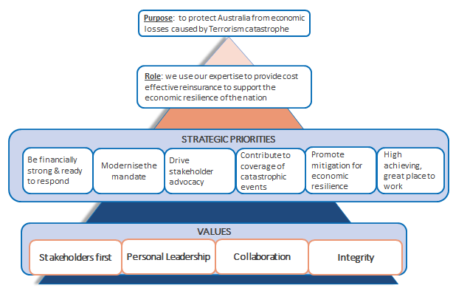

Values
The strategy is underpinned by ARPC’s culture and values. This is fundamental to everything ARPC does and is critical to the success of the organisation. ARPC’s executive and staff have updated the values that underpin our decision making. These values support the ARPC Code of Conduct.

Integrity
Collaboration
Personal Leadership
Stakeholders First

do the right thing
be trustworthy
speak with positive intent
value and embrace diversity
be consistent
work together
coach and mentor others
celebrate our success
be authentic
empower and trust our colleagues
be proactive
take ownership
lead by example
take the initiative
respect one another
understand stakeholder needs
exceed client expectations
focus on finding solutions for stakeholder problems
communicate with transparency

Environment

Market failure
ARPC was established to address market failure in the terrorism risk insurance market for Australian commercial properties. Since 11 September 2001, insurance policies covering Australian commercial property have included terrorism exclusion clauses. The TI Act, however, makes it compulsory for insurers to cover terrorism losses that result from a DTI. Although it is optional for insurers to take out terrorism reinsurance cover, almost all commercial property insurers choose to reinsure their terrorism risk with ARPC.
There remains no whole-of-market, sustainable, alternative provider of terrorism reinsurance. The reinsurance market has insufficient capacity to offer uniform terrorism insurance coverage to the market at affordable prices, a situation which is unlikely to change during the next four years.
The 2016 retrocession program purchased by ARPC was close to the total available global capacity at reasonable prices. This was only about 30 per cent of the $10 billion cover provided by the Commonwealth guarantee which provides further evidence of market failure in the terrorism insurance market for Australian commercial property.
The Treasury 2015 Terrorism Insurance Act Review (the Triennial Review) considered the availability of reinsurance for terrorism risk in detail. It concluded that the availability and pricing of private sector terrorism insurance has improved over time due to the low incidence of major terrorism claims, better risk modelling and greater competition among reinsurers. Terrorism loss reinsurance prices have also fallen over time. In addition, coverage has improved for small events.
Nonetheless, there is still a market failure. The Pottinger report estimates that terrorism risk retrocessions available to Australian insurers at a reasonable price total around $5 billion, which is well below the approximately $13 billion of reinsurance cover provided by the scheme.
There also seems to be no material likelihood of market conditions changing such that adequate private sector supply of terrorism insurance at reasonable prices becomes available over the near to medium term. The development of a private market for terrorism insurance in Australia depends on further growth in the capacity of global reinsurance markets for terrorism risk. Recent developments overseas indicate that government support of terrorism insurance arrangements continues to be required.
Many governments and insurance markets around the world have introduced terrorism insurance pools (including the United States, United Kingdom, and France). Some were created in response to the events of 11 September 2001, while others were established in response to specific terrorist threats within each country. There are approximately 23 terrorism pools providing cover across major economies. The US Parliament, for example, recently voted to reinstate the national terrorist insurance scheme, which had lapsed in December 2014. The Bill passed with bipartisan support.
Current conditions do not imply the continued availability of private sector terrorism insurance at an economic price over the medium to longer term, particularly in the event of a major claim in Australia or overseas. Further, the Pottinger report indicates that, while there is increasing capacity to insure the risk pool managed by the ARPC, there is no guarantee that the same capacity would be available to individual insurers. The report identifies the risk-pooling mechanism as a key factor in providing cost-effective reinsurance of terrorism risk.

Legislative framework constraints
ARPC must operate within the legislative framework of its enabling act, the TI Act, whilst also being fully compliant with Australian Government obligations under the PGPA Act.
The TI Act prescribes the function of ARPC and focuses on providing insurance cover for terrorism losses. The premiums that ARPC can charge its insurers are set through Ministerial Direction.
The TI Act Regulations (the Regulations) are also relevant to our legislative framework and these define what is excluded from coverage under the TI Act.

Three-year review (triennial review)
At the time of establishing ARPC, it was uncertain whether the private market would return to full capacity. Section 41 of the TI Act requires that the Treasury must undertake a review of the operation of the TI Act at least every three years. Today there is a heightened threat of terrorism attack as evidenced by the Australian National Terrorism Public Alert System raising the threat level to High in September 2014. Under the new National Terrorism Threat Advisory System introduced in 2015, the threat level remains at ‘Probable’.
Thirteen years after ARPC was established, successive triennial reviews have recommended that the organisation and the TI Act continue.

2015 Triennial Review
The 2015 Triennial Review was conducted by Treasury late in 2014 and early 2015. Pottinger assisted in this process by conducting market soundings on the need for ARPC to continue to administer the terrorism insurance scheme. The Treasury also commissioned Finity to undertake a review of terrorism insurance cover for high-rise residential and mixed-use commercial property.
The final review report was published on 15 December 2015. It considered whether the TI Act should continue, the scheme rationale, ARPC’s ownership structure, as well as ongoing financial sustainability. In summary, the Review concluded that market failure still exists in the Australian terrorism insurance market and recommends that ARPC remain in place under the current ownership structure and administration.
The Triennial Review recommended that “the current ownership and administration structure of the scheme as set out in the Act be retained, while noting that there is scope to revisit alternative structures in future if there is a significant change in market conditions. Nevertheless, as the need for the scheme has persisted for more than a decade, the policy framework against which its operation is assessed should no longer be limited to one that conceives of the scheme as a short-term, temporary measure. While the ongoing need for the scheme should continue to be periodically reviewed, the fact that it has matured into at least a medium-term policy response should be recognised and reflected in decisions about the nature and scope of its operation.“
10 recommendations were made in the final report, in summary the key recommendations included that the scheme be expanded to include both mixed use and high value residential buildings and that coverage be clarified for losses attributable to terrorist attacks that use chemical or biological means. The review also recommended that premiums be increased from 1 April 2016 to enable ARPC to remain self-funded over the medium term, while reasonably compensating the Australian Government and maintaining an appropriate level of capital.
The detailed recommendations of the 2015 Triennial Review are included in Appendix A.

Implementation of triennial review recommendations
The new premium rates recommended in the Triennial review are listed in the table below. These rates have applied from 1 April 2016.

Table 1: New Tier Rates (1 April 2016)
Tier | Rate
A | 16% of gross base premium (was 12%)
B | 5.3% of gross base premium (was 4%)
C | 2.6% of gross base premium (was 2%)

The price changes for the scheme have been implemented from 1 April 2016. Drafting is in progress for a regulatory amendment that will allow mixed use residential and commercial, and high value residential buildings to be included in the scheme.
A minor legislative amendment to clarify cover for biological or chemical attacks in the scheme is expected to be incorporated into an Omnibus Bill during the 2016-17 financial year. The timing of this Bill will be dependent on the legislative program adopted by the new Government.
At the time of publication, work is in progress relating to insurer retention levels. Under section 41 of the TI Act, the Minister must report on the next triennial review before 30 June 2018.

Pricing constraints
ARPC is a corporate Commonwealth entity operating in a private sector environment that is subject to global economic factors. These are often outside ARPC’s control but they can significantly impact the organisation’s financial sustainability.

Global factors
Like all insurers, ARPC is subject to the impact of global catastrophes on the market, as well as market pricing cycles. Catastrophes such as Hurricane Katrina (2005) in the USA, the earthquake and subsequent tsunami in Japan (2011) and the earthquake in Christchurch New Zealand (2011) resulted in large claims against major reinsurers, with consequential rises in catastrophe insurance premiums. However, since 2011, there have been no large-scale catastrophes globally. This has caused reinsurance and direct insurance premium rates to generally fall to levels not seen for many years. Because ARPC premiums are charged as a percentage of each insurer’s gross written premiums, this has had a flow-on effect, causing ARPC premium revenue to fall in parallel. However, we do note that this fall has been somewhat offset by a reduction in our retrocession premium.

Pricing terrorism insurance
For ARPC, the difficulty in pricing terrorism insurance is compounded by the difficulty in predicting terrorism attacks and the likely timing, number and size of potential claims. Although ARPC utilises sophisticated loss estimation models to assist with predicting the size of possible losses, the frequency of a loss is not possible to model owing to a complex set of factors involved in terrorist attacks. As a consequence, it is acknowledged globally that terrorism risk is extremely difficult to accurately price. ARPC can only adjust its premium rates through a Ministerial Direction.

Premiums
ARPC is not funded through Commonwealth budget appropriations. ARPC’s premium income from insurers and investment income is used to fund all operations, including our retrocession premiums and payments to government for fees and dividends, while building the reserve for claims available to meet future claims. Premium rates increased for the first time with effect from 1 April 2016 as a result of the 2015 Triennial Review recommendations.
Premiums are set based on the applicable postcode of each commercial property. All postcodes are placed in one of three pricing tiers according to population density. Premiums are then calculated as a percentage of each insurer’s gross written premium (GWP) for eligible insurance contracts located in each tier.
Because ARPC receives a fixed percentage of insurers’ premiums, premium income earned by ARPC is subject to premium price fluctuations, which are beyond our control. Consequently ARPC is constrained not only by having to seek a Ministerial Direction to increase premium rates, but is also vulnerable to general insurance market fluctuations that make forecasting premium income difficult.
Should a DTI lead to major losses and consequently major payouts to insurers, there would need to be a substantial increase in ARPC‘s premium rates to remain financially sustainable. In this event, ARPC could not initiate premium increases on its own, but would require a Ministerial Direction.
Further explanation of the variability in premium income is shown in Table 2 below. This shows a snapshot of insurance risks as at 30 June 2016, tabling all premiums for policies commencing within the financial year, which is called an “underwriting year”.

Table 2: Insurance risk report, as at 30 June 2016
Underwriting year | Premium income $million (A) | Insurer client sum insured $trillion (B) | Insurer client gross written premium $billion (C) | Premium as % of Gross Written Premium  (A) ÷ (C)
2012-13 | 129.9 | 3.0 | 3.7 | 3.5%
2013-14 | 126.7 | 3.1 | 3.6 | 3.5%
2014-15 | 128.4 | 3.2 | 3.7 | 3.5%
2015-16 | 126.2 | 3.4 | 3.5 | 3.6%
* The 2015-16 risk reports are not submitted by insurers to ARPC until September 2016.

Declining capital
ARPC uses its premium and investment income to fund its operations and build a claims reserve. ARPC has prudently invested its surplus funds to supplement its income from premium revenues, with the size of the reserve for claims growing to $666 million in 30 June 2011. This has subsequently reduced to $480 million as at 30 June 2016 owing to the dividend and Guarantee Fee payments made to the Australian Government since 2011.
It was envisaged from the establishment of ARPC that the Government would be fairly compensated for the risk of the Commonwealth guarantee being claimed against. The 2012 Triennial Review determined that ARPC should commence making annual payments to the Government for the provision of the $10 billion Commonwealth guarantee, taking into account the backdating of payments since ARPC’s inception. The first payment was made by ARPC in January 2013.
In 2015/16, ARPC will pay the Federal Government $112.5 million in fees and dividends and will pay a further $147.5 million in 2016/17. Because these payments are reducing ARPC’s capital, we have commissioned Finity Consulting to complete a Capital Management Plan to determine a prudent level of minimum capital. The Capital Management Plan will be used as the basis for discussion with the government on the appropriate level of future payments being related, not only to a prudent level of minimum capital, but also to net annual profit.
Since January 2013, ARPC’s net assets have been progressively reduced by these payments to the Federal Government. As a consequence of the progressive decline in funds, there has been a corresponding decline in investment revenue, compounded by the recent decline in interest rates.
ARPC remains vigilant to these variations and has monitoring mechanisms in place to quickly respond to potential revenue fluctuations.

Purchasing retrocession
Since 2009, ARPC has placed an annual retrocession program. For the 2016 calendar year program, ARPC purchased $2.9 billion in reinsurance capacity through 61 reinsurers, all of which must have a Standard and Poor’s rating of A- or better (or equivalent). By purchasing retrocession, ARPC is not only providing a valuable overseas funding source for rebuilding Australian commercial infrastructure, but is also protecting the Government from ARPC drawing on the Commonwealth guarantee.
This annual purchase encourages the re-emergence of the commercial terrorism insurance market, but it is subject to potential volatility in both capacity and pricing that is impacted by exchange rate movements and also natural catastrophes. This exposes ARPC to market factors that are not within our control, which necessitates that the program undergo close and regular scrutiny by ARPC.

Performance
In compliance with the PGPA Act, we must remain financially sustainable and manage our public resources in an efficient, effective, economical and ethical manner as we continue to fulfil our purpose.
There are four key Corporate Plan activities that ARPC will undertake over the reporting years that will facilitate achieving our purpose. These are:
1. Providing reinsurance for eligible terrorism losses.
2. Encouraging private sector participation through the retrocession program.
3. Compensating the Government.
4. Maintaining financial sustainability.
These are outlined below together with how ARPC measures and assesses the success of key activities in achieving our purpose and role.

Providing reinsurance for eligible terrorism losses
This is our functional obligation as prescribed by section 10 of the TI Act. Over the period covered by the Corporate Plan, success for this activity will be measured by ARPC’s total premium income, with the target premium level for the forecast period being above $110 million per annum.

Measure 1: Gross written premium income
Measure 1: To improve financial sustainability, achieve higher than the target premium in each plan period.

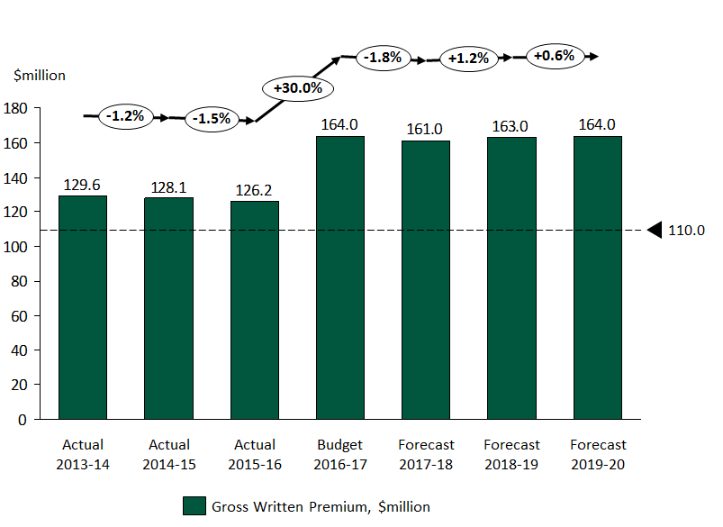

Encouraging private sector participation through retrocession
Market failure was the trigger for the Government’s intervention in the terrorism insurance market, following the events in the USA on 11 September 2001. Successive triennial reviews have confirmed that the reinsurance market has insufficient capacity to offer uniform terrorism insurance coverage at affordable prices for the foreseeable future. Consequently, encouraging private sector participation remains a key policy objective for ARPC’s terrorism insurance scheme.
We use our premium income to purchase retrocession (reinsurance cover from private sector reinsurers) and to compensate the Government. Through our access to retrocession and the Commonwealth guarantee, in 2016 we have a total of $13.4 billion in funding available for losses arising from a DTI.

Total funding available for a DTI – 2016

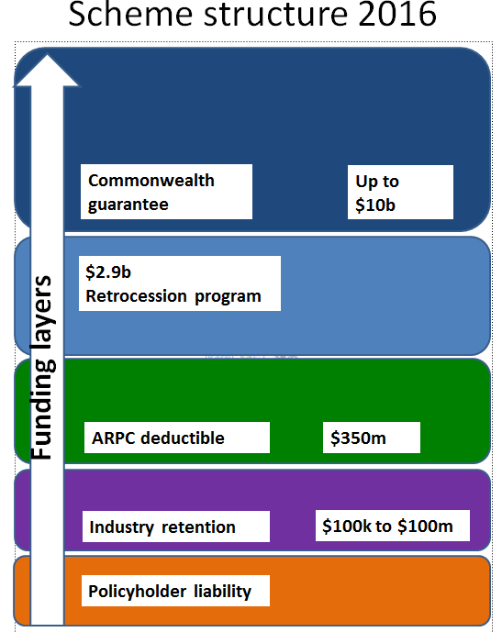

Since 2009, ARPC has purchased reinsurance from global terrorism reinsurers (retrocession), thereby transferring a proportion of the risk to the private market in an effort to encourage private sector participation in risk sharing and reduce the risk to Government and the Australian economy. Reinsurers or ‘retrocessionaires’ provide private cover for the first tranches of claims payments.
Each year, ARPC negotiates and places a program of retrocession with major global reinsurers, seeking a placement that provides value-for-money whilst encouraging maximum participation of global insurers. Since 2009, ARPC has, on these principles, only been able to procure a capacity of about one third of the known probable maximum loss of an event in the Sydney CBD, but has secured the participation of all major global reinsurers.
To measure success in this activity, ARPC will measure total retrocession capacity purchased each calendar year and the total purchase cost, whilst continuing to monitor the number of participating retrocessionaires.

Measure 2: Scheme capacity, before the Commonwealth guarantee, per calendar year
Measure 2: To protect the government from losses, purchase more than $2.5 billion in retrocession each program period.

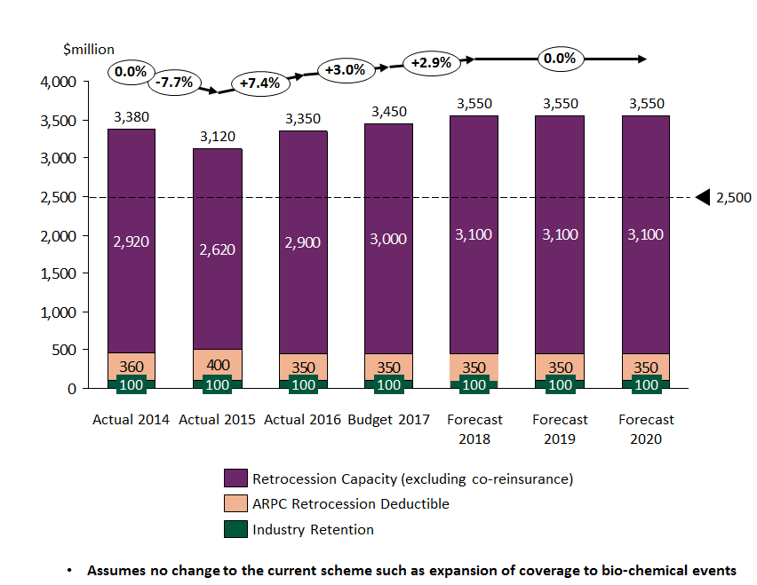
We also aim to be cost effective and to purchase retrocession on a value-for-money basis. We therefore set a budget each year for the purchase of retrocession and we seek to maximise our capacity within the available budget.
To achieve value-for-money each year, we will aim to purchase the maximum capacity within our budget approved by ARPC’s Board each year for retrocession purposes, but ideally spending no more than $72 million.

Measure 3: Retrocession program cost, per calendar year
Measure 3: Our objective is to maximise our capacity purchased within the budget that we have available in each program period.

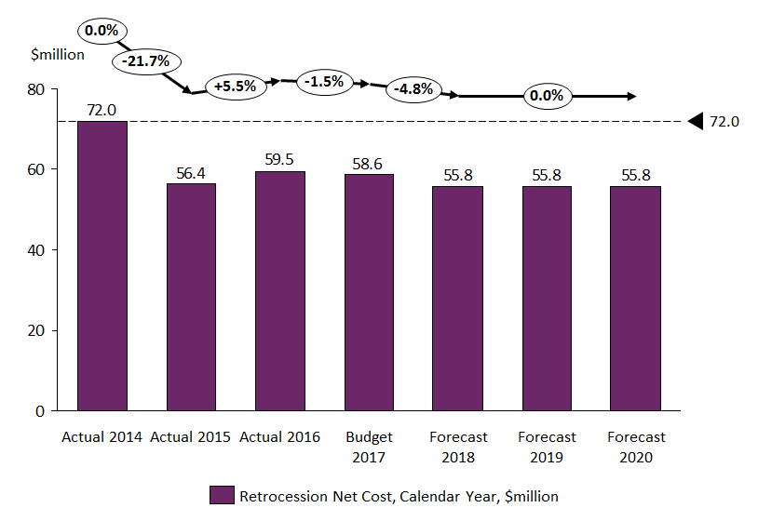

Compensating Government
ARPC pays the Government a fee for the use of the Commonwealth guarantee, as well as a dividend to reflect return on capital for Government as the owner of ARPC. These payments are outlined in the Budget Papers and the Mid-Year Economic and Fiscal Outlook, and implemented through Ministerial Direction.

Measure 4: Payments to Government
Measure 4: To meet our obligations, the target is to deliver the Government payments in each plan period. The payments are set by Ministerial Direction.

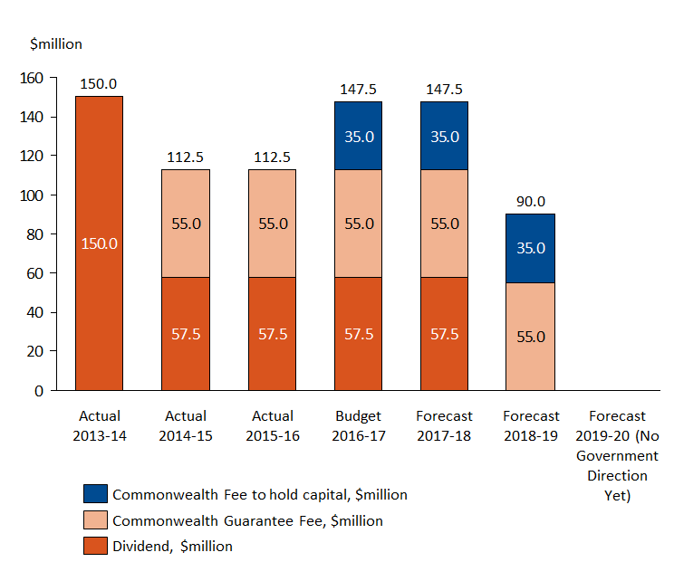

Maintaining financial sustainability
As is the case with any insurer, in order to retain our operational effectiveness, ARPC must remain financially sustainable by putting in place robust financial systems and controls.
Key factors impacting ARPC’s financial sustainability include:
1) any claims costs associated with a DTI;
2) our premium rates and premium income;
3) the size, structure and timing of fees and dividends payable to the Government;
4) the size and cost of our retrocession program; and
5) our investment return.
To measure and assess our financial sustainability, ARPC measures net assets. ARPC notes that future years will see a net cash outflow due to ongoing payments to Government exceeding net income.

Measure 5: Financial sustainability
Measure 5: Maintain sufficient net assets to support the retrocession deducible ($350 million in 2016).

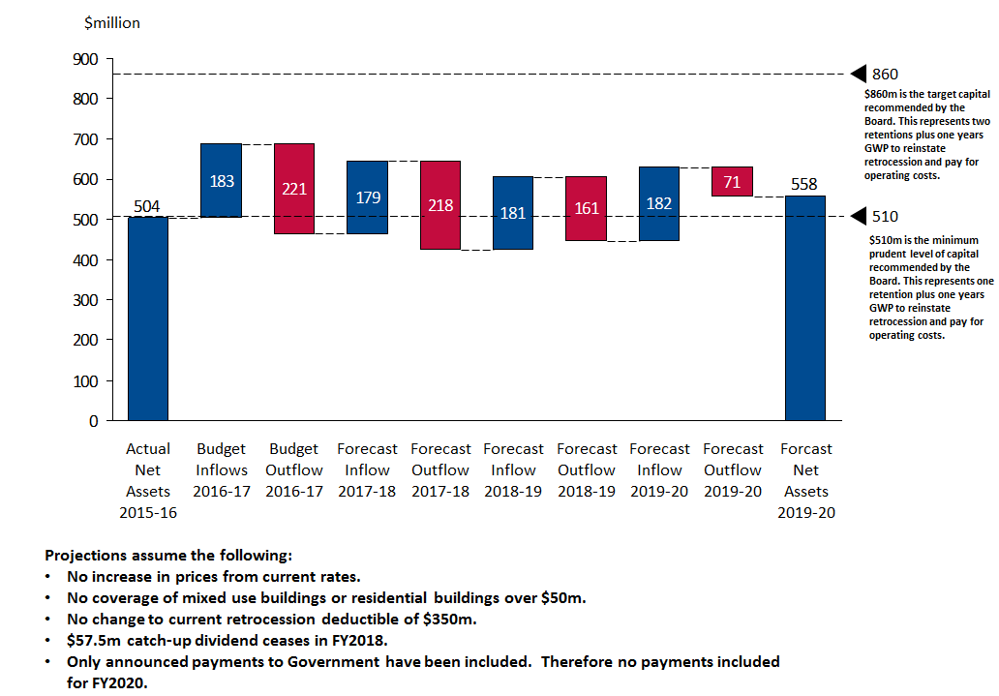

Capability

Workforce capabilities
In 2015, in order to be closer to our insurer and reinsurer stakeholders, the ARPC Canberra office was closed and all operations transferred to Sydney. By 30 June 2016, following the conclusion of several senior executive handover periods, our full-time staff will total 20.
ARPC is required to conduct reinsurance market operations as well as fulfil governance, risk and compliance obligations. The skills and capabilities within our organisational structure support all ARPC activities. Our organisational structure is shown in Appendix B.
ARPC promotes a values-based approach to our workforce and decision-making. Our values place an emphasis on ‘Stakeholders First’. ARPC’s organisational structure supports our focus on engaging with stakeholders across Commonwealth, State and Territory governments, plus the insurance, reinsurance, investment and property sectors.
Under the TI Act, ARPC is required to respond to any potential terrorism incident, advise our Minister, the Attorney General and our insurers, and subsequently pay eligible claims. We undertake workforce planning and succession planning, so that ARPC has high performing staff with the appropriate skills to undertake our core functions.

Operating cost efficiency
Our general operating expenses (including acquisition costs and other operating expenses) totalled $8.2 million in 2015-16. This was $1.7 million (17.5 per cent) better than plan and $0.2 million (2 per cent) higher than the previous year. Our result for general operating expenses was outstanding as this fully included the fit-out of our new Sydney office, the decommissioning of our old Canberra and old Sydney office, and redundancy payments for our Canberra staff that did not elect to transfer to Sydney.
Our general operating expenses in 2016/17 will be $8.5 million and only $0.3 million (3.7%) higher than the previous year. The main factors driving this increase are that a number of positions remained vacant during 2015/16 and our new Enterprise Agreement became effective on 27 May 2016.

General Operating Expenses
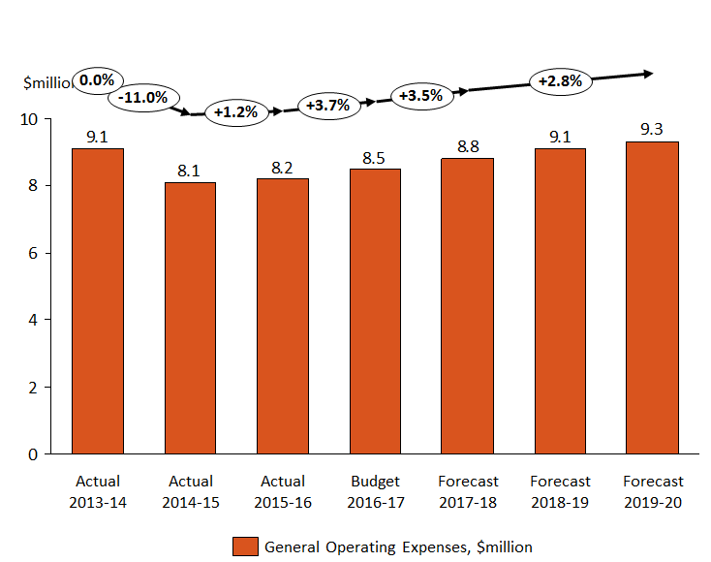

Key strategies and initiatives
Each year, ARPC’s Board and Executive Management team review the organisation’s strategic direction, developing initiatives that will enable the organisation to achieve its objectives.
A high level objective for ARPC is to be regarded by our stakeholders as a trusted advisor for terrorism and catastrophe insurance. We are the first recourse for accurate and informed terrorism insurance advice across all government jurisdictions, as well as the commercial property, insurance and reinsurance sectors.
In early 2016, the strategic direction was revisited for the purpose of drafting the Corporate Plan. ARPC’s six strategic priority areas were updated for the reporting years, with revised key initiatives provided for each strategic priority in the next financial year.

Table 3: 2016-17 Strategic priorities and activities/deliverables
Strategic priority | Activities to support the priority
Be financially strong and ready to respond | Develop and implement a holistic Capital Management Plan to support ARPC financial sustainability by integrating all of our operating levers (price/dividends/fees/retrocession/reserves/investments).  Complete the implementation of new premium rates and monitor accuracy of premiums submitted by insurers.  Purchase retrocession to increase our total funds available for claims and protecting the Government from having to pay initial claims.  Update and test the DTI response plan.
Modernise the mandate | Complete implementation of the 2015 triennial review recommendations.  Engage with stakeholders to develop consensus on the TI Act and Regulations where there are areas of uncertainty of coverage (such as biochemical events); resolve coverage gaps; the Act is fit for purpose in the contemporary environment (life/personal/industry/length of reviews/risk mitigation) in time for the 2018 Triennial Review.  Continue discussions with State and Territory Government insurance schemes on terrorism reinsurance across all areas of terrorism risk.  Continue to support the Government in its understanding of the role of reinsurance pooling for large scale catastrophes.  Continue to raise awareness on emerging terrorism risks like cyber terrorism.
Drive stakeholder advocacy | Continue stakeholder engagement plan to provide more information to stakeholders, extending our relationship and reach to achieve advocacy for ARPC initiatives.  Deliver the OECD-ARPC Global Terrorism Risk Insurance Conference in October 2016.  Publish thought leadership articles on terrorism risk reinsurance.  Undertake a stakeholder satisfaction survey.
Contribute to coverage of catastrophic events | Provide advice to Government on the financial management of large scale catastrophe, using our competencies of quantifying and pricing risk, pricing and collecting premium and reinsuring risk where there is market failure.  Continue development of loss estimating modelling for blasts and biochemical events.  Participate in national and international forums on terrorism and catastrophe insurance and financing.  Participate in the OECD High level Advisory Board for the Financial Management of Large Scale Catastrophe.  Provide technical input to the Australian Government and be ready to respond to Government policy on the Northern Australia Insurance Premiums Taskforce for the option of a storm reinsurance pool.
Promote mitigation for economic resilience | Extend the value proposition of ARPC from pool reinsurance to facilitating resilience through terrorism risk loss mitigation. Evaluate the business case for risk loss mitigation rebates to policyholders.  Explore pathways for sharing our data and expertise with industry to provide additional support for risk management for terrorism incidents.
High achieving and great place to work | Develop high achieving teams and be recognised by prospective employees as a preferred employer.  Staff participating in business planning workshops.  New performance review system.  Staff engagement survey.

Table 4: 2016/17 – 2019/20 Strategic Priorities
Strategic Priorities | 2016/17 | 2017/18 | 2018/19 | 2019/20
Be financially strong & ready to respond | Implement Capital Management Plan
 | Purchase retrocession | Purchase retrocession | Purchase retrocession | Purchase retrocession
 | Review postcode update |  | Review postcode update
 | Update and test DTI Response Plan |  | Update and test DTI Response Plan
 | Claims audit guideline | Evaluate upgrade of claims management system
Modernise the mandate | Integrate Triennial Review findings | Provide advice to the next Triennial Review | Participate in the Triennial Review | Implement any new Triennial Review recommendations
 |  | Review ARPC vision and purpose | Deliver next generation ARPC vision & purpose
 |  |  | Review ARPC IP
 | Review State & Territory Government insurance schemes for gaps in terrorism cover
 | Support Government understanding of financial management of catastrophe
 | Raise cyber terrorism awareness | Address the computer crime exclusion in the next triennial review

Drive stakeholder advocacy | Publish thought leadership articles
 | OECD/APPC Global Terrorism Risk Insurance conference | OECD cyber terrorism conference | OECD terrorism conference | OECD other catastrophe conferences
 |  | Undertake stakeholder satisfaction survey |  | Undertake stakeholder satisfaction survey
 | Continue stakeholder engagement plan | Continue stakeholder engagement plan | Continue stakeholder engagement plan | Continue stakeholder engagement plan
Contribute to coverage of catastrophic events | Continue blast and biochemical event modelling
 | Provide advice to Northern Australian Insurance Premiums Taskforce |  | Respond if requested to Government policy on natural catastrophe
 |  | Clarify ‘grey’ areas, gaps in cover prior to Triennial Review
 | Participate in terrorism and catastrophe insurance forums. | Participate in terrorism and catastrophe insurance forums. | Participate in terrorism and catastrophe insurance forums. | Participate in terrorism and catastrophe insurance forums.
Promote mitigation for economic resilience | Research and scope terrorism risk loss mitigation certification and rebates | Implement certification and rebates
 | Share industry data and expertise
High achieving, great place to work | Business planning workshops | Business planning workshops | Business planning workshops | Business planning workshops
 | Develop staff engagement survey | Cross agency secondments
 | New staff performance appraisal system |  | New Enterprise Agreement

Risk Oversight and Management
The ARPC Board and management are committed to a comprehensive, coordinated and systematic approach to enterprise risk management. Effective risk management has a critical role in all organisational decisions. ARPC’s approach to risk management is to support managers at all levels to anticipate uncertain events, identify opportunities and to respond appropriately to potential weaknesses. This includes:
  - harnessing resources to more effectively manage any risk which will impact ARPC from achieving its objectives;
  - protecting people;
  - understanding and managing the risks arising from our relationships with our clients and other organisations; and
  - managing assets, resources and the environment in an efficient, effective, economical and ethical manner.

Enterprise Risk Management Framework
Under the PGPA Act, ARPC is a corporate Commonwealth entity and, as such, has an obligation to establish risk management systems and controls. The Enterprise Risk Management Framework (ERMF) assists ARPC to meet its risk management obligations under the PGPA Act. The ERMF includes the Risk Management Strategy, as approved and adopted by the Board, and the Risk Management Plan and Risk Policy Statement.
ARPC undertakes a Fraud Risk Assessment at least every two years, which is completed by an independent external consultant. This requirement complies with ARPC’s Fraud Control Plan, which also documents the internal controls established within the organisation to mitigate against fraud occurrence. The Board’s Risk Appetite and Tolerance Statement states that the Board has zero tolerance for fraud, and the Risk Management Strategy within the ERMF documents the measures in place to further mitigate against fraud occurrence.
As a corporate Commonwealth entity, ARPC is not required to comply with the Commonwealth Risk Management Policy. However, APRC’s ERMF has incorporated the Commonwealth’s nine elements of risk management as a matter of best practice. The ERMF incorporates the Risk Management Policy Statement which states that ARPC will manage risk in accordance with the international risk management standard AS/NZS/ISO 31000:2009 Risk Management—Principles and Guidelines. In addition to being consistent with the Commonwealth Risk Management Policy, ARPC’s approach to risk management aligns with relevant ASX Governance Principles relating to risk management, and as far as practicable, APRA’s Prudential Standard GPS 220.

Risk Management Plan
Based on the ERMF, ARPC has a Risk Management Plan, which specifies the approach, management components and risk management resources to be applied to risk at ARPC. This includes the procedures, practices, assignment of responsibilities and risk management timing and sequencing.

Accountabilities
As the accountable authority, the ARPC Board has overall responsibility for providing strategic direction, risk oversight and setting and communicating the organisation’s risk appetite and tolerance. Risk accountability is also clearly outlined in the ERMF.
The ARPC Board has a standing agenda item to examine risk at each Board meeting. Under section 17 of the PGPA Act, the ARPC Audit and Compliance Committee is responsible for reviewing the appropriateness of ARPC’s risk management systems and internal controls. ARPC’s internal controls are routinely reviewed by ARPC’s Internal Auditor, which under the Internal Audit Charter is an external organisation completely independent of management. ARPC’s financial statements are audited annually by the Australian National Audit Office and published in the ARPC Annual Report.
The Chief Executive Officer is responsible for the implementation and maintenance of sound risk management within ARPC and has delegated responsibility for overseeing and maintaining risk management processes to the General Manager, Governance, Risk and Compliance.

Risk appetite and tolerance statements
Each year, the ARPC Board must review and approve the Risk Appetite and Tolerance Statement which is closely aligned with the Risk Management Strategy. This is undertaken as part of the annual strategic direction workshop held by the Board, together with the Executive Management team. ARPC’s risk register is regularly revised to capture new or emerging risks, as well as changes to the risk appetite and tolerance statement. Senior Managers review the risk register frequently and monitor risk target levels and ratings for potential changes. The ARPC Board receives regular reporting, sourced from the risk register, on risks which are outside tolerance levels.

Legislative compliance
ARPC staff are made aware of legislative requirements through ongoing information and training sessions, as well as personal acknowledgement of their obligations contained in associated policies.
All staff attest to compliance with key policies, which includes particular policies on key ARPC legislative obligations. Management also provide quarterly attestations on compliance with legislative obligations.

Appendices
Appendix A

2015 Triennial Review recommendations:
Structure of the ARPC
- Recommendation 1: That the Act remains in force, subject to future three-yearly statutory reviews.
- Recommendation 2: That the current administration structure of the ARPC as set out in the Act be retained.
Retentions
- Recommendation 3: The four per cent rate of gross fire and industrial special risk premium (less any fire services levy) should be increased to five per cent.
- Recommendation 4: Current maximum retention levels for individual insurers should be removed.
- Recommendation 5: The maximum industry retention should be increased from $100 million to $200 million.
Retrocession
- Recommendation 6: That the ARPC continue to have the discretion to purchase retrocession, subject to the ARPC assessing the need for, and levels of, its retrocession programme and value for money.
Fee for the government guarantee
- Recommendation 7: That the ARPC pay to the Commonwealth each year, commencing in 2016-17:
  - a fee of $55 million in respect of the Commonwealth guarantee of the ARPC’s liabilities; and
  - an additional amount of $35 million per annum to reflect the Commonwealth’s support in making the ARPC reserves available for payment of claims.
Premiums
- Recommendation 8: That the premiums charged by the ARPC be increased, with effect from 1 April 2016 to:
  - 16 per cent for Tier A,
  - 5.3 per cent for Tier B, and
  - 2.6 per cent for Tier C.
Scope of the scheme
- Recommendation 9:That the scope of the scheme be extended so that it applies to:
  - buildings in which at least 20 per cent of floor space is used for commercial purposes; and
  - buildings with a sum-insured value of at least $50 million, whether used for commercial or other purposes.
- Recommendation 10: That the application of the Act be clarified by amendments that remove doubt about whether certain losses would be covered under the scheme; in particular, losses attributable to terrorism attacks that use chemical or biological means.

Appendix B:

ARPC organisational structure July 2016

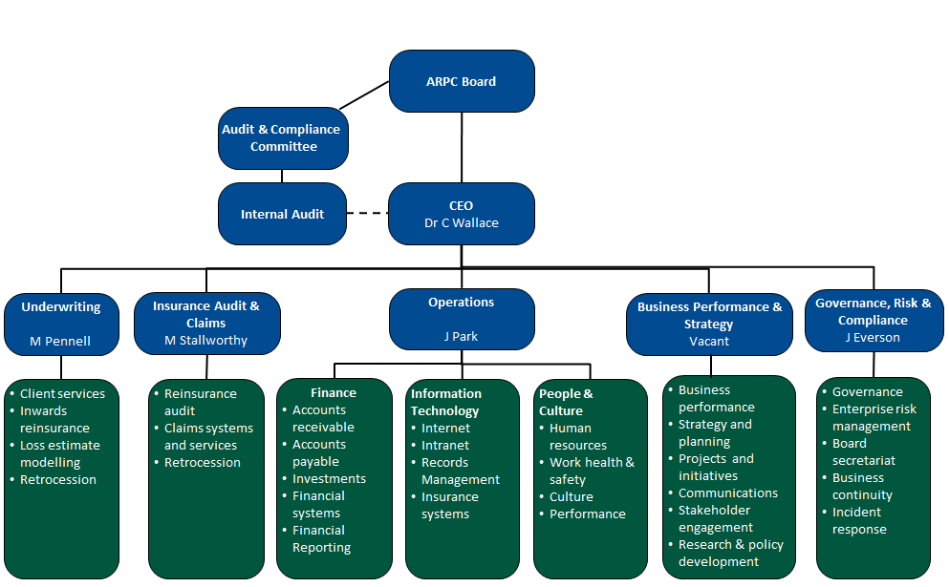

This review was prepared by an external consulting firm Pottinger

