The Hon Josh Frydenberg MP
Assistant Treasurer
Parliament House
CANBERRA ACT 2600

Dear Assistant Treasurer
I have pleasure in presenting to you the corporate plan of the Australian Reinsurance Pool Corporation (ARPC) for the financial year 2015–16. The plan commences 1 July 2015 and spans the three subsequent reporting periods to 30 June 2019.
This plan has been approved by the Board as the Accountable Authority of ARPC, and as required under paragraphs 35(1) and 35(2) of the Public Governance, Performance and Accountability Act 2013 (PGPA Act). The plan is prepared in accordance with the Public Governance, Performance and Accountability Rule 2014 (PGPA Rule).
Each year ARPC undertakes a strategic planning process in conjunction with the Board and executive to set our purpose and role, values, and strategic priorities for future years. These strategic priorities focus our efforts on activities and initiatives to deliver the plan.
Should you have any questions or require further information please do not hesitate to contact me.
Yours sincerely

Joan Fitzpatrick BA (Hons), LLB, ANZIIF (Fellow), CIP, GAICD
Chair

cc The Hon Mathias Cormann MP
Minister for Finance

Correspondence to: GPO Box 3024, Canberra ACT 2601
Level 3, 14 Childers Street, Canberra ACT 2600
T +61 2 6279 2100 | F +61 2 6279 2111 | E enquiries@arpc.gov.au
www.arpc.gov.au | ABN 74807136872

Contents
1. Executive summary 3
2. Introduction 4
Background 4
Terrorism insurance scheme objectives 4
3. Purpose statement 5
ARPC Strategic Plan 2015–2019 6
Values 7
4. Environment 8
Market failure 8
Legislative framework constraints 8
Three-year review (triennial review) 8
2015 Triennial Review 9
Pricing constraints 9
Premiums 9
Declining capital 10
Purchasing retrocession 11
5. Performance 11
5.1 Provide cost effective reinsurance for eligible terrorism losses 12
5.2 Encourage private sector participation through retrocession reinsurance 13
5.3 Compensate Government 16
5.4 Maintain financial sustainability 17
6. Capability 18
Workforce capabilities 18
Efficient operating costs 18
Key strategies and initiatives 19
Strategic priorities and activities 20
7. Risk Oversight and Management 22
Enterprise risk management framework 22
Risk management plan 22
Accountabilities 23
Risk appetite and tolerance statements 23
Legislative compliance 23
8. Appendices 24
Recommendations of 2015 Triennial Review: 24

Executive summary
Our purpose is to protect Australia from economic losses caused by terrorism catastrophe. Through our role we use our expertise to provide cost effective reinsurance to support the economic resilience of the nation. In order to deliver our purpose and role, in 2015-16 we will:
Provide terrorism reinsurance cover to over $3.1 trillion in assets  $122.0  million  Premiums | Protect the Australian economy  $13.3  billion  Total funding for claims
Protect the Government and encourage private sector participation  $2.8  billion  Private sector funding for claims | Compensate the  Government  $112.5  million  Fees and dividends
Sustain the pool
$496
million
Net assets

Introduction

Background
ARPC is a statutory authority established under the Terrorism Insurance Act 2003 (TI Act). We were created after the terrorist attacks in the USA on 11 September 2001. After this attack there was a global withdrawal of terrorism insurance cover leaving commercial property in Australia uninsured against terrorism attacks. ARPC was established by the Australian Government with the support of stakeholders in the property, banking, insurance, and reinsurance sectors.
Section 9 of the TI Act established ARPC as a statutory authority, while section 10 prescribed the key function of ARPC, which is to ‘provide insurance cover for eligible terrorism losses (whether by entering into contracts or by other means)’. ARPC is a corporate Commonwealth entity under the Public Governance, Performance and Accountability Act 2013 (PGPA Act). We are subject to the PGPA Act financial and non-financial reporting requirements.
ARPC provides reinsurance cover of up to $13.3 billion for a declared terrorist incident (DTI), protecting private commercial assets that have an aggregate sum insured exposure of over $3.0 trillion.
In July 2003, the ARPC terrorism insurance pool (the scheme) was established. When a DTI is declared, the TI Act responds by rendering invalid any terrorism exclusion clause in an eligible insurance contract. Although insurers remain liable for commercial terrorism risks, the scheme is not compulsory. Insurers can choose to carry the risk of terrorism losses following a DTI, reinsure the risk through the commercial insurance market, or choose to reinsure with ARPC by paying the scheme premiums.
Commercial property owners who hold eligible insurance policies with those insurers are covered by the ARPC scheme. Consequently, the ARPC scheme plays a crucial role in supporting Australia’s economic resilience following a DTI, by providing a claims payment framework that facilitates the prompt payment of eligible claims and the ability to draw on international funds through ARPC’s purchase of retrocession reinsurance for rebuilding and re-establishing commercial business activity.
ARPC provides cost effective reinsurance cover to insurers and their commercial customers and provides a framework which can respond following a terrorist attack. ARPC enables the sharing and mitigation of risk in a difficult area where there is a continuing gap caused by inadequate capacity to cover the Australian commercial market for terrorism insurance.

Terrorism insurance scheme objectives
At the time of establishing the ARPC, The Explanatory Memorandum of the TI Act outlined the policy objectives for ARPC (see the Revised Explanatory Memorandum of the Terrorism Insurance Bill 2002, page 6). The policy objectives were that intervention would need to be consistent with:
- the need to maintain, to the greatest extent possible, private sector involvement
- ensuring risk transferred to the Commonwealth is appropriately priced and that the Commonwealth is compensated by those benefiting from the assistance
- allowing the re-emergence of the commercial markets for terrorism risk cover
- global solutions.

Purpose statement
We will continue to support those original scheme policy objectives and, through our purpose and role, are strengthening our connection with all our stakeholders. Our overarching objective is to become a trusted advisor to Government and stakeholders on terrorism risk insurance (and reinsurance) and through this to also advise on the financial management of catastrophes.
We have articulated our purpose and role as follows:
Purpose: to protect Australia from economic losses caused by terrorism catastrophe.
Role: we use our expertise to provide cost effective reinsurance to support the economic resilience of the nation.
Our corporate plan has initiatives over short, medium, and long-term horizons. In the short term our focus is on enhancing our core operations; the medium term is on providing expanded coverage within the TI Act; the long term focus is on becoming a trusted advisor on terrorism insurance (and reinsurance).
Our plan has six broad strategic priorities, which support our purpose and role. These priorities are to:
- Drive stakeholder communication and engagement
- Foster a flexible, efficient, and high performing culture
- Be a trusted advisor on terrorism and catastrophe reinsurance
- Manage our risks effectively
- Maximise our financial performance to support our financial sustainability
- Expand our coverage within the Terrorism Insurance Act 2003.

ARPC Strategic Plan 2015–2019
PURPOSE — We are here to protect Australia from economic losses caused by Terrorism catastrophe.
HORIZONS
Enhance the core
Expand within the Act
Trusted advisor for terrorism reinsurance
STRATEGIC PRIORITIES
Drive stakeholder communication and engagement
Foster a flexible, efficient and high performing culture
Be a trusted advisor on terrorism and catastrophe reinsurance
Manage our risks effectively
Maximise our financial performance to support financial sustainability
Expand our coverage within the Terrorism Insurance Act 2003
ROLE — And we do this by using our expertise in reinsurance and providing cost effective cover to support the economic resilience of the nation.

Values
ARPC’s executive and staff have developed a set of values that are used in all decision making and in delivering our strategic objectives. These values support the ARPC Code of Conduct.

Stakeholders first | Empower our people | Be courageous | Work smart | Continuously improve
treat all stakeholders professionally  understand stakeholder needs  exceed client expectations  focus on finding solutions for stakeholder problems  commitment with integrity | take personal accountability  lead, empower and trust our colleagues  collaborate with and respect each other  communicate clear expectations  value diversity | be transparent in communications  speak up with positive intent  be resilient and responsive  have a go  do the right thing | provide expertise in terrorism insurance  promote our capability  be active in advising the market  identify gaps in the market place  promote our expertise  promote learning and best practice | coach, mentor and celebrate success  challenge the status quo  deliver outcomes effectively and efficiently  be energetic  seek, provide and act on feedback

Environment

Market failure
ARPC was established to address market failure in the area of terrorism risk insurance for Australian commercial properties. Since 11 September 2001, Australian commercial policies incorporate terrorism exclusion clauses; however, the TI Act makes it compulsory for insurers to cover terrorism losses that result from a DTI. Although it is optional for insurers to take out terrorism reinsurance cover with ARPC, almost all commercial property insurers choose to reinsure their terrorism risk with ARPC.
After 13 years of operation, there is still no whole-of-market, sustainable, alternative provider of terrorism reinsurance. The reinsurance market still has insufficient capacity to offer uniform terrorism insurance coverage at affordable prices, a situation which is unlikely to change in the period covered by this corporate plan.
Market failure is further evidenced by the fact that the 2015 retrocession program purchased by ARPC was close to the total available global capacity, yet was only about 30 per cent of the $10 billion cover provided by the Commonwealth guarantee.

Legislative framework constraints
ARPC must operate within the legislative framework of its enabling act, the TI Act, whilst also being fully compliant with Australian Government obligations under the PGPA Act.
The TI Act prescribes the function of ARPC, with the focus of providing insurance cover for terrorism losses. Although operating in the private market, the premiums that ARPC can charge its insurers are set through a Ministerial Direction. Premiums have remained unchanged since ARPC’s establishment in 2003.
The Terrorism Insurance Act Regulations (the Regulations) are also relevant to our legislative framework and these define what is excluded from coverage under the TI Act.

Three-year review (triennial review)
At the time of establishing ARPC, it was uncertain whether the private market would return to full capacity. To monitor the ongoing need for the TI Act, section 41 of the TI Act provides that the Department of the Treasury must undertake a review of the operation of the TI Act at least every three years. Today there is a heightened threat of terrorism attack as evidenced by the Australian National Terrorism Public Alert System raising the threat level to High in September 2014, where it has remained. Thirteen years after ARPC’s establishment, successive triennial reviews have each recommended that ARPC and the TI Act continue in operation.
Unfortunately, the three-year review causes cyclical uncertainty among stakeholders, due to the potential consequence of a change in policy that could impact the operation of the TI Act. While market failure remains a contemporary issue, the concerns of insurers heighten at the time of each review, due to the potential need for insurers to find alternative terrorism insurance capacity (albeit very limited) should there be scheme changes.
Industry concern was particularly high as the 2015 Triennial Review was conducted in the climate of heightened terrorism threat levels, in addition to what was then an apparent increased Government appetite for privatisations across Government agencies.

2015 Triennial Review
The 2015 Triennial Review was conducted by Treasury late in 2014 and early 2015 with the assistance of a consultant, Pottinger, who conducted market soundings in relation to the need for ARPC to continue to administer the terrorism insurance scheme. The Treasury also commissioned Finity to undertake a review of terrorism insurance cover for high-rise residential and mixed-use commercial property. These independent reviews were used by Treasury to inform its review of the TI Act, which was released for limited stakeholder consultation in June 2015.
At the time of our corporate plan going to print, the review report has not been approved for public release. Our plan will be updated to incorporate recommendations from the triennial review once the report is published. We anticipate that the implementation of the triennial review recommendations will have an overall positive impact on ARPC’s financial sustainability and operational effectiveness.
The recommendations of the 2015 Triennial Review will be included in Appendix A once that report is published.
In compliance with section 41 of the TI Act, the Minister must report on the next triennial review before 30 June 2018.

Pricing constraints
ARPC is a corporate Commonwealth entity operating in a private sector environment that is subject to global economic factors, which are outside its control but which can significantly impact ARPC’s financial sustainability.

Global factors
Like all insurers, ARPC is subject to the impact that global catastrophes have on the market, as well as market pricing cycles. Catastrophes such as Hurricane Katrina (2005) in the USA, the earthquake and subsequent tsunami in Japan and the earthquake in Christchurch New Zealand (2011), all resulted in large claims against major reinsurers, with consequential rises in catastrophe insurance premiums. However, since 2011 there have been no large-scale catastrophes globally, causing reinsurance and direct insurance premium rates to generally fall in a ‘soft’ market to levels not seen for many years. As ARPC premiums are charged as a percentage of insurer’s gross written premiums, this has had a flow-on effect, causing ARPC premium revenue to fall in parallel.

Pricing terrorism insurance
For ARPC, the difficulty in pricing terrorism insurance is compounded by the difficulty in predicting terrorism attacks and the likely timing, number and size of potential claims. Although ARPC utilises sophisticated loss estimation models to assist with predicting the size of possible losses, the frequency of a loss is not possible to model due to the human factor involved in terrorist attacks. As a consequence, it is acknowledged globally that terrorism risk is extremely complex to price with any degree of accuracy. This pricing dilemma is made more complex by the fact that ARPC can only adjust its premium rates through a Ministerial Direction.

Premiums
ARPC is not funded through Commonwealth budget appropriations. ARPC’s premium income from insurers and investment income is used to fund all operations, including our retrocession premiums and government fees and dividends, while building the claims reserve available to meet future claims. As mentioned earlier, the premium rates charged to insurers by ARPC are set by Ministerial Direction. These prices have not been increased since the inception of ARPC. Despite this, and the recent softening market conditions, our gross written premiums are a reflection of the continued participation in, and support by insurers for our scheme.
Premiums are set in three tiers by postcode, having regard to population density in a given postcode area. The premiums are calculated as a percentage of each insurer’s gross written premium (GWP) for eligible insurance contracts located in each tier. Percentages of gross written premium used to calculate premiums are as follows:
- Tier A: 12 per cent
- Tier B: 4 per cent
- Tier C: 2 per cent.
Because ARPC receives a fixed percentage of insurers’ premiums, premium income earned by ARPC is subject to premium price fluctuations, which are beyond the control of ARPC. Consequently ARPC is constrained not only by having to seek a Ministerial Direction to increase premium rates; it is also vulnerable to market fluctuations that make the forecasting of premium income subject to error. The global trend to lower premiums mentioned above continues to impact ARPC’s ability to accurately forecast its premium income and appropriately allocate budget funds.
Should a declared terrorist incident lead to major losses and consequently major payouts by ARPC, there would need to be a substantial increase in premium rates for ARPC to remain financially sustainable. Despite this being justifiable, ARPC cannot instigate any premium increase, but would need to approach the Minister seeking a Ministerial Direction to remain financially sustainable.
Further explanation of the variability in premium income is shown in Table 1 below. This shows a snapshot of insurance risks as at 17 August 2015, tabling all premiums for policies commencing within the financial year, which is called an “underwriting year”.
Table 1: Insurance risk report, as at 17 August 2015
Underwriting year | Premium income $million (A) | Insurer client sum insured $million (B) | Insurer client gross written premium $million (C) | Premium as % of GWP  (A) ÷ (C)
2012-13 | 129.9 | 3,009,662 | 3,712 | 3.5%
2013-14 | 126.7 | 3,114,901 | 3,610 | 3.5%
2014-15 | 128.4 | Not yet available* | 3,658 | 3.5%
*The 2014-15 risk reports are not submitted by insurers to ARPC until September 2015.

Declining capital
ARPC uses its premium and investment income to fund its operations and build the claims reserve. ARPC has prudently invested its surplus funds to supplement its income from premium revenues, with the size of the pool growing to $665 million by 30 June 2011. This has subsequently reduced to $538 million as at 30 June 2015.
It was envisaged from the commencement of ARPC that the Government would be fairly compensated for the risk of the Commonwealth guarantee being claimed against. The 2012 Triennial Review determined that ARPC should commence making annual payments to the Government for the provision of the $10 billion Commonwealth guarantee, taking into consideration the backdating of the payments for ARPC’s inception. The first payment was made by ARPC in January 2013.
As a result of the 2014 Federal Budget, all previously directed dividends were replaced with an annual dividend payment of $57.5 million over the next four years, together with an annual Government ‘fee’ of $55 million for the Commonwealth guarantee.
Since January 2013, ARPC’s net assets have been progressively reduced by these payments to Government. As a consequence of the progressive decline in surplus funds, there has been a corresponding decline in investment revenue, compounded by the recent decline in interest rates. With the rate of this decline being subject to global financial markets, and the premium revenue that generates the surplus also subject to global insurance and reinsurance markets, the task of forecasting ARPC’s revenue remains difficult. For ARPC as a business, the variations from one year to the next are likely to be the norm rather than the exception.
ARPC remains vigilant to these variations and has monitoring and control mechanisms in place to enable agile responses to potential revenue fluctuations.

Purchasing retrocession
Since 2009, ARPC has placed an annual retrocession program. For the 2015 program ARPC purchased around $2.9 billion in reinsurance capacity through almost 60 reinsurers, all of which must be rated by Standard and Poor’s as A- or better, and most of which are located overseas. Through purchasing retrocession, ARPC is not only providing a valuable overseas funding source for rebuilding Australian commercial infrastructure, but is also protecting the Government from drawing on the Commonwealth guarantee.
While this annual purchase encourages the re-emergence of the commercial terrorism insurance market, it is subject to potential volatility in both capacity and pricing that is impacted by exchange rate movements and also natural catastrophes. This exposes ARPC to market factors that are not within ARPC’s control, necessitating that the program undergoes close and regular scrutiny by ARPC.

Performance
In compliance with the PGPA Act, we must remain financially sustainable, managing our public resources in an efficient, effective, economical and ethical manner as we continue to fulfil our purpose. There are four key corporate plan activities that ARPC will undertake over the reporting years that will facilitate achieving our purpose. These are:
- Provide cost effective reinsurance for eligible terrorism losses.
- Encourage private sector participation through retrocession reinsurance.
- Compensate the Government.
- Maintain financial sustainability.
These are outlined below together with how ARPC will measure and assess the success of each activity in achieving our purpose and role.

5.1 Provide cost effective reinsurance for eligible terrorism losses
This is our functional obligation as prescribed by section 10 of the TI Act. Over the period covered by the corporate plan, success for this activity will be measured by ARPC’s total premium income, with the target premium level for the forecast period being $110 million per annum.

Measure 1 — Gross written premium income
Measure 1: To support financial sustainability, achieve higher than the target premium in each plan period.
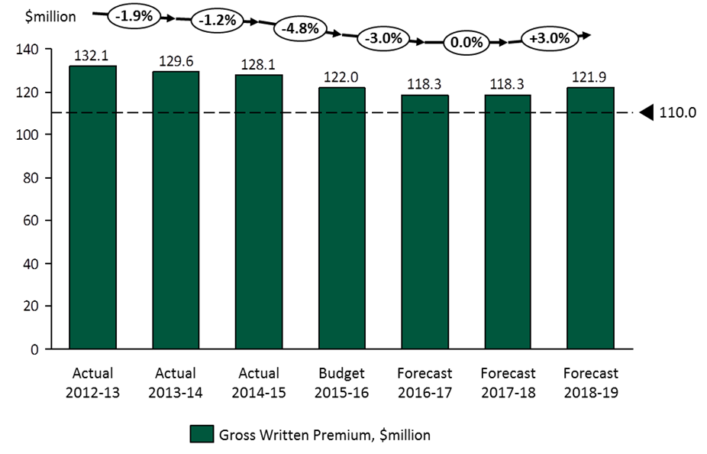

5.2 Encourage private sector participation through retrocession reinsurance
Market failure was the trigger for the Government’s intervention in the terrorism insurance market, following the events in the USA in September 2001. Successive triennial reviews have confirmed that the reinsurance market has insufficient capacity to offer uniform terrorism insurance coverage at affordable prices for the foreseeable future. Consequently, encouraging private sector participation remains a key policy objective for ARPC’s terrorism insurance scheme, and remains a key activity of ARPC.
We use our premium income to purchase retrocession reinsurance (reinsurance cover from private sector reinsurers) and to compensate the Government. Through our access to retrocession and the Commonwealth guarantee, in 2015 we have a total of $13.3 billion in funding available for losses arising from a declared terrorist incident.
Total funding available for a Declared Terrorist Incident — 2015
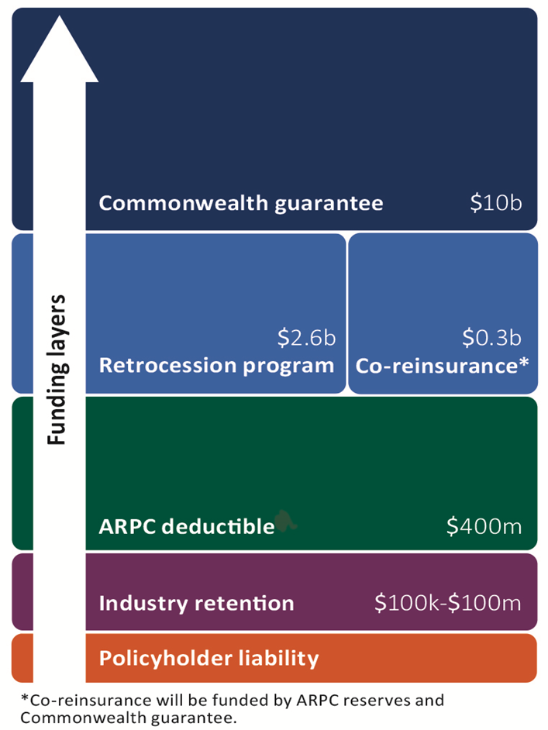

Since 2009 ARPC has purchased reinsurance from global terrorism insurers (retrocession reinsurance), transferring a proportion of the risk to the private market in an effort to encourage private sector participation in risk sharing and reduce the risk to Government and the Australian economy. Reinsurers or ‘retrocessionaires’ provide private cover for the first tranches of claims payments.
Each year, ARPC negotiates and places a program of retrocession reinsurance with major global reinsurers, seeking a placement that provides value-for-money whilst encouraging maximum participation of global insurers. Since 2009, ARPC has only been able to procure a capacity of about one third of the known probable maximum loss of an event in the Sydney CBD, but has secured the participation of all major global reinsurers.
To measure success in this activity, ARPC will measure total reinsurance capacity purchased each calendar year and the total purchase cost, whilst continuing to monitor the number of participating retrocession reinsurers.

Measure 2 — Retrocession program capacity, per calendar year
Measure 2: To protect the government from losses, purchase more than $2.5 billion in retrocession each program period.
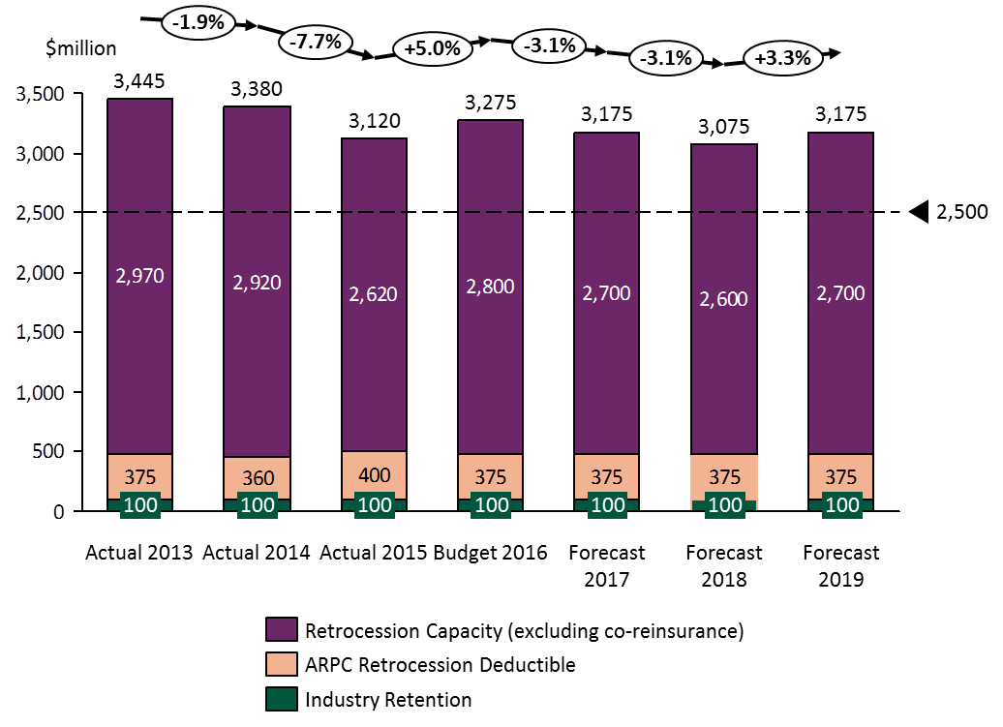

We also aim to be cost effective and to purchase retrocession on a value-for-money basis. We therefore set a budget each year for the purchase of retrocession and we seek to maximise our capacity within the available budget.

Measure 3 — Retrocession program cost, per calendar year
Measure 3: Our objective is to maximise our capacity purchased within the budget that we have available in each program period.
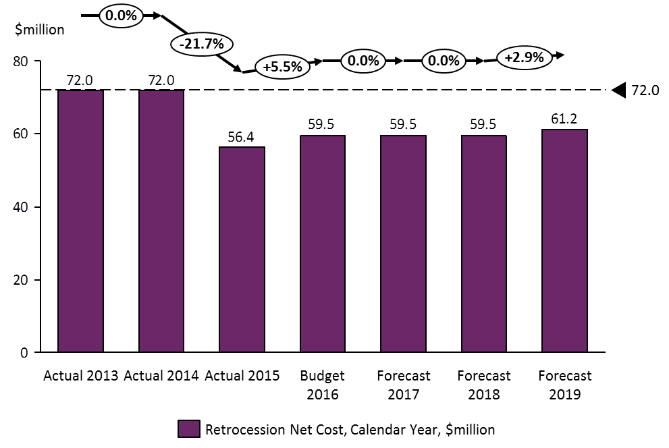
To achieve value-for-money each year, we will aim to purchase the maximum capacity within our budget allocated by ARPC’s Board each year for retrocession purposes, but ideally spending no more than $72 million.

5.3 Compensate Government
ARPC pays the Government a fee for the use of the Commonwealth guarantee as well as a dividend to reflect return on capital for Government as the owner of ARPC.

Measure 4 — Payments to Government
Measure 4: To meet our obligations, the target is to deliver the Government payments in each plan period. The payments are set by Ministerial Direction.
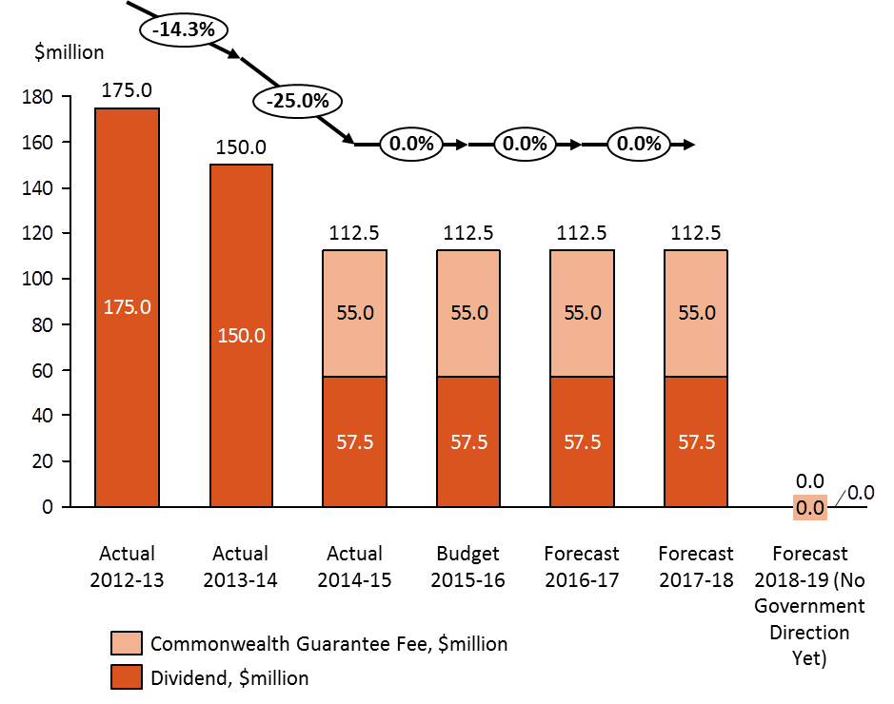

5.4 Maintain financial sustainability
As is the case with any insurer, in order to retain our operational effectiveness, ARPC must remain financially sustainable by putting in place robust financial systems and controls; maintaining close working relationships with relevant Treasury officials is equally important.
Key factors impacting ARPC’s financial sustainability are:
- our premium rates and premium income
- our investment return
- the size and cost of our retrocession reinsurance program
- any claims costs associated with a declared terrorist incident
- the size, structure and timing of fees and dividends payable to the Government.
To measure and assess our financial sustainability, ARPC will measure net assets, which is the final balance as impacted by all of the above key factors. ARPC notes that future years will see a net cash outflow due to ongoing payments to Government.

Measure 5 — Financial sustainability
Measure 5: Maintain sufficient net assets to support the retrocession deducible ($400 million in 2015).
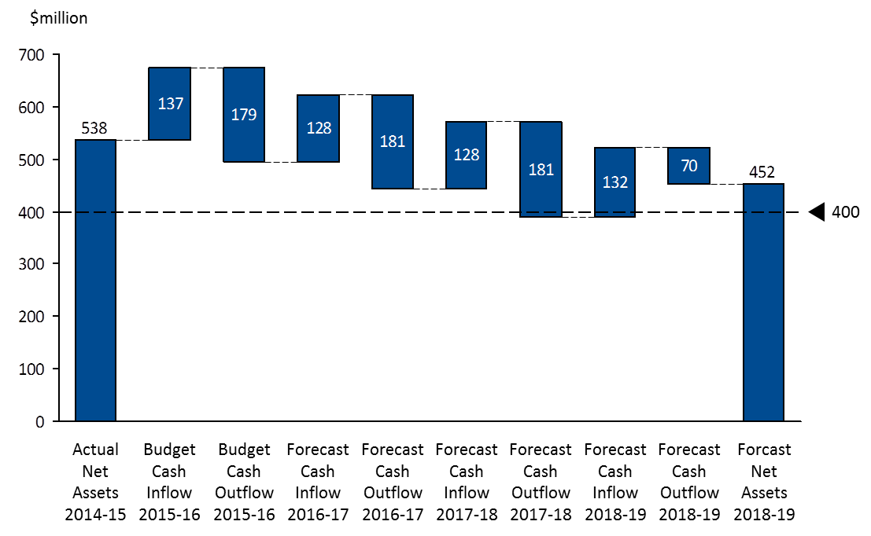

Capability

Workforce capabilities
Consistent with Government’s policy objectives of smaller government, in July 2014 ARPC underwent an organisational restructure, flattening its structure and combining roles to produce a more efficient organisation, reducing full time employees from 25 to 20. ARPC is required to conduct reinsurance market operations as well as fulfil governance, risk, and compliance obligations. Our skills and capabilities within our organisational structure support all ARPC activities. Our organisation structure is shown in Appendix B.
ARPC promotes a values based approach to our workforce and decision-making. Our values place an emphasis on ‘Stakeholders First’. The organisation structure supports our focus on engaging with stakeholders, across Commonwealth, State and Territory governments, plus the insurance, reinsurance and property sectors.
In accordance with the TI Act, ARPC is required to respond to any potential terrorism incident, advise our Minister, the Attorney General and our insurers, and subsequently pay eligible claims. We undertake workforce planning and succession planning such that ARPC has high performance staff with the appropriate skills to undertake our core functions.

Efficient operating costs
Historically, ARPC has operated two offices, one in Canberra and one in Sydney. In May 2015 the ARPC Board approved a consolidation of operations to a single office in Sydney. The relocation project commenced in June 2015 and has the objective of transferring all operations to the Sydney office from October 2015. The new office supports our strategic priority of supporting stakeholders, with the largest proportion of industry stakeholders being located in Sydney. The Sydney office will be smaller than the existing operations and will deliver significant cost savings.
Consolidation of ARPC’s operations to one site will create immediate efficiencies in all business areas. It will allow an increase in the engagement of industry expertise to enhance ARPC’s workforce capabilities, including access to actuarial, insurance modelling, insurance and reinsurance skills, and enable closer interaction with stakeholders.
General operating expenses
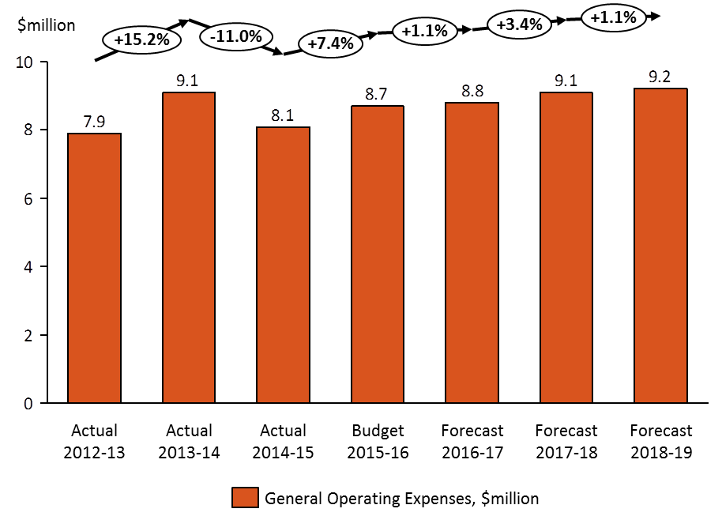

Key strategies and initiatives
Each year, ARPC’s Board and Executive Management Team review the organisation’s strategic direction, developing initiatives that will facilitate the organisation to achieve its objectives.
A high level objective for ARPC is to be regarded by our stakeholders as a trusted advisor for terrorism and catastrophe insurance. We are the first recourse for accurate and informed terrorism insurance advice across all government jurisdictions, as well as the commercial property sector and the insurance and reinsurance sectors. The office relocation to Sydney and development of our workforce capabilities will be a critical factor in supporting and maintaining this objective.
In early 2015, the strategic direction was revisited for the purpose of drafting the corporate plan; six strategic priority areas were identified for the reporting years, with key initiatives listed for each of the reporting periods.

Strategic priorities and activities
Strategic priority | Activities to support the priority
Drive stakeholder communication and engagement | Each year, ARPC develops and implements a Stakeholder Communications Plan. Success will be measured by the increase in stakeholder engagement achieved and by the percentage of anticipated meetings/presentations that are completed.  ARPC has and will be undertaking a process of continuous improvement on stakeholder engagement activity as we acknowledge that both our internal (Commonwealth government) and external stakeholders are central to our operations, service delivery and delivering on our key objectives.
Foster a flexible, efficient and high performing culture | ARPC is developing a smaller, professional and agile workforce. We will be implementing a renewed Enterprise Agreement and Employment Policy in FY 2015–16.  The Integrated Leadership System (ILS) developed by the Australian Public Service Commission (APSC) will also be implemented during the 2016 calendar year.  We aim to undertake annual staff engagement surveys.
Be a trusted advisor on terrorism and catastrophe reinsurance | ARPC is involved and participates in national and international forums on terrorism and catastrophe insurance and financing.  ARPC responds to a range of requests for advice and input, in particular from Treasury and government.  Our activities include providing technical input to the Northern Australia Insurance Affordability Taskforce, in particular for the option of a storm reinsurance pool.  As a focus, in 2015–16, ARPC will develop and publish a white paper on cyber terrorism and cyber insurance to inform discussion on this issue.  ARPC is continuously and proactively building our profile, relevance and trust across partner agencies and private sector organisations in the security, economic policy and financial sector environments.  ARPC is exploring pathways to sharing our custom data and expertise with partners to provide additional support for risk management for terrorism incidents.
Manage our risks effectively | ARPC strives to foster a risk management culture across the organisation. As a focus in 2015–16, ARPC will implement all Government recommendations within the 2015 Triennial Review Report. ARPC has formalised its enterprise risk management framework and underlying control systems that identify, rate and quantify our risks, and enable their ongoing mitigation (see chapter 7).  ARPC is working in partnership with actuarial advisers in an effort to better understand and manage the global fluctuations in premiums that impact on our revenue forecasting ability. In addition, ARPC is developing a policy and/or process for the regular review of premium rates, in order to make a subsequent recommendation to Government. This review process will provide assurance that the premiums gathered will sustain ARPC’s business operations, whilst remaining responsive to the national conditions and Government policy in the context of global market fluctuations.
Maximise our financial performance to support our financial sustainability | As a key corporate plan activity, ARPC measures its financial performance by recording and monitoring its net assets and operating surplus, as recorded at the end of the financial year immediately preceding each corporate plan.  The purchase of retrocession reinsurance by ARPC also increases our capability to pay claims whilst protecting the Government from having to pay initial claims. We will report on the outcomes of our annual retrocession reinsurance purchase.  Our activities will also include consolidating our operations into our Sydney CBD office in order to be more closely aligned with our insurance industry stakeholders and to be more efficient overall.
Expand our coverage within the Terrorism Insurance Act | ARPC has identified gaps in coverage for terrorism insurance, a factor that has informed the triennial review process.  Another area of focus is the gap in cover between State and Territory Government schemes (which are not included in the ARPC scheme).  We will continue to support the Government in its understanding of the role of pools for extreme catastrophes and advise on the provision of catastrophe insurance to all stakeholders.  ARPC will continue to position the organisation as a ‘centre of excellence’ for policy makers and partners on all related or potentially related insurance matters.

Risk Oversight and Management
The ARPC Board and management are committed to a comprehensive, coordinated and systematic approach to the management of risk. Effective risk management is considered the critical driver in all organisational decisions. With the need for sound assessment and management of risk, there remains an ongoing requirement to balance the cost and benefit of a particular course of action to achieve acceptable levels of residual risk, with consideration of effort remaining commensurate with ARPC resources. ARPC’s adopted approach to risk management is to support managers at all levels to anticipate uncertain events, exploit opportunities, and to respond appropriately to potential weaknesses. This includes:
- harnessing resources to manage more effectively any risk to the achievement of objectives
- protecting people
- understanding and managing the risks arising from our relationships with our clients and other organisations
- managing assets, resources and the environment in an efficient, effective, economical and ethical manner.

Enterprise risk management framework
Under the PGPA Act, ARPC is considered a corporate Commonwealth entity and, as such, has an obligation to establish and maintain systems of risk and controls. ARPC has revised its Enterprise Risk Management Framework (ERMF), which facilitates ARPC meeting its risk management obligations under the PGPA Act. The ERMF incorporates the Risk Management Strategy, as approved and adopted by the Board, and the Risk Management Plan and Policy Statement.
ARPC undertakes a Fraud Risk Assessment at least every two years, which is completed by an independent external consultant. This requirement is in compliance with ARPC’s Fraud Control Plan, which also documents the internal controls established within the organisation to mitigate against fraud occurrence. The Board’s Risk Appetite and Tolerance Statement documents that the Board has zero tolerance for fraud, and the Risk Management Strategy within the ERMF documents the measures implemented to further mitigate against fraud occurrence.
As a corporate Commonwealth entity, ARPC is not required to comply with the Commonwealth Risk Management Policy. However, APRC’s ERMF has incorporated the Commonwealth’s nine elements of risk management as a matter of better practice. The ERMF incorporates the Risk Management Policy Statement that ARPC will manage risk in accordance with the international risk management standard AS/NZS/ISO 31000:2009 Risk Management—Principles and Guidelines. In addition to being consistent with the Commonwealth Risk Management Policy, ARPC’s approach to risk management will align with relevant ASX Governance Principles relating to risk management, and as far as practicable, APRA’s Prudential Standard GPS 220.

Risk management plan
Based on the ERMF, ARPC has a Risk Management Plan, specifying the approach, the management components and resources to be applied to the management of risk in ARPC. This includes the procedures, practices, assignment of responsibilities and the sequence and timing of risk management activities.

Accountabilities
The areas of accountability for risk are clearly outlined in the ERMF. As the accountable authority, the ARPC Board has overall responsibility for providing strategic direction, risk oversight and setting and communicating the organisation’s risk appetite and tolerance.
In 2013, the ARPC Board made a decision to heighten its focus on risk by creating a standing agenda item to examine risk at each Board meeting. Until that time, risk had been considered by a Risk Committee that met twice each year. Under section 17 of the PGPA Act, the ARPC Audit and Compliance Committee is responsible to review the appropriateness of ARPC’s systems of risk oversight, management and internal controls. These internal controls are the subject of routine reviews by ARPC’s Internal Auditor, which under the Internal Audit Charter is an external organisation, ensuring complete independence of internal audit activities. ARPC’s financial statements are audited annually by the Australian National Audit Office, and reported in the ARPC Annual report.
The Chief Executive Officer (CEO), is responsible for the successful implementation and maintenance of sound risk management within ARPC and has delegated responsibility of overseeing and maintaining risk management processes throughout ARPC to the General Manager, Governance, Risk and Compliance (GMGRC).

Risk appetite and tolerance statements
Each year the ARPC Board must review and approve it Risk Appetite and Tolerance Statement, and the closely aligned Risk Management Strategy. This is undertaken as part of the annual strategic direction workshop held by the Board, together with the Executive Management team. Subsequently, the risk register is revised for alignment with the risk appetite and tolerance statement such that any new or emerging risks are captured. At a weekly meeting, ARPC’s senior managers review the risk register and monitor risk target levels and ratings for potential changes so that they remain appropriately aligned to the Risk Appetite and Tolerance Statement.

Legislative compliance
Throughout 2014, the transition to the new finance law (the PGPA Act) was closely guided by the GMGRC through participation in Department of Finance committees and workshops. Training was provided to all staff; a lawyer from the Australian Government Solicitor provided an information session to Board members on their obligations as directors and officers under the PGPA Act.
In 2015, ARPC commissioned an internal audit of the implementation of the PGPA Act by the organisation, which concluded that ARPC had a high level of compliance with the requirements of the PGPA Act.
ARPC’s staff are made aware of all relevant legislative obligations placed on them within the workplace through ongoing information and training sessions, and a requirement to acknowledge their understanding of their requirements within all associated policies. The annual certificate of compliance for reporting in ARPC’s Annual Report includes all relevant Acts with which ARPC must comply. The 2014–15 Annual Report will also include a note on staff compliance with ARPC key policy documents.

Appendices

Recommendations of 2015 Triennial Review:
At the time of writing this corporate plan, the 2015 Triennial Review has not yet been approved for public release.

ARPC organisation structure
